
UNITED STATES
SECURITIES AND EXCHANGE COMMISSION
WASHINGTON, DC 20549
FORM 8-K
CURRENT REPORT
Pursuant to Section 13 or 15(d) of the
Securities Exchange Act of 1934
Date of report (Date of earliest event reported): May 7, 2026
STRATTEC SECURITY CORPORATION
(Exact Name of Registrant as Specified in Charter)
Wisconsin |  | 0-25150 |  | 39-1804239
(State or Other Jurisdiction  of Incorporation) |  | (Commission  File Number) |  | (I.R.S. Employer  Identification No.)

3333 West Good Hope Road, Milwaukee, Wisconsin 53209
(Address of Principal Executive Offices, and Zip Code)
(414) 247-3333
Registrant’s Telephone Number, Including Area Code

(Former name or former address, if changed since last report)
Check the appropriate box below if the Form 8-K filing is intended to simultaneously satisfy the filing obligation of the registrant under any of the following provisions:
 | ☐ | Written communication pursuant to Rule 425 under the Securities Act (17 CFR 230.425)
 | ☐ | Soliciting material pursuant to Rule 14a-12 under the Exchange Act (17 CFR 240.14a-12)
 | ☐ | Pre-commencement communication pursuant to Rule 14d-2(b) under the Exchange Act (17 CFR 240.14d-2(b))
 | ☐ | Pre-commencement communication pursuant to Rule 13e-4(c) under the Exchange Act (17 CFR 240.13e-4(c))
Securities registered pursuant to Section 12(b) of the Act:
Title of each class |  | Trading Symbol |  | Name of each exchange on which registered
Common Stock, $.01 par value |  | STRT |  | The Nasdaq Global Stock Market
Indicate by check mark whether the registrant is an emerging growth company as defined in Rule 405 of the Securities Act of 1933 (§230.405 of this chapter) or Rule 12b-2 of the Securities Exchange Act of 1934 (§240.12b-2 of this chapter).
Emerging growth company ☐
If an emerging growth company, indicate by check mark if the registrant has elected not to use the extended transition period for complying with any new or revised financial accounting standards provided pursuant to Section 13(a) of the Exchange Act. ☐

Item 2.02 | Results of Operations and Financial Condition.
On May 7, 2026, Strattec Security Corporation (the “Company”) issued a press release (the “Press Release”) announcing results for the fiscal third quarter ended March 29, 2026. A copy of the Press Release is attached as Exhibit 99.1 to this Current Report on Form 8-K.
Also on May 7, 2026, the Company first provided investors with a supplemental presentation regarding fiscal third quarter earnings and other current financial information, attached as Exhibit 99.2 hereto and incorporated by reference herein (the “Investor Presentation”).

Pursuant to General Instruction B.2 of Current Report on Form 8-K, the information in this Item 2.02 and Exhibits 99.1 and 99.2 is being furnished and shall not be deemed to be “filed” for purposes of Section 18 of the Securities Exchange Act of 1934, as amended (the “Exchange Act”), or otherwise subject to the liability of that section. Furthermore, the information in this Item 2.02 and Exhibits 99.1 and 99.2 shall not be deemed to be incorporated by reference into the filings of the Company under the Securities Act of 1933, as amended (the “Securities Act”), except as may be expressly set forth by specific reference in such filing.
Item 7.01 | Regulation FD Disclosure.
As described in “Item 2.02 Results of Operations and Financial Condition” above, on May 7, 2026, the Company issued a Press Release announcing earnings results for the fiscal third quarter ended March 29, 2026 and an Investor Presentation containing supplemental fiscal third quarter earnings and other current financial information. The Press Release and Investor Presentation issued in connection with the announcement are attached as Exhibits 99.1 and 99.2 to this Current Report on Form 8-K.
Pursuant to General Instruction B.2 of Current Report on Form 8-K, the information in this Item 7.01 and Exhibits 99.1 and 99.2 is being furnished and shall not be deemed to be “filed” for purposes of Section 18 of the Exchange Act, or otherwise subject to the liability of that section. Furthermore, the information in this Item 7.01 and Exhibits 99.1 and 99.2 shall not be deemed to be incorporated by reference into the filings of the Company under the Securities Act, except as may be expressly set forth by specific reference in such filing.
Item 9.01 | Financial Statements and Exhibits.

(d) Exhibits.

Exhibit Number | Description
99.1 | Press Release of Strattec Security Corporation, issued May 7, 2026
99.2 | Investor Presentation
104 | 104 – Cover Page Interactive Data File (embedded within the Inline XBRL document).

SIGNATURE

Pursuant to the requirements of the Securities Exchange Act of 1934, the registrant has duly caused this report to be signed on its behalf by the undersigned hereunto duly authorized.

STRATTEC SECURITY CORPORATION

By:/s/ Matthew P. Pauli
Matthew P. Pauli, Senior Vice President and
Chief Financial Officer

Date: May 7, 2026

NEWS
RELEASE

FOR IMMEDIATE RELEASE
For Third Quarter Fiscal 2026, Strattec Continued to Advance Transformation Efforts to Strengthen Business Performance
•
Strong balance sheet provides financial flexibility with $107 million of cash; $11.4 million of cash generated from operations in the third quarter
•
Sales declined 4.5%, consistent with expectations, on lower North American OEM automotive production volumes of key platforms
•
Gross margin improved 50 basis points year-over-year to 16.5%, despite the sales decline and 170 basis point foreign currency exchange rate headwind
•
Net income attributable to Strattec was $3.2 million, or $0.78 per diluted share; Adjusted EBITDA1 was $10.1 million, or 7.3% of net sales

MILWAUKEE, WI, May 7, 2026 — Strattec (Nasdaq: STRT), a global provider of highly engineered access solutions for the automotive and mobility industries, today reported financial results for its third quarter of fiscal year 2026, which ended March 29, 2026.
Jennifer Slater, President and CEO of Strattec, said, “We are continuing to progress on our strategy to transform Strattec into a more predictable, higher performing business even as we continually face the challenges of the automotive industry including weak end market demand, platform changes, tariffs and the long-cycle nature of the sector. Our near-term objectives remain focused on improving our cost structure and driving a stronger more predictable business while positioning ourselves to win new opportunities on future platforms for model years 2029 and beyond and developing deeper relationships with both current and prospective customers.”
She concluded, “Our team is leaning into the challenges and recognizes there is still more work to be done. We are encouraged with our potential and are supported with a very solid balance sheet and strong cash generation.”
FY 2026 Third Quarter Financial Summary
Net sales were $137.6 million, down $6.5 million, or 4.5% from the prior-year period. Lower sales were the result of $7.7 million in lower volume including $3.4 million lower sales related to customer EV program cancellations. The volume declines were partially offset by $1.3 million in pricing including $0.6 million in tariff recoveries.

1 Refer to use of “Non-GAAP Financial Metrics and Additional Financial Information” as well as accompanying reconciliations to GAAP

3333 WEST GOOD HOPE ROAD  MILWAUKEE, WI 53209 | 414.247.3333  WWW.STRATTEC.COM | NASDAQ:  STRT

For Third Quarter Fiscal 2026, Strattec Continued to Advance Transformation Efforts to Strengthen Business Performance
May 7, 2026
Page 2 of 10
Gross profit was $22.7 million, compared with $23.1 million in the prior year, on lower volume. Gross margin expanded 50 basis points to 16.5% primarily as a result of $1.7 million in restructuring savings and $0.6 million of recoveries from customer program cancellations. Partially offsetting these benefits were $2.5 million higher costs related to unfavorable changes in foreign exchange rates,
a $0.5 million increase in labor and benefit costs, and $0.3 million of incremental tariff costs.
Selling, administrative and engineering (“SAE”) expenses increased $1.6 million to $17.6 million, or 12.8% of sales, compared with $16.0 million, or 11.1% of sales, in the prior-year period. Elevated SAE expenses included $1.4 million in business transformation and executive transition costs, $1.3 million increase in salaries and employee benefits and $0.4 million increase in professional fees. These costs were partially offset by $0.7 million in recoveries related to customer cancelled EV programs and restructuring savings of $0.2 million.
Interest income grew $0.4 million on higher cash balances, while interest expenses declined
$0.2 million on lower borrowings. Other expense increased $0.7 million primarily as a result of unfavorable foreign currency movements at the end of the reported period and related fair value adjustments to foreign currency forward contracts.
Net income attributable to Strattec was $3.2 million, or $0.78 per diluted share, compared with
$5.4 million, or $1.32 per diluted share, in the prior-year period. On an adjusted basis, third quarter fiscal 2026 net income attributable to Strattec was $3.7 million and adjusted diluted earnings per share1 was $0.90, compared with $1.50 in the prior year. Lower adjusted dilutive earnings per share was primarily the result of changes in foreign currency exchange rates, which unfavorably impacted year-over-year comparisons of both cost of goods sold and other income and expense.
Adjusted EBITDA1 for the quarter was $10.1 million compared with $12.9 million in the prior-year period. Adjusted EBITDA margin of 7.3%, compared with 8.9% in the fiscal 2025 third quarter.
Strong Balance Sheet
Cash from operations in the third quarter of fiscal 2026 was $11.4 million, compared with
$20.7 million in the prior-year period. Despite lower net income, cash from operations benefited from the collection of $5.0 million of VAT balances and $1.5 million in recovery of pre-production costs.
At March 29, 2026, Strattec had $107 million in cash and cash equivalents, up from
$99.0 million at the end of the second quarter of fiscal 2026 and $84.6 million at the end of the prior fiscal year. Subsequent to end of the quarter, the Company replaced its existing joint venture credit facility with a new revolving credit facility which extended the maturity date.
Third Quarter Fiscal Year 2026 Webcast and Conference Call
Strattec will host a conference call and webcast tomorrow, Friday, May 8, 2026, at 8:00 am Central Time/9:00 am Eastern Time to review the financial and operating results for the period ended March 29, 2026, and provide an update on its transformation progress. A question-and-answer session will follow.

For Third Quarter Fiscal 2026, Strattec Continued to Advance Transformation Efforts to Strengthen Business Performance
May 7, 2026
Page 3 of 10
You can access the call by phoning +1 (201) 689-8470 or find the webcast and accompanying slide presentation at investors.strattec.com.
A telephonic replay will be available from 12:00 p.m. ET on the day of the call through Thursday, May 21, 2026. To listen to the archived call, dial +1 (412) 317-6671 and enter replay PIN 13759857. The webcast replay will be available on the Investor Relations section of the Company’s website investors.strattec.com, where a transcript will be posted once available.
About Strattec
Strattec is a global automotive access company that designs and delivers safe, secure, and highly engineered access solutions for the automotive and mobility industries. Built on generations of access and security engineering expertise, Strattec partners closely with OEMs to create differentiated, system-level access experiences for end consumers. Strattec’s portfolio spans the access journey from Permission, enabling secure vehicle entry through advanced mechanical and electronic systems; to Motion, delivering effortless, reliable powered access that enhances everyday usability; and through to Hold, providing precision-engineered latching solutions that give drivers confidence through proven strength, safety, and durability trusted by OEMs worldwide.
As access becomes increasingly intelligent, connected, and central to vehicle experience, Strattec’s strategy is to expand its market share, further diversify its customers and geographic reach while becoming the most trusted access partner to drive long-term growth across global automotive and mobility markets. For more information, visit www.strattec.com.
Safe Harbor Statement
Certain statements contained in this release contain “forward-looking statements” within the meaning of the Private Securities Litigation Reform Act of 1995. These statements may be identified by the use of forward-looking words or phrases such as “anticipate,” “believe,” “could,” “expect,” “intend,” “may,” “planned,” “potential,” “should,” “will,” and “would.” Such forward-looking statements are inherently subject to many uncertainties in the Company’s operations and business environment. These uncertainties include general economic conditions, in particular, relating to the automotive industry, consumer demand for the Company’s and its customers’ products, competitive and technological developments, customer purchasing actions, changes in warranty provisions and customer product recall policies, work stoppages at the Company or at the location of its key customers as a result of labor disputes, foreign currency fluctuations, uncertainties stemming from U.S. trade policies, tariffs and reactions to the same from foreign countries, matters adversely impacting the timing and availability of component parts and raw materials needed for the production of the Company’s products and the products of its customers and fluctuations in costs of operation. Shareholders, potential investors and other readers are urged to consider these factors carefully in evaluating the forward-looking statements and are cautioned not to place undue reliance on such forward-looking statements. Such uncertainties and other operational matters are discussed further in the Company’s quarterly and annual filings with the Securities and Exchange Commission. The forward-looking statements made herein are only made as of the date of this press release and the

For Third Quarter Fiscal 2026, Strattec Continued to Advance Transformation Efforts to Strengthen Business Performance
May 7, 2026
Page 4 of 10
Company undertakes no obligation to publicly update such forward-looking statements to reflect subsequent events or circumstances occurring after the date of this release.
Use of Non-Gaap Financial Metrics and Additional Financial Information
In addition to reporting financial results in accordance with generally accepted accounting principles, or GAAP, Strattec provides Adjusted Non-GAAP information as additional information for its operating results. References to Adjusted Non-GAAP information are to non-GAAP financial measures. These measures are not required by, in accordance with, or an alternative for, GAAP and may be different from similarly titled non-GAAP financial measures used by other companies. Strattec’s management uses these measures to make strategic decisions, establish budget plans and forecasts, identify trends affecting Strattec’s business, and evaluate performance. Management believes that providing these non-GAAP financial measures to investors, as a supplement to GAAP financial measures, will help investors evaluate Strattec’s core operating and financial performance and business trends consistent with how management evaluates such performance and trends. Investors are encouraged to review the related GAAP financial measures and the reconciliation of these non-GAAP financial measures to their most directly comparable GAAP financial measures.
###

Investor Contact:
Deborah K. Pawlowski, IRC
Alliance Advisors IR
Phone: 716-843-3908
Email: dpawlowski@allianceadvisors.com

For Third Quarter Fiscal 2026, Strattec Continued to Advance Transformation Efforts to Strengthen Business Performance
May 7, 2026
Page 5 of 10
STRATTEC SECURITY CORPORATION
CONDENSED CONSOLIDATED STATEMENTS OF INCOME (UNAUDITED)
(in thousands, except per share amounts)
 | Three Months Ended |  |  |  |  |  |  |  | Nine Months Ended
 | March 29,  2026 |  |  |  | March 30,  2025 |  |  |  | March 29,  2026 |  |  |  | March 30,  2025
Net sales | $ | 137,632 |  |  | $ | 144,082 |  |  | $ | 427,565 |  |  | $ | 413,053
Cost of goods sold |  | 114,971 |  |  |  | 120,977 |  |  |  | 355,848 |  |  |  | 353,876
Gross profit |  | 22,661 |  |  |  | 23,105 |  |  |  | 71,717 |  |  |  | 59,177
Gross margin |  | 16.5 | % |  |  | 16.0 | % |  |  | 16.8 | % |  |  | 14.3 | %
Selling, administrative and engineering expenses |  | 17,615 |  |  |  | 16,020 |  |  |  | 51,362 |  |  |  | 44,895
Income from operations |  | 5,046 |  |  |  | 7,085 |  |  |  | 20,355 |  |  |  | 14,282
Operating margin |  | 3.7 | % |  |  | 4.9 | % |  |  | 4.8 | % |  |  | 3.5 | %
Interest income |  | 879 |  |  |  | 529 |  |  |  | 2,641 |  |  |  | 1,286
Interest expense |  | (70 | ) |  |  | (243 | ) |  |  | (322 | ) |  |  | (795 | )
Other (expense) income, net |  | (748 | ) |  |  | (16 | ) |  |  | 668 |  |  |  | (369 | )
Income before provision for income taxes and  non-controlling interest |  | 5,107 |  |  |  | 7,355 |  |  |  | 23,342 |  |  |  | 14,404
Income tax expense |  | 1,282 |  |  |  | 1,644 |  |  |  | 5,337 |  |  |  | 3,547
Net income |  | 3,825 |  |  |  | 5,711 |  |  |  | 18,005 |  |  |  | 10,857
Net income attributable to non-controlling interest |  | 585 |  |  |  | 315 |  |  |  | 1,289 |  |  |  | 439
Net income attributable to Strattec | $ | 3,240 |  |  | $ | 5,396 |  |  | $ | 16,716 |  |  | $ | 10,418
Earnings per share attributable to Strattec
Basic | $ | 0.79 |  |  | $ | 1.34 |  |  | $ | 4.10 |  |  | $ | 2.59
Diluted | $ | 0.78 |  |  | $ | 1.32 |  |  | $ | 4.04 |  |  | $ | 2.56
Weighted average shares outstanding:
Basic |  | 4,085 |  |  |  | 4,039 |  |  |  | 4,073 |  |  |  | 4,026
Diluted |  | 4,141 |  |  |  | 4,085 |  |  |  | 4,133 |  |  |  | 4,067

For Third Quarter Fiscal 2026, Strattec Continued to Advance Transformation Efforts to Strengthen Business Performance
May 7, 2026
Page 6 of 10
STRATTEC SECURITY CORPORATION
CONDENSED CONSOLIDATED BALANCE SHEETS (UNAUDITED)
(in thousands, except share amounts)
 | March 29,  2026 |  |  |  | June 29,  2025
ASSETS
Current Assets:
Cash and cash equivalents | $ | 106,957 |  |  | $ | 84,579
Receivables, net |  | 102,164 |  |  |  | 102,061
Inventories, net |  | 73,401 |  |  |  | 64,701
Pre-production costs |  | 5,304 |  |  |  | 8,657
Value-added tax recoverable |  | 9,935 |  |  |  | 19,389
Other current assets |  | 6,396 |  |  |  | 10,676
Total current assets |  | 304,157 |  |  |  | 290,063
Noncurrent Assets:
Property, plant and equipment, net |  | 71,400 |  |  |  | 77,410
Deferred income taxes |  | 19,694 |  |  |  | 19,531
Other long-term assets |  | 4,296 |  |  |  | 4,450
Total Assets | $ | 399,547 |  |  | $ | 391,454
LIABILITIES AND SHAREHOLDERS’ EQUITY
Current Liabilities:
Accounts payable | $ | 64,742 |  |  | $ | 65,824
Accrued payroll and benefits |  | 18,074 |  |  |  | 22,956
Value-added tax payable |  | 7,905 |  |  |  | 11,933
Warranty reserve |  | 8,603 |  |  |  | 8,900
Current portion of borrowings under credit facilities |  | 1,000 |  |  |  | —
Other current liabilities |  | 15,522 |  |  |  | 9,737
Total current liabilities |  | 115,846 |  |  |  | 119,350
Noncurrent Liabilities:
Noncurrent portion of borrowings under credit facilities |  | — |  |  |  | 8,000
Post-employment benefits |  | 12,774 |  |  |  | 13,325
Other noncurrent liabilities |  | 3,774 |  |  |  | 4,348
Total Liabilities |  | 132,394 |  |  |  | 145,023
Shareholders’ Equity:
Common stock, authorized 18,000,000 shares, $.01 par value, 7,701,768 issued shares at March 29, 2026 and 7,635,883 issued shares at June 29, 2025 |  | 77 |  |  |  | 76
Capital in excess of par value |  | 106,425 |  |  |  | 103,784
Retained earnings |  | 286,013 |  |  |  | 269,297
Accumulated other comprehensive loss |  | (15,209 | ) |  |  | (16,113 | )
Less: treasury stock, at cost (3,616,086 shares at March 29, 2026 and 3,596,549 shares at June 29, 2025) |  | (136,795 | ) |  |  | (135,452 | )
Total Strattec shareholders’ equity |  | 240,511 |  |  |  | 221,592
Non-controlling interest |  | 26,642 |  |  |  | 24,839
Total Shareholders' Equity |  | 267,153 |  |  |  | 246,431
Total Liabilities and Shareholders' Equity | $ | 399,547 |  |  | $ | 391,454

For Third Quarter Fiscal 2026, Strattec Continued to Advance Transformation Efforts to Strengthen Business Performance
May 7, 2026
Page 7 of 10
STRATTEC SECURITY CORPORATION
CONDENSED CONSOLIDATED STATEMENTS OF CASH FLOWS (UNAUDITED)
(in thousands)
 | Three Months Ended |  |  |  |  |  |  |  | Nine Months Ended
 | March 29,  2026 |  |  |  | March 30,  2025 |  |  |  | March 29,  2026 |  |  |  | March 30,  2025
OPERATING ACTIVITIES:
Net income | $ | 3,825 |  |  | $ | 5,711 |  |  | $ | 18,005 |  |  | $ | 10,857
Adjustments to reconcile net income to net cash provided by operating activities:
Depreciation |  | 3,772 |  |  |  | 3,746 |  |  |  | 11,450 |  |  |  | 10,952
Foreign currency transaction loss (gain) |  | (603 | ) |  |  | 141 |  |  |  | 531 |  |  |  | (1,052 | )
Stock-based compensation expense |  | 811 |  |  |  | 760 |  |  |  | 2,605 |  |  |  | 1,839
Unrealized (gain) loss on peso forward contracts |  | 3,182 |  |  |  | (705 | ) |  |  | 2,810 |  |  |  | 231
Other, net |  | (439 | ) |  |  | 261 |  |  |  | 105 |  |  |  | 1,077
Change in operating assets and liabilities
Receivables |  | (11,266 | ) |  |  | (17,616 | ) |  |  | 1,628 |  |  |  | (10,237 | )
Inventories |  | (1,467 | ) |  |  | 5,920 |  |  |  | (8,700 | ) |  |  | 6,058
Prepaids and other assets |  | 5,333 |  |  |  | (1,850 | ) |  |  | 11,982 |  |  |  | 5,994
Accounts payable |  | 5,428 |  |  |  | 20,720 |  |  |  | (934 | ) |  |  | 16,730
Accrued liabilities |  | 2,865 |  |  |  | 3,632 |  |  |  | (2,832 | ) |  |  | (948 | )
Net cash provided by operating activities |  | 11,441 |  |  |  | 20,720 |  |  |  | 36,650 |  |  |  | 41,501
INVESTING ACTIVITIES:
Purchase of property, plant and equipment |  | (1,752 | ) |  |  | (1,170 | ) |  |  | (5,913 | ) |  |  | (4,160 | )
Proceeds from sale of property, plant and equipment |  | — |  |  |  | — |  |  |  | 259 |  |  |  | —
Net cash used in investing activities |  | (1,752 | ) |  |  | (1,170 | ) |  |  | (5,654 | ) |  |  | (4,160 | )
FINANCING ACTIVITIES:
Borrowings under credit facilities |  | — |  |  |  | — |  |  |  | — |  |  |  | 3,000
Repayment of borrowings under credit facilities |  | (1,500 | ) |  |  | — |  |  |  | (7,000 | ) |  |  | (3,000 | )
Payment for debt issuance costs |  | — |  |  |  | — |  |  |  | (98 | ) |  |  | —
Payment for taxes withheld from stock-based awards |  | (79 | ) |  |  | — |  |  |  | (1,353 | ) |  |  | —
Share issuances |  | 16 |  |  |  | 16 |  |  |  | 47 |  |  |  | 44
Net cash (used in) provided by financing activities |  | (1,563 | ) |  |  | 16 |  |  |  | (8,404 | ) |  |  | 44
Foreign currency impact on cash |  | (196 | ) |  |  | (85 | ) |  |  | (214 | ) |  |  | (689 | )
NET INCREASE IN CASH AND CASH EQUIVALENTS |  | 7,930 |  |  |  | 19,481 |  |  |  | 22,378 |  |  |  | 36,696
CASH AND CASH EQUIVALENTS
Beginning of period |  | 99,027 |  |  |  | 42,625 |  |  |  | 84,579 |  |  |  | 25,410
End of period | $ | 106,957 |  |  | $ | 62,106 |  |  | $ | 106,957 |  |  | $ | 62,106
SUPPLEMENTAL DISCLOSURE OF CASH FLOW INFORMATION:

For Third Quarter Fiscal 2026, Strattec Continued to Advance Transformation Efforts to Strengthen Business Performance
May 7, 2026
Page 8 of 10
Cash paid during the period for:
Income taxes | $ | 764 |  |  | $ | 596 |  |  | $ | 1,921 |  |  | $ | 9,135
Interest | $ | 34 |  |  | $ | 172 |  |  | $ | 218 |  |  | $ | 731
Non-cash investing activities:
Change in capital expenditures in accounts payable | $ | (7 | ) |  | $ | 1,176 |  |  |  | (7 | ) |  | $ | 726

For Third Quarter Fiscal 2026, Strattec Continued to Advance Transformation Efforts to Strengthen Business Performance
May 7, 2026
Page 9 of 10
Strattec Security Corporation
Reconciliation of GAAP to Non-GAAP Financial Measures
(In thousands, except per share amounts)
 |  | Fiscal 2025 |  |  |  |  |  |  |  |  |  |  |  |  |  |  |  | Fiscal 2026
 |  | Q1 |  |  | Q2 |  |  | Q3 |  |  | Q4 |  |  | Total |  |  |  | Q1 |  |  | Q2 |  |  | Q3 |  |  | Q4 |  |  | Total
NET SALES:
Net Sales (GAAP) |  | $ | 139,052 |  | $ | 129,919 |  | $ | 144,082 |  | $ | 152,013 |  | $ | 565,066 |  |  | $ | 152,399 |  | $ | 137,534 |  | $ | 137,632 |  |  |  |  | $ | 427,565
ADJUSTED EBITDA:
Net income attributable to Strattec (GAAP) |  | $ | 3,703 |  | $ | 1,319 |  | $ | 5,396 |  | $ | 8,267 |  | $ | 18,685 |  |  | $ | 8,529 |  | $ | 4,947 |  | $ | 3,240 |  |  |  |  | $ | 16,716
Net income (loss) attributable to non-controlling interest |  |  | 45 |  |  | 79 |  |  | 315 |  |  | (205 | ) |  | 234 |  |  |  | 8 |  |  | 696 |  |  | 585 |  |  |  |  |  | 1,289
Income tax expense |  |  | 1,498 |  |  | 405 |  |  | 1,644 |  |  | 2,170 |  |  | 5,717 |  |  |  | 2,356 |  |  | 1,699 |  |  | 1,282 |  |  |  |  |  | 5,337
Other (income) expense, net |  |  | (129 | ) |  | 482 |  |  | 16 |  |  | (1,189 | ) |  | (820 | ) |  |  | 275 |  |  | (1,691 | ) |  | 748 |  |  |  |  |  | (668 | )
Interest income |  |  | (349 | ) |  | (408 | ) |  | (529 | ) |  | (753 | ) |  | (2,039 | ) |  |  | (877 | ) |  | (885 | ) |  | (879 | ) |  |  |  |  | (2,641 | )
Interest expense |  |  | 295 |  |  | 257 |  |  | 243 |  |  | 212 |  |  | 1,007 |  |  |  | 156 |  |  | 96 |  |  | 70 |  |  |  |  |  | 322
Income from operations |  |  | 5,063 |  |  | 2,134 |  |  | 7,085 |  |  | 8,502 |  |  | 22,784 |  |  |  | 10,447 |  |  | 4,862 |  |  | 5,046 |  |  | - |  |  | 20,355
Adjustments:
Depreciation |  |  | 3,662 |  |  | 3,544 |  |  | 3,746 |  |  | 3,812 |  | $ | 14,764 |  |  |  | 3,785 |  |  | 3,893 |  |  | 3,772 |  |  |  |  | $ | 11,450
Non-cash stock-based compensation |  |  | 188 |  |  | 891 |  |  | 760 |  |  | 887 |  |  | 2,726 |  |  |  | 669 |  |  | 1,125 |  |  | 811 |  |  |  |  |  | 2,605
Restructuring and similar charges |  |  | - |  |  | 265 |  |  | 809 |  |  | (676 | ) |  | 398 |  |  |  | - |  |  | 1,305 |  |  | 424 |  |  |  |  |  | 1,729
Retroactive FY23 one-time pricing recovery, net |  |  | - |  |  | - |  |  | - |  |  | - |  |  | - |  |  |  | - |  |  | - |  |  |  |  |  |  |  |  | -
Cancelled program settlements |  |  | - |  |  | - |  |  | - |  |  | - |  |  | - |  |  |  | - |  |  | - |  |  | (1,323 | ) |  |  |  |  | (1,323 | )
Executive transition costs |  |  | 941 |  |  | 921 |  |  | 214 |  |  | (17 | ) |  | 2,058 |  |  |  | 136 |  |  | 88 |  |  | 423 |  |  |  |  |  | 647
Business transformation costs |  |  | 74 |  |  | 215 |  |  | 259 |  |  | 479 |  |  | 1,027 |  |  |  | 514 |  |  | 994 |  |  | 960 |  |  |  |  |  | 2,468
 |  |  | 4,865 |  |  | 5,836 |  |  | 5,788 |  |  | 4,485 |  |  | 20,974 |  |  |  | 5,104 |  |  | 7,405 |  |  | 5,067 |  |  | - |  |  | 17,576
Adjusted EBITDA (Non-GAAP) |  | $ | 9,928 |  | $ | 7,970 |  | $ | 12,873 |  | $ | 12,987 |  | $ | 43,758 |  |  | $ | 15,551 |  | $ | 12,267 |  | $ | 10,113 |  | $ | - |  | $ | 37,931
Adjusted EBITDA as a % of Net Sales |  |  | 7.1 | % |  | 6.1 | % |  | 8.9 | % |  | 8.5 | % |  | 7.7 | % |  |  | 10.2 | % |  | 8.9 | % |  | 7.3 | % |  |  |  |  | 8.9 | %

For Third Quarter Fiscal 2026, Strattec Continued to Advance Transformation Efforts to Strengthen Business Performance
May 7, 2026
Page 10 of 10
ADJUSTED NET INCOME AND
EARNINGS/(LOSS) PER SHARE:
Net income attributable to Strattec (GAAP) |  | $ | 3,703 |  | $ | 1,319 |  | $ | 5,396 |  | $ | 8,267 |  | $ | 18,685 |  |  | $ | 8,529 |  | $ | 4,947 |  | $ | 3,240 |  |  |  |  | $ | 16,716
Adjustments:
Restructuring and similar charges |  |  | - |  |  | 265 |  |  | 809 |  |  | (676 | ) |  | 398 |  |  |  | 570 |  |  | 1,165 |  |  | 572 |  |  |  |  |  | 2,307
Cancelled program settlements |  |  | - |  |  | - |  |  | - |  |  | - |  |  | - |  |  |  | - |  |  | - |  |  | (1,323 | ) |  |  |  |  | (1,323 | )
Executive transition costs |  |  | 1,224 |  |  | 1,225 |  |  | 214 |  |  | 115 |  |  | 2,778 |  |  |  | 136 |  |  | 88 |  |  | 423 |  |  |  |  |  | 647
Business transformation costs |  |  | 74 |  |  | 215 |  |  | 259 |  |  | 479 |  |  | 1,027 |  |  |  | 514 |  |  | 994 |  |  | 960 |  |  |  |  |  | 2,468
Non-controlling interest impact on above adjustments |  |  | - |  |  | - |  |  | (160 | ) |  | 160 |  |  | - |  |  |  | (196 | ) |  | 190 |  |  | (9 | ) |  |  |  |  | (15 | )
Tax effect on above adjustments |  |  | (292 | ) |  | (384 | ) |  | (376 | ) |  | 107 |  |  | (945 | ) |  |  | (383 | ) |  | (335 | ) |  | (139 | ) |  |  |  |  | (857 | )
 |  |  | 1,006 |  |  | 1,321 |  |  | 746 |  |  | 185 |  |  | 3,258 |  |  |  | 641 |  |  | 2,102 |  |  | 484 |  |  | - |  |  | 3,227
Adjusted Net Income attributable to Strattec (Non-GAAP) |  | $ | 4,709 |  | $ | 2,640 |  | $ | 6,142 |  | $ | 8,452 |  | $ | 21,943 |  |  | $ | 9,170 |  | $ | 7,049 |  | $ | 3,724 |  | $ | - |  | $ | 19,943
Weighted Average Basic Shares Outstanding |  |  | 4,005 |  |  | 4,035 |  |  | 4,039 |  |  | 4,039 |  |  | 4,030 |  |  |  | 4,054 |  |  | 4,080 |  |  | 4,085 |  |  |  |  |  | 4,073
Weighted Average Diluted Shares Outstanding |  |  | 4,046 |  |  | 4,070 |  |  | 4,085 |  |  | 4,105 |  |  | 4,076 |  |  |  | 4,127 |  |  | 4,131 |  |  | 4,141 |  |  |  |  |  | 4,133
Diluted earnings per share (GAAP) |  | $ | 0.92 |  | $ | 0.32 |  | $ | 1.32 |  | $ | 2.01 |  | $ | 4.58 |  |  | $ | 2.07 |  | $ | 1.20 |  | $ | 0.78 |  |  |  |  | $ | 4.04
Adjusted dilutive earnings per share (Non-GAAP) |  | $ | 1.16 |  | $ | 0.65 |  | $ | 1.50 |  | $ | 2.06 |  | $ | 5.38 |  |  | $ | 2.22 |  | $ | 1.71 |  | $ | 0.90 |  |  |  |  | $ | 4.83

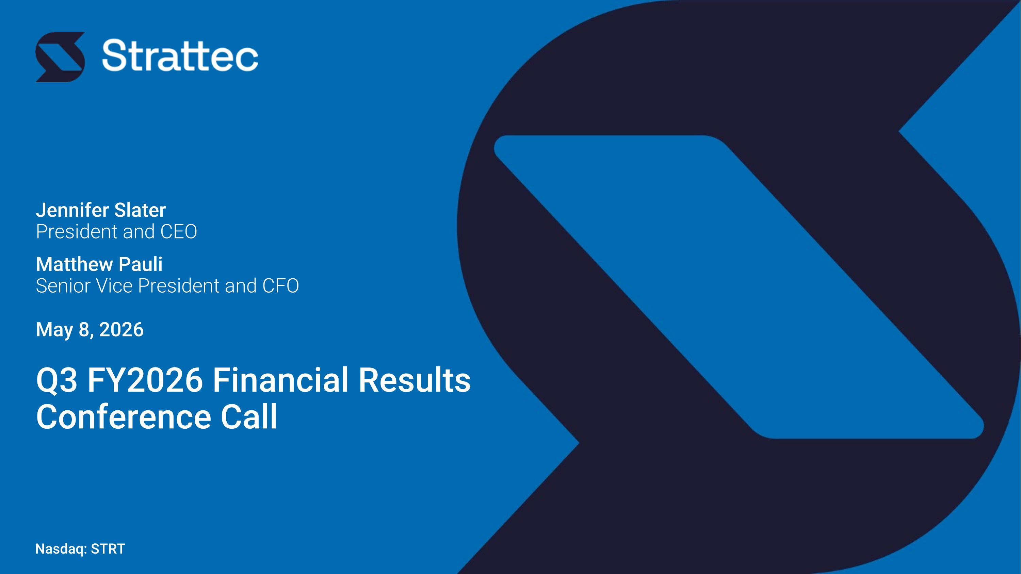
Nasdaq: STRT Jennifer Slater ?President and CEO Matthew Pauli ?Senior Vice President and CFO May 8, 2026 Q3 FY2026 Financial Results?Conference Call

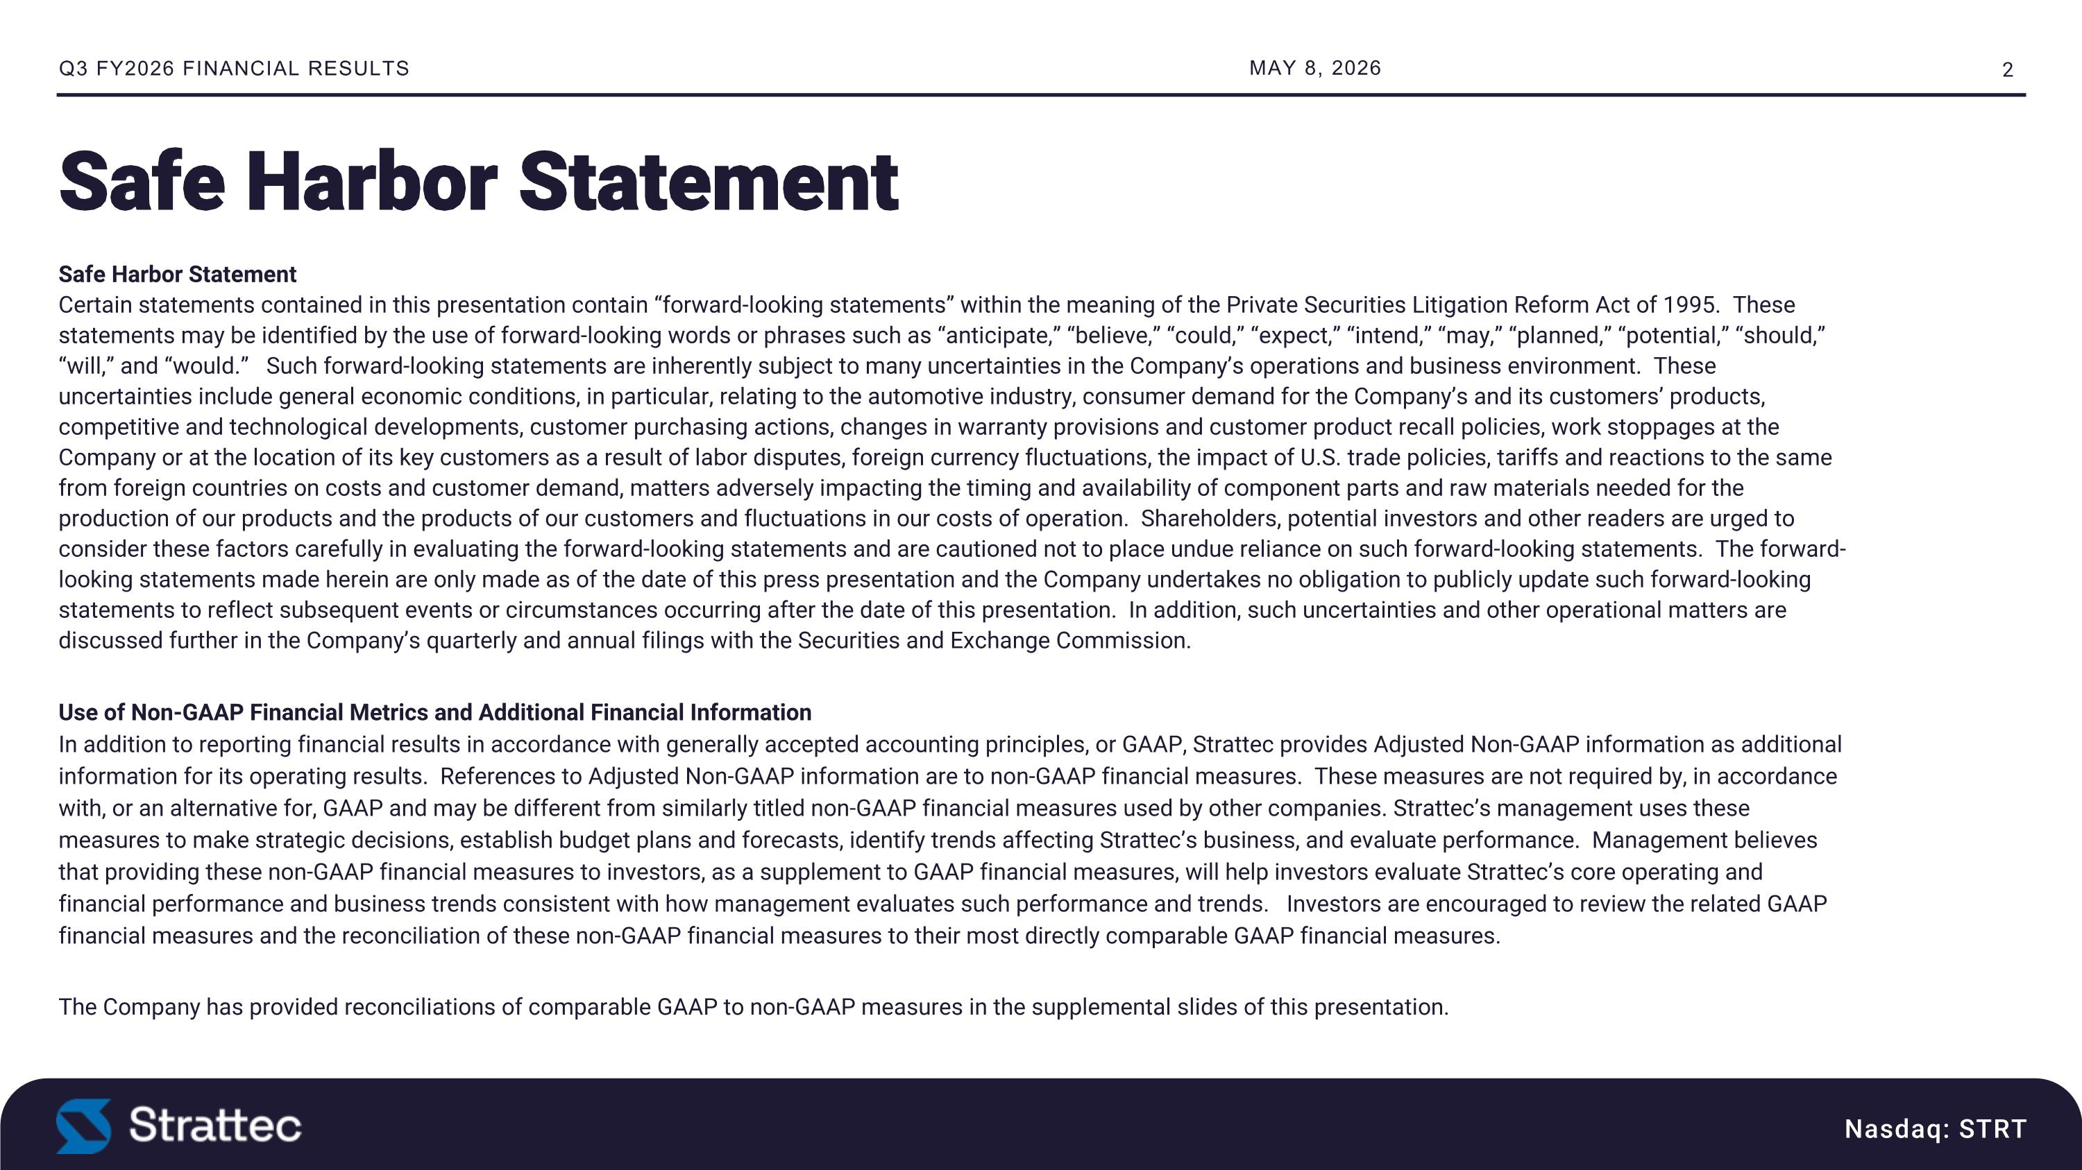
Safe Harbor Statement?Certain statements contained in this presentation contain “forward-looking statements” within the meaning of the Private Securities Litigation Reform Act of 1995. These statements may be identified by the use of forward-looking words or phrases such as “anticipate,” “believe,” “could,” “expect,” “intend,” “may,” “planned,” “potential,” “should,” “will,” and “would.” Such forward-looking statements are inherently subject to many uncertainties in the Company’s operations and business environment. These uncertainties include general economic conditions, in particular, relating to the automotive industry, consumer demand for the Company’s and its customers’ products, competitive and technological developments, customer purchasing actions, changes in warranty provisions and customer product recall policies, work stoppages at the Company or at the location of its key customers as a result of labor disputes, foreign currency fluctuations, the impact of U.S. trade policies, tariffs and reactions to the same from foreign countries on costs and customer demand, matters adversely impacting the timing and availability of component parts and raw materials needed for the production of our products and the products of our customers and fluctuations in our costs of operation. Shareholders, potential investors and other readers are urged to consider these factors carefully in evaluating the forward-looking statements and are cautioned not to place undue reliance on such forward-looking statements. The forward-looking statements made herein are only made as of the date of this press presentation and the Company undertakes no obligation to publicly update such forward-looking statements to reflect subsequent events or circumstances occurring after the date of this presentation. In addition, such uncertainties and other operational matters are discussed further in the Company’s quarterly and annual filings with the Securities and Exchange Commission. Use of Non-GAAP Financial Metrics and Additional Financial Information?In addition to reporting financial results in accordance with generally accepted accounting principles, or GAAP, Strattec provides Adjusted Non-GAAP information as additional information for its operating results. References to Adjusted Non-GAAP information are to non-GAAP financial measures. These measures are not required by, in accordance with, or an alternative for, GAAP and may be different from similarly titled non-GAAP financial measures used by other companies. Strattec’s management uses these measures to make strategic decisions, establish budget plans and forecasts, identify trends affecting Strattec’s business, and evaluate performance. Management believes that providing these non-GAAP financial measures to investors, as a supplement to GAAP financial measures, will help investors evaluate Strattec’s core operating and financial performance and business trends consistent with how management evaluates such performance and trends. Investors are encouraged to review the related GAAP financial measures and the reconciliation of these non-GAAP financial measures to their most directly comparable GAAP financial measures. The Company has provided reconciliations of comparable GAAP to non-GAAP measures in the supplemental slides of this presentation. MAY 8, 2026 Nasdaq: STRT Q3 FY2026 FINANCIAL RESULTS Safe Harbor Statement

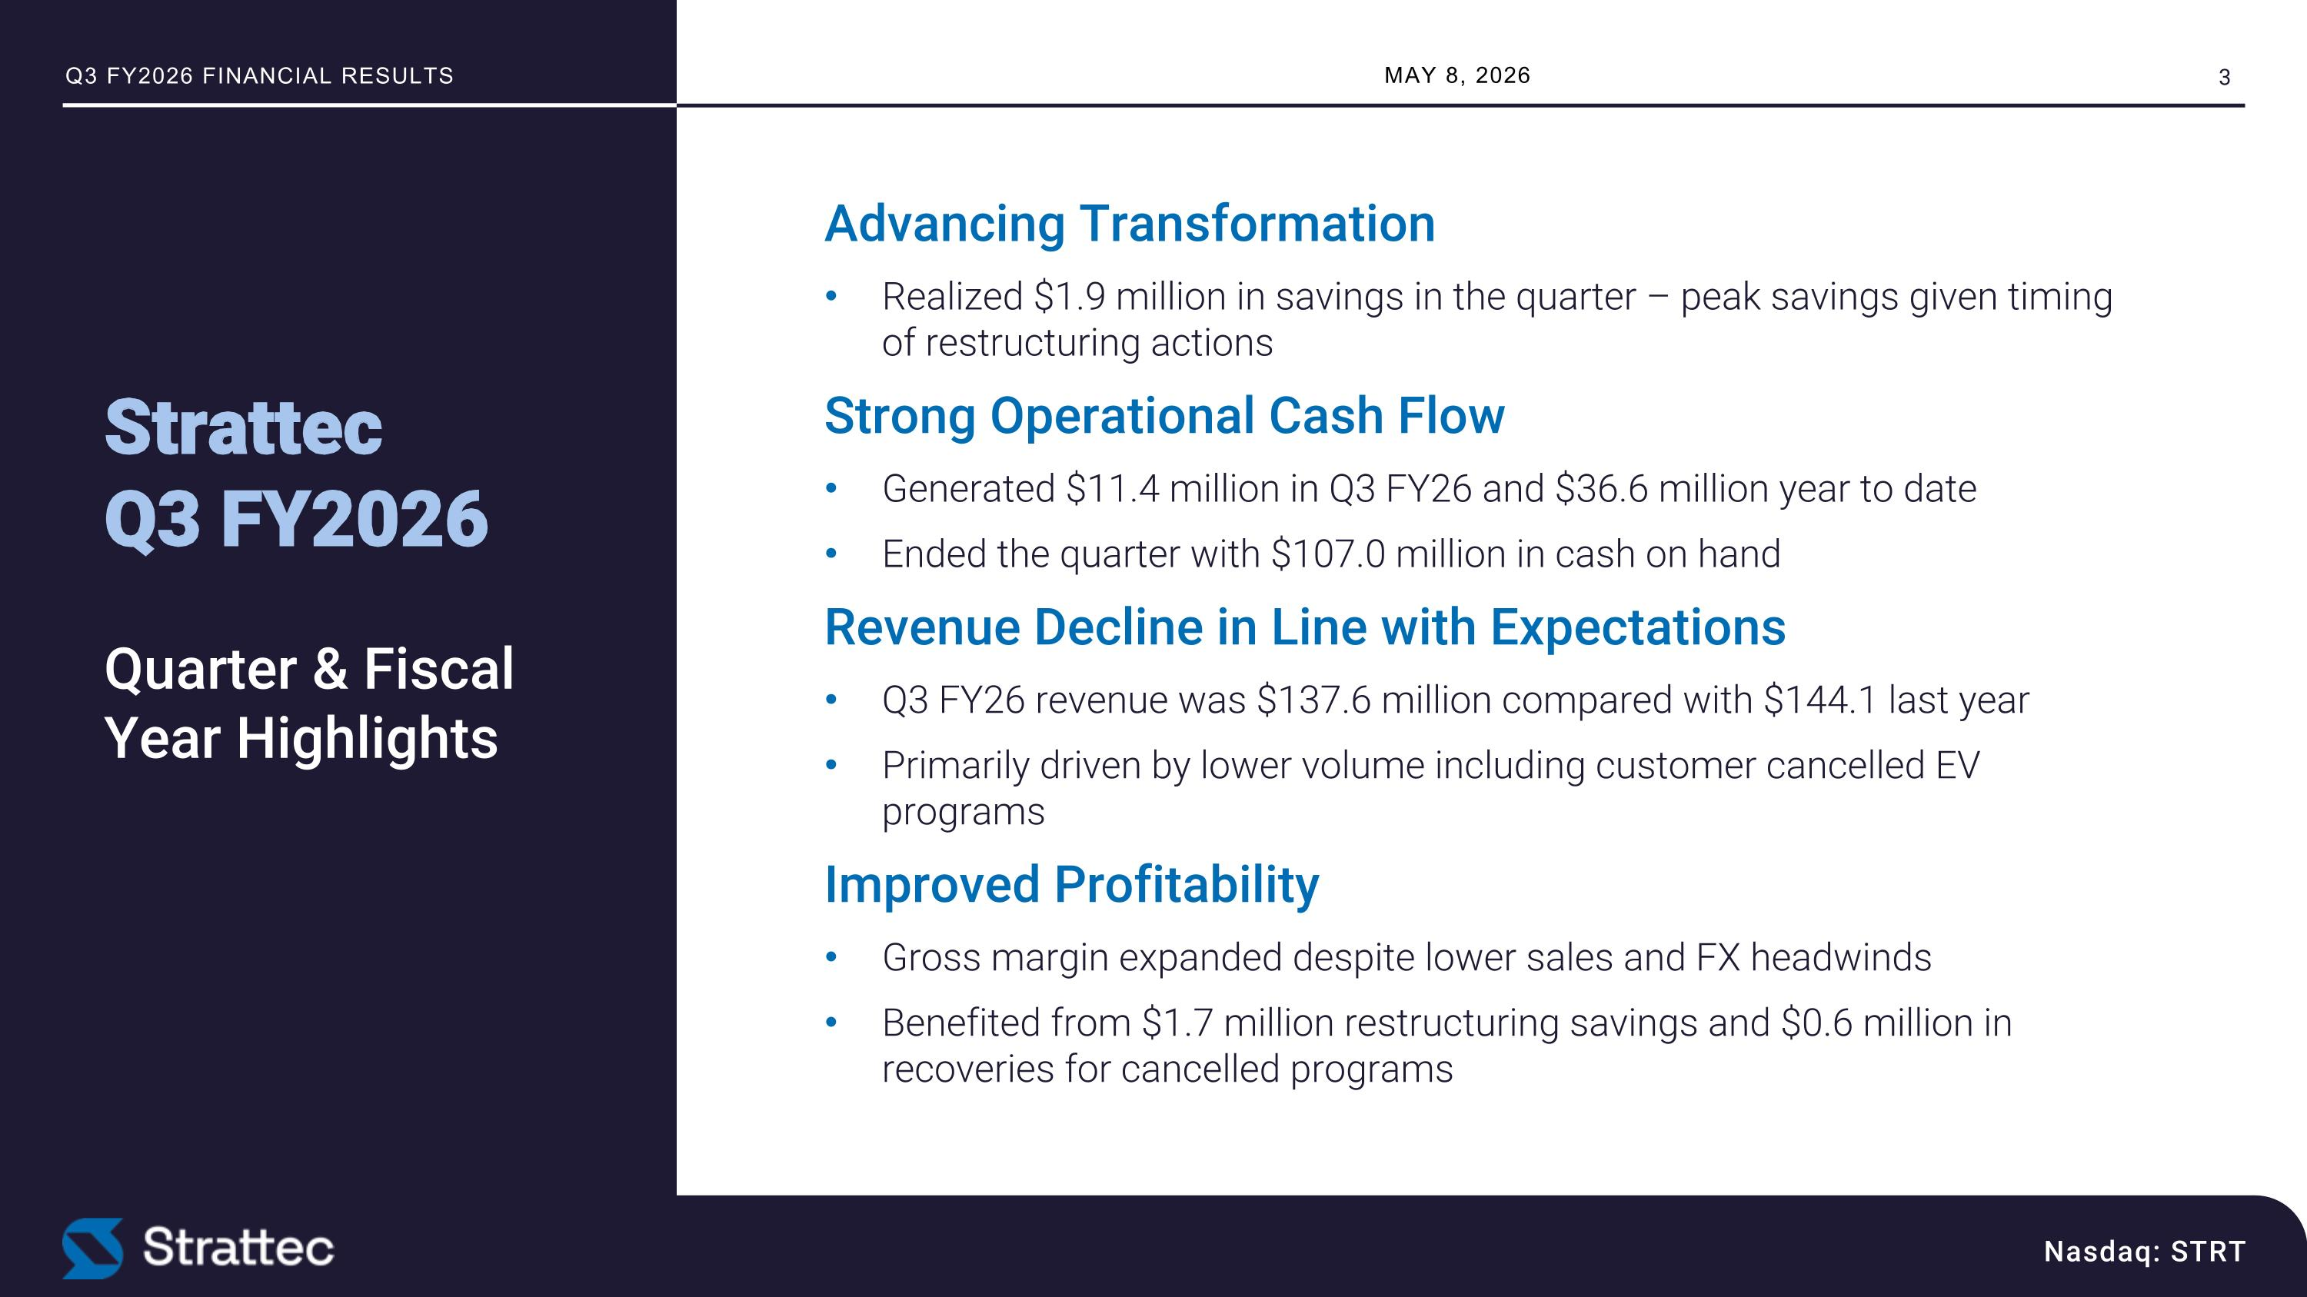
MAY 8, 2026 Nasdaq: STRT Q3 FY2026 FINANCIAL RESULTS Advancing Transformation Realized $1.9 million in savings in the quarter – peak savings given timing of restructuring actions Strong Operational Cash Flow Generated $11.4 million in Q3 FY26 and $36.6 million year to date Ended the quarter with $107.0 million in cash on hand Revenue Decline in Line with Expectations Q3 FY26 revenue was $137.6 million compared with $144.1 last year Primarily driven by lower volume including customer cancelled EV programs Improved Profitability Gross margin expanded despite lower sales and FX headwinds Benefited from $1.7 million restructuring savings and $0.6 million in recoveries for cancelled programs Strattec ?Q3 FY2026??Quarter & Fiscal Year Highlights

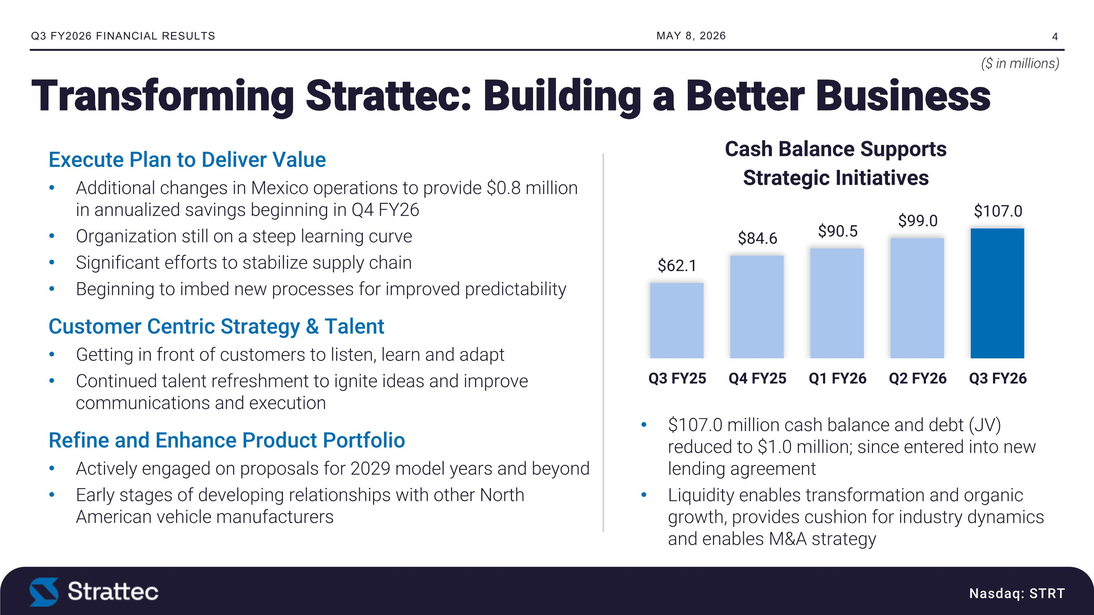
MAY 8, 2026 Nasdaq: STRT Q3 FY2026 FINANCIAL RESULTS Transforming Strattec: Building a Better Business Execute Plan to Deliver Value Additional changes in Mexico operations to provide $0.8 million in annualized savings beginning in Q4 FY26 Organization still on a steep learning curve Significant efforts to stabilize supply chain Beginning to imbed new processes for improved predictability Customer Centric Strategy & Talent Getting in front of customers to listen, learn and adapt Continued talent refreshment to ignite ideas and improve communications and execution Refine and Enhance Product Portfolio Actively engaged on proposals for 2029 model years and beyond Early stages of developing relationships with other North American vehicle manufacturers $107.0 million cash balance and debt (JV) reduced to $1.0 million; since entered into new lending agreement Liquidity enables transformation and organic growth, provides cushion for industry dynamics and enables M&A strategy ($ in millions)

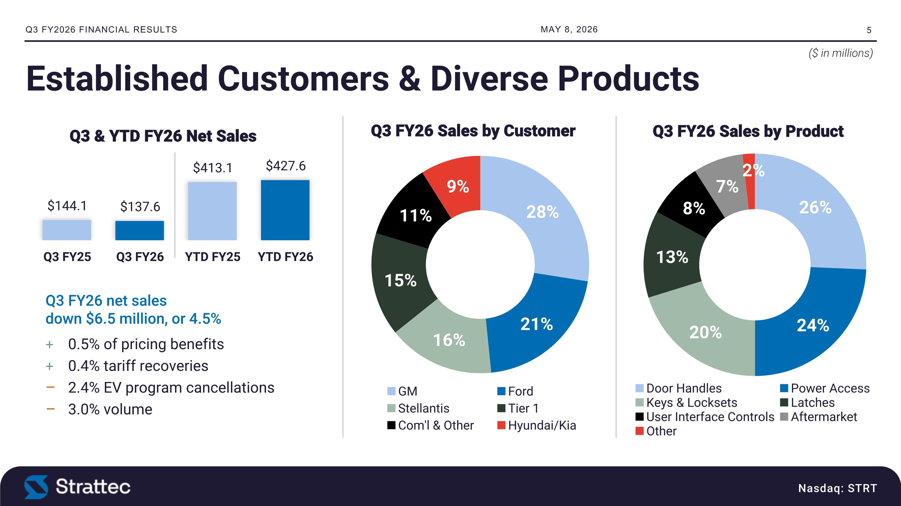
Nasdaq: STRT MAY 8, 2026 Q3 FY2026 FINANCIAL RESULTS Established Customers & Diverse Products ($ in millions) Q3 FY26 net sales ?down $6.5 million, or 4.5% 0.5% of pricing benefits 0.4% tariff recoveries 2.4% EV program cancellations 3.0% volume

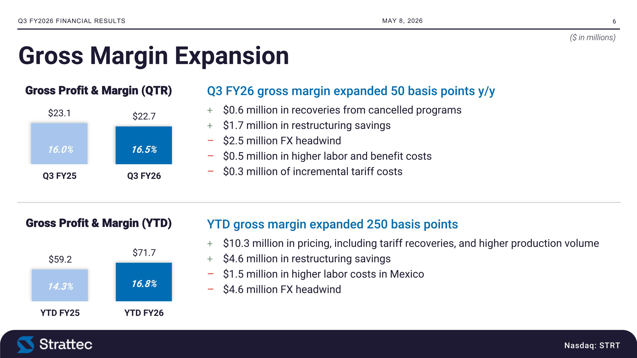
Nasdaq: STRT Q3 FY26 gross margin expanded 50 basis points y/y $0.6 million in recoveries from cancelled programs $1.7 million in restructuring savings $2.5 million FX headwind $0.5 million in higher labor and benefit costs $0.3 million of incremental tariff costs YTD gross margin expanded 250 basis points $10.3 million in pricing, including tariff recoveries, and higher production volume $4.6 million in restructuring savings $1.5 million in higher labor costs in Mexico $4.6 million FX headwind Gross Margin Expansion MAY 8, 2026 Q3 FY2026 FINANCIAL RESULTS ($ in millions) 16.5% 16.0% 16.8% 14.3%

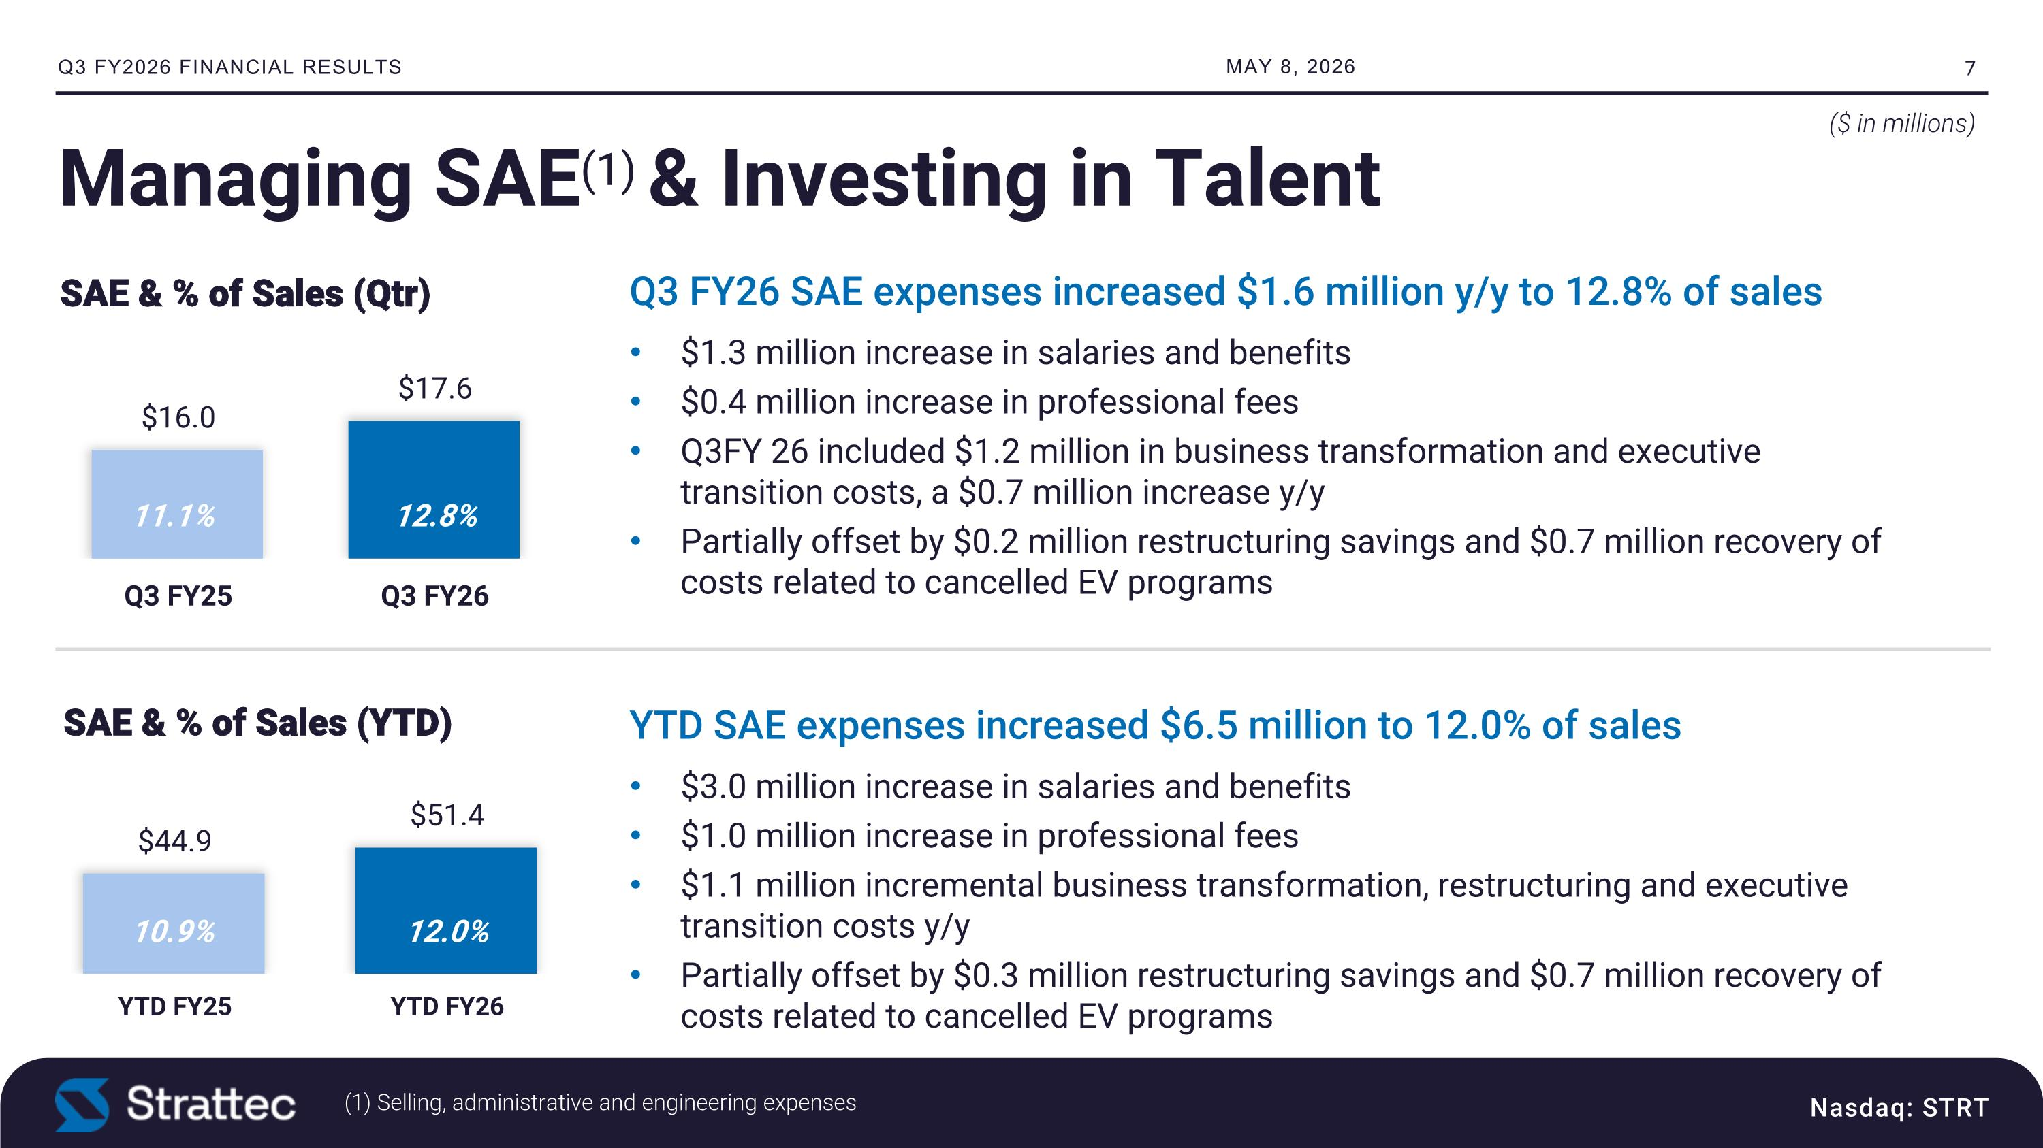
Nasdaq: STRT Q3 FY26 SAE expenses increased $1.6 million y/y to 12.8% of sales $1.3 million increase in salaries and benefits $0.4 million increase in professional fees Q3FY 26 included $1.2 million in business transformation and executive transition costs, a $0.7 million increase y/y Partially offset by $0.2 million restructuring savings and $0.7 million recovery of costs related to cancelled EV programs YTD SAE expenses increased $6.5 million to 12.0% of sales $3.0 million increase in salaries and benefits $1.0 million increase in professional fees $1.1 million incremental business transformation, restructuring and executive transition costs y/y Partially offset by $0.3 million restructuring savings and $0.7 million recovery of costs related to cancelled EV programs Managing SAE(1) & Investing in Talent MAY 8, 2026 Q3 FY2026 FINANCIAL RESULTS ($ in millions) (1) Selling, administrative and engineering expenses 12.8% 11.1% 12.0% 10.9%

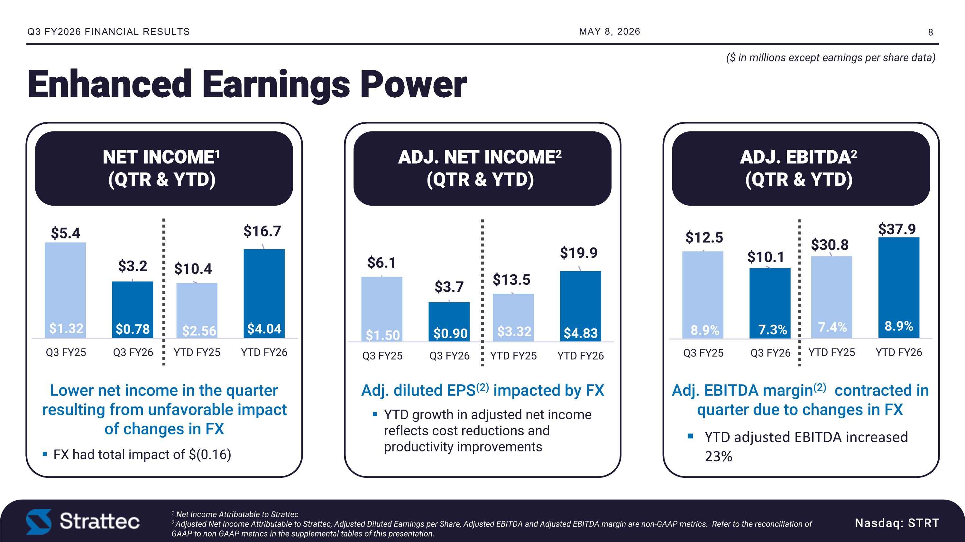
ADJ. NET INCOME2 (QTR & YTD) ADJ. EBITDA2 ?(QTR & YTD) NET INCOME1?(QTR & YTD) Enhanced Earnings Power Nasdaq: STRT Q3 FY2026 FINANCIAL RESULTS 1 Net Income Attributable to Strattec?2 Adjusted Net Income Attributable to Strattec, Adjusted Diluted Earnings per Share, Adjusted EBITDA and Adjusted EBITDA margin are non-GAAP metrics. Refer to the reconciliation of GAAP to non-GAAP metrics in the supplemental tables of this presentation. Lower net income in the quarter resulting from unfavorable impact of changes in FX FX had total impact of $(0.16) Adj. diluted EPS(2) impacted by FX YTD growth in adjusted net income reflects cost reductions and productivity improvements Adj. EBITDA margin(2) contracted in quarter due to changes in FX YTD adjusted EBITDA increased 23% MAY 8, 2026 ($ in millions except earnings per share data)

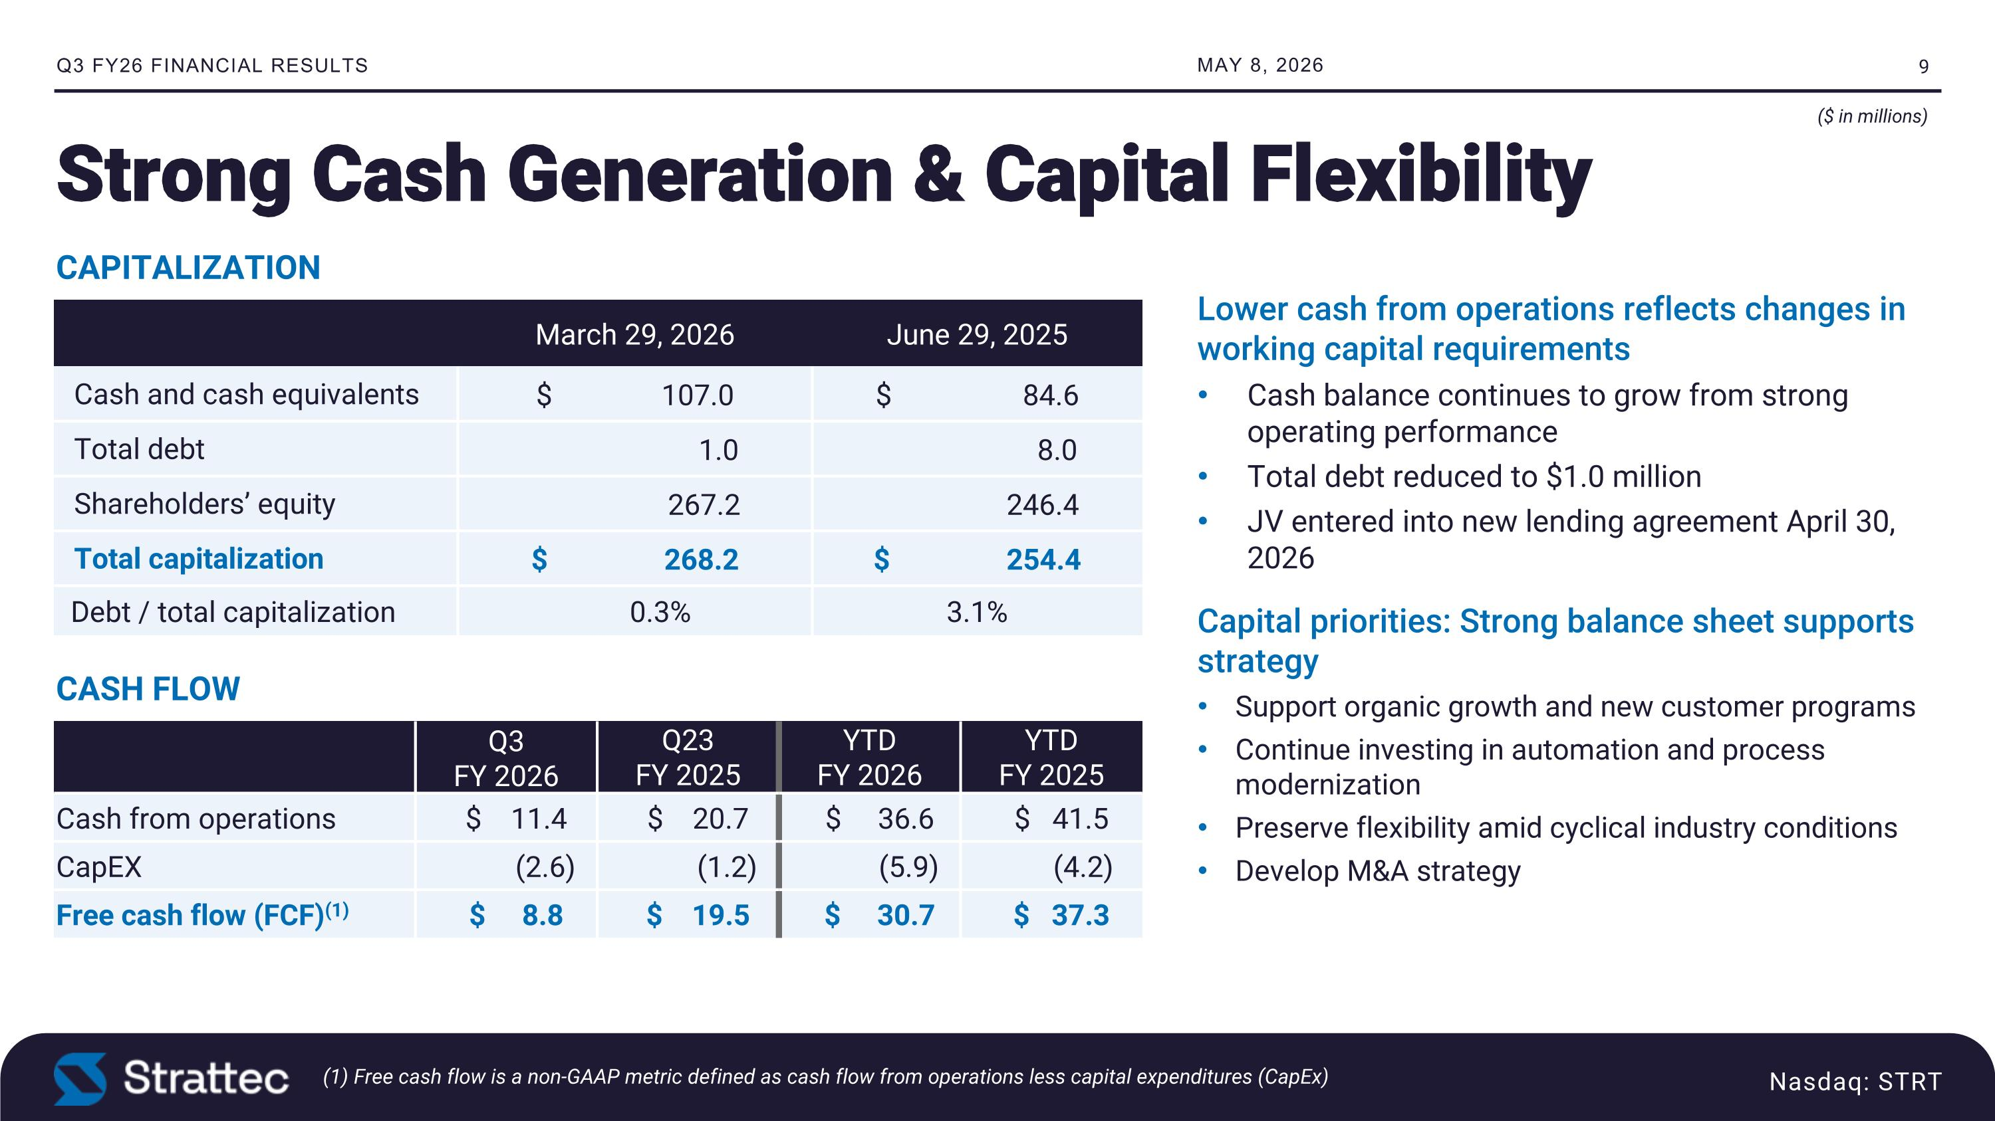
Strong Cash Generation & Capital Flexibility ($ in millions) (1) Free cash flow is a non-GAAP metric defined as cash flow from operations less capital expenditures (CapEx) Q3 FY26 FINANCIAL RESULTS Nasdaq: STRT Lower cash from operations reflects changes in working capital requirements Cash balance continues to grow from strong operating performance Total debt reduced to $1.0 million JV entered into new lending agreement April 30, 2026 Capital priorities: Strong balance sheet supports strategy Support organic growth and new customer programs Continue investing in automation and process modernization Preserve flexibility amid cyclical industry conditions Develop M&A strategy March 29, 2026 June 29, 2025 Cash and cash equivalents $ 107.0 $ 84.6 Total debt 1.0 8.0 Shareholders’ equity 267.2 246.4 Total capitalization $ 268.2 $ 254.4 Debt / total capitalization 0.3% 3.1% CAPITALIZATION Q3 ?FY 2026 Q23?FY 2025 YTD?FY 2026 YTD?FY 2025 Cash from operations $ 11.4 $ 20.7 $ 36.6 $ 41.5 CapEX (2.6) (1.2) (5.9) (4.2) Free cash flow (FCF)(1) $ 8.8 $ 19.5 $ 30.7 $ 37.3 CASH FLOW MAY 8, 2026

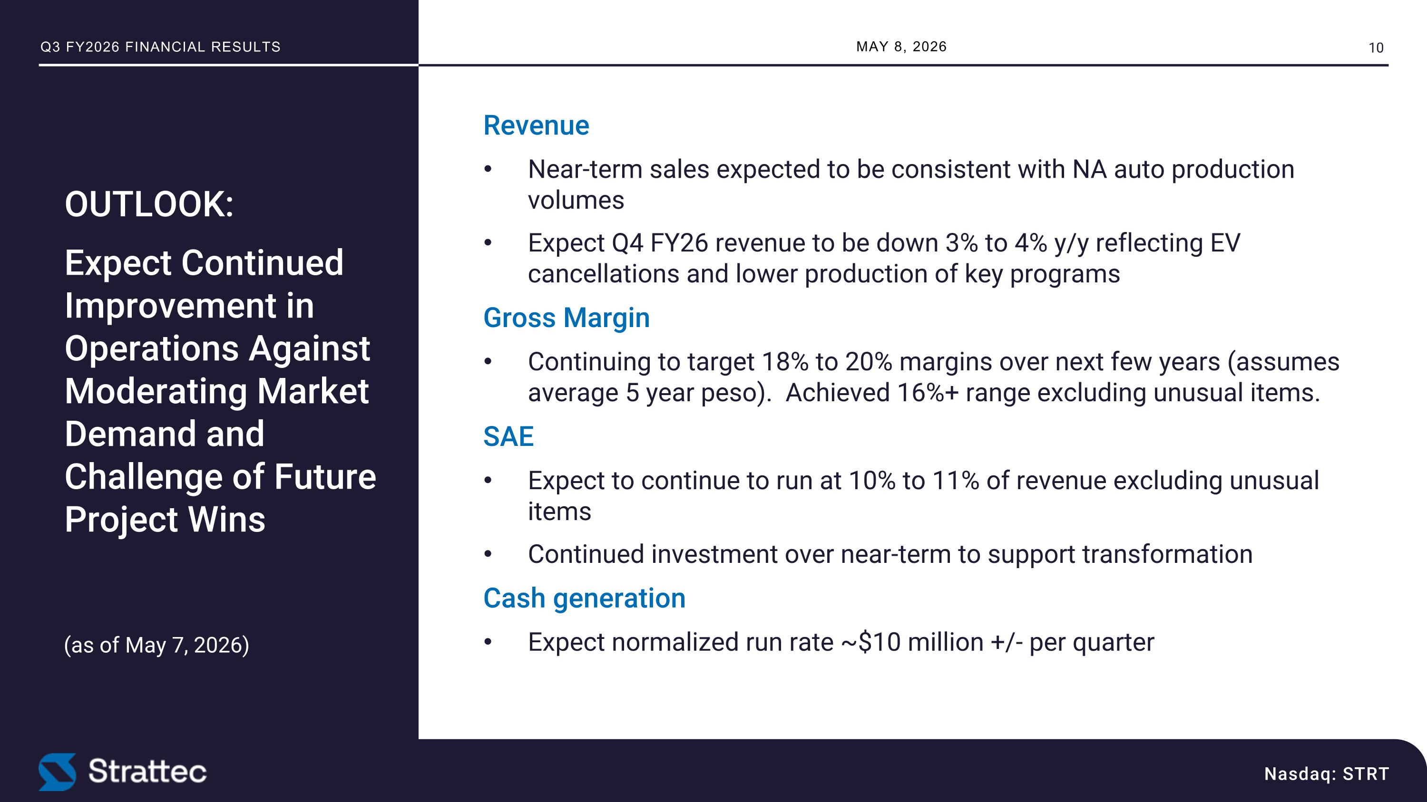
(as of May 7, 2026) Nasdaq: STRT Revenue Near-term sales expected to be consistent with NA auto production volumes Expect Q4 FY26 revenue to be down 3% to 4% y/y reflecting EV cancellations and lower production of key programs Gross Margin Continuing to target 18% to 20% margins over next few years (assumes average 5 year peso). Achieved 16%+ range excluding unusual items. SAE Expect to continue to run at 10% to 11% of revenue excluding unusual items Continued investment over near-term to support transformation Cash generation Expect normalized run rate ~$10 million +/- per quarter OUTLOOK: Expect Continued Improvement in Operations Against Moderating Market Demand and Challenge of Future Project Wins MAY 8, 2026 Q3 FY2026 FINANCIAL RESULTS


PREMISSION, MOTION & HOLD Our Vision : To be the most trusted, global leader in safe and secure access solutions for the automotive and mobility industries by creating the ultimate access experience for consumers. WE ENGINEER THE ACCESS EXPERIENCE


Q3 FY2026 Financial Results Supplemental Slides www.strattec.com

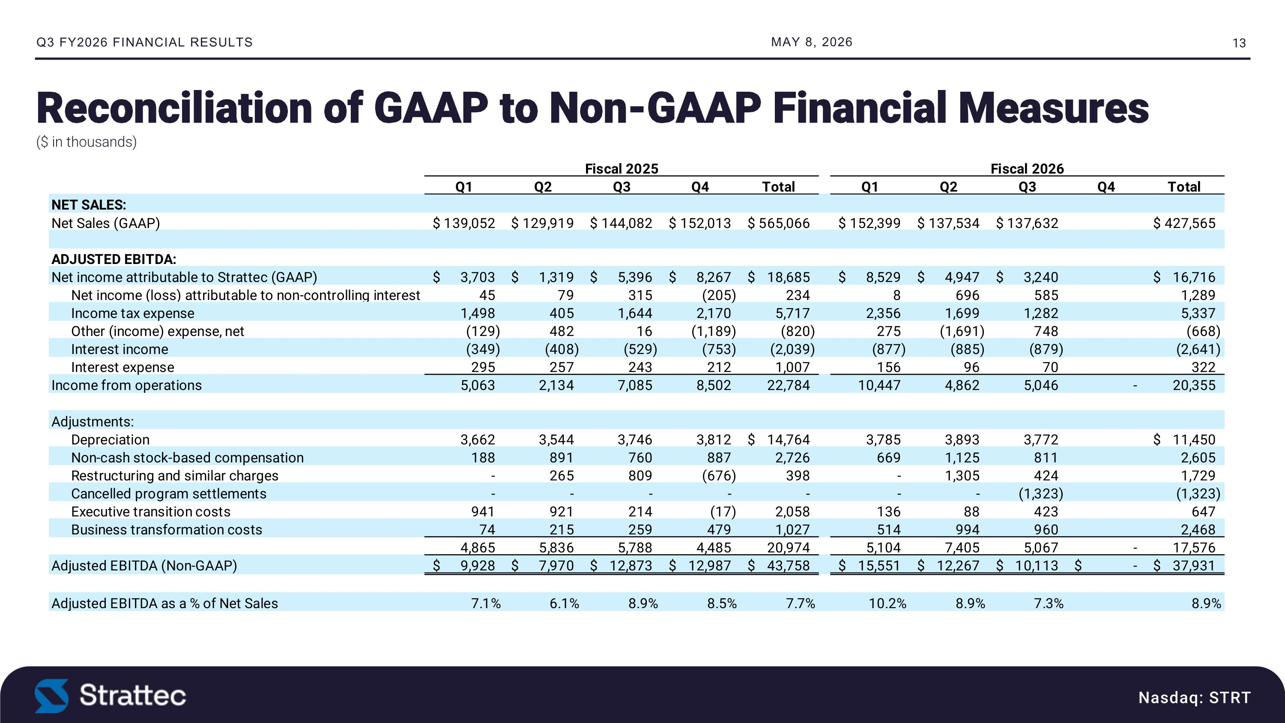
Nasdaq: STRT Reconciliation of GAAP to Non-GAAP Financial Measures ($ in thousands) MAY 8, 2026 Q3 FY2026 FINANCIAL RESULTS

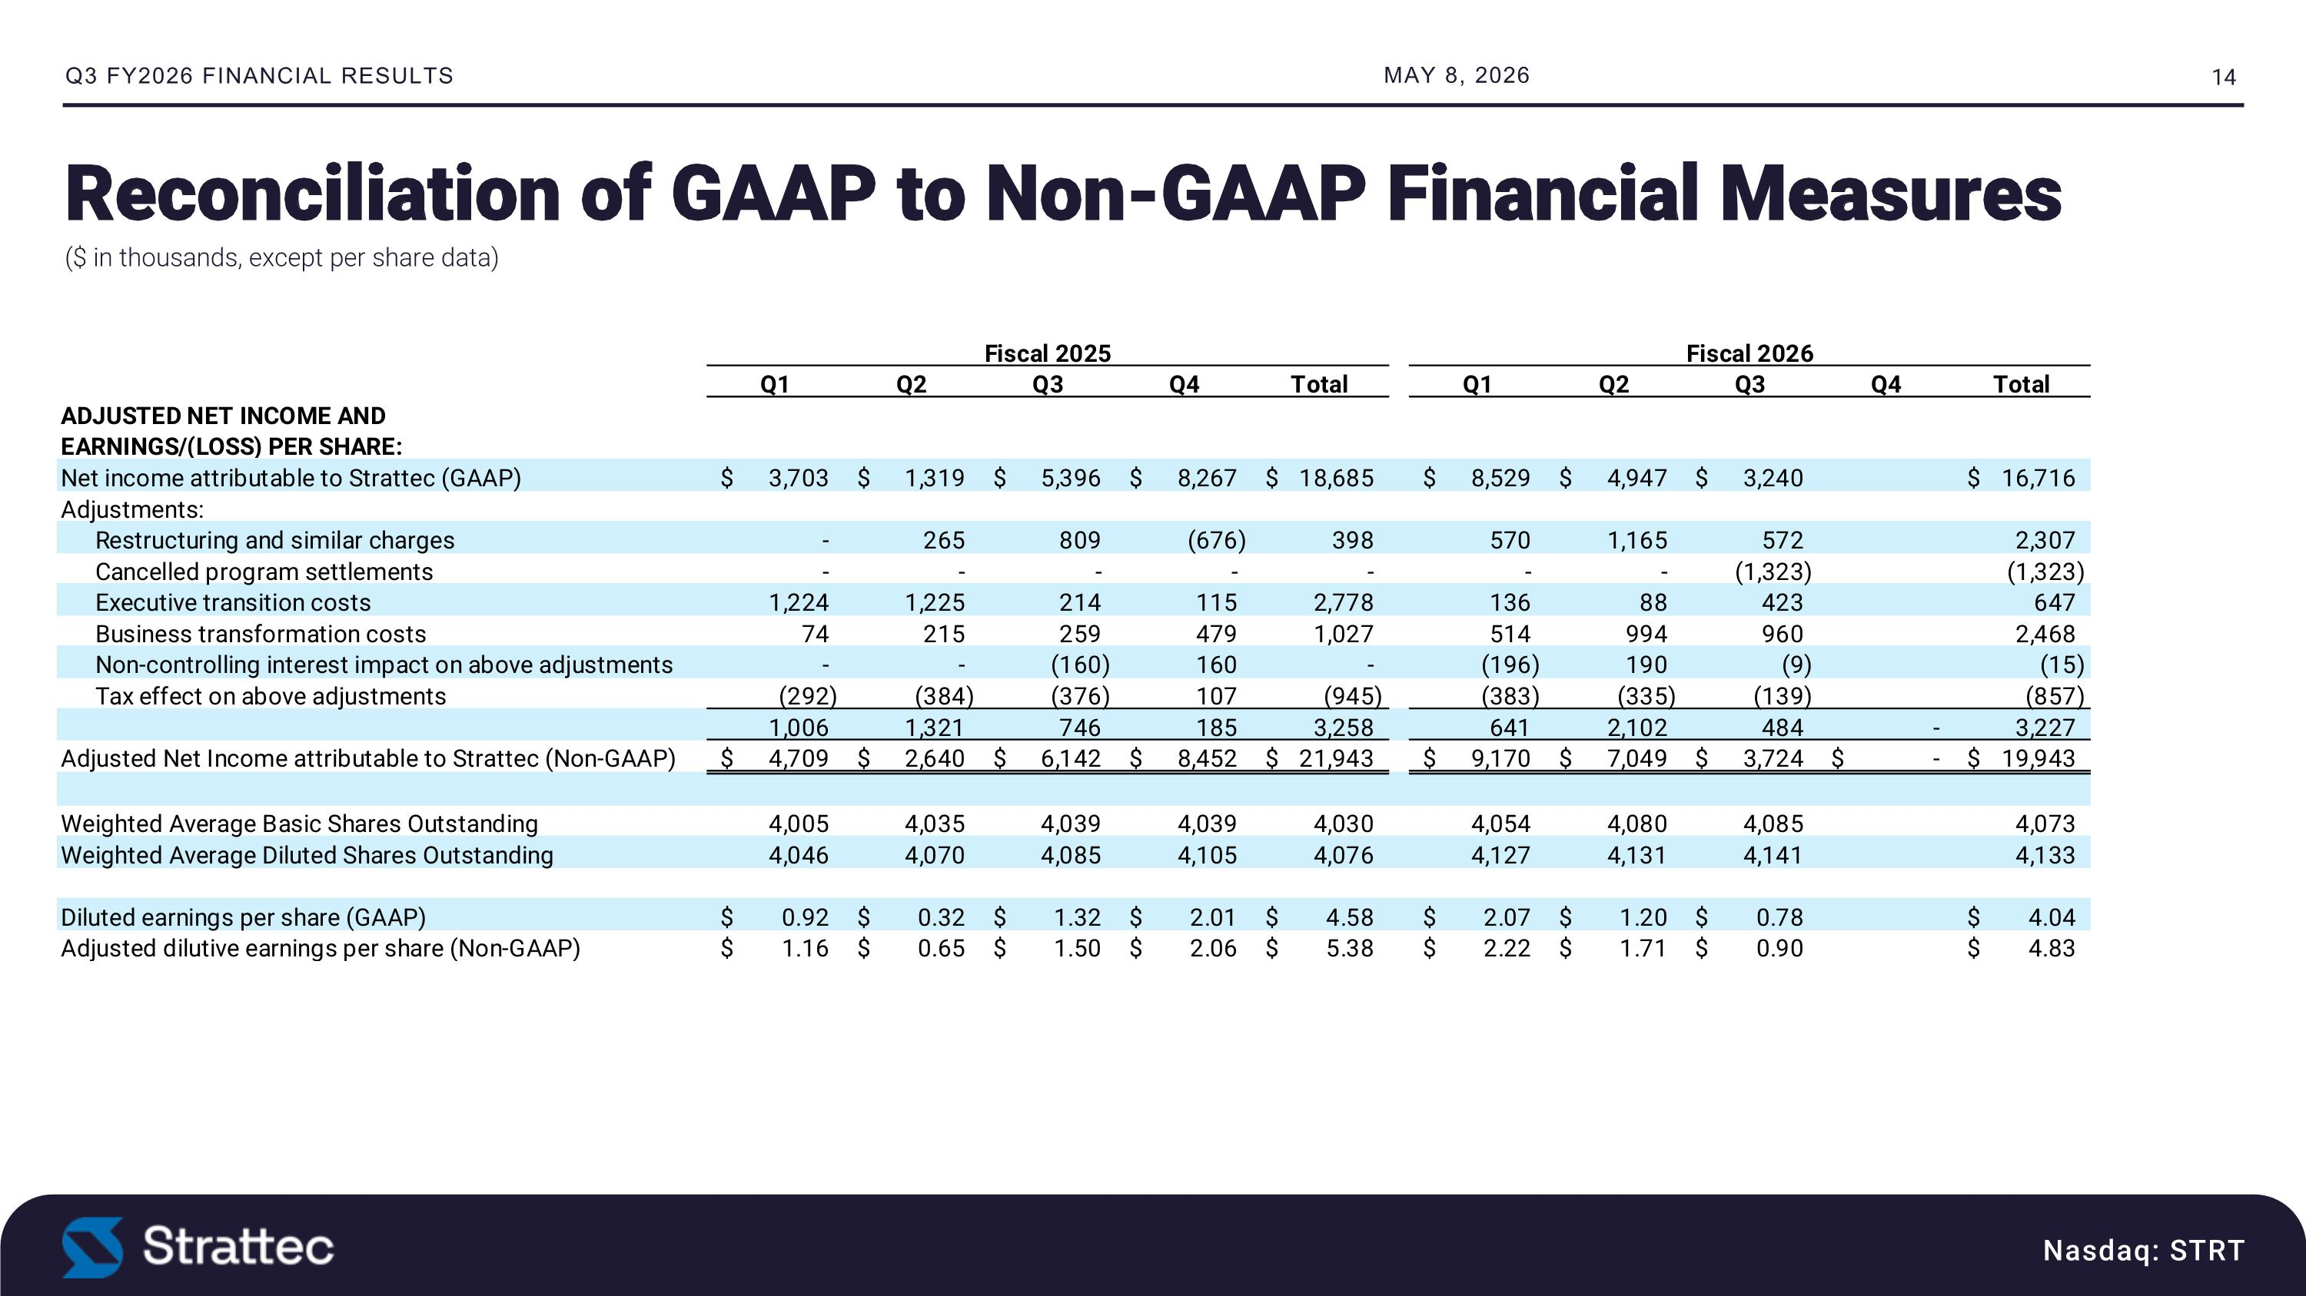
Nasdaq: STRT Reconciliation of GAAP to Non-GAAP Financial Measures ($ in thousands, except per share data) MAY 8, 2026 Q3 FY2026 FINANCIAL RESULTS


Strattec: The Access Engine Investor Relations Contact: Deborah K. Pawlowski, Alliance Advisors IR?716-843-3908 dpawlowski@allianceadvisors.com

