
UNITED STATES

SECURITIES AND EXCHANGE COMMISSION
WASHINGTON D.C. 20549
SCHEDULE 14A
(Rule 14a-101)
INFORMATION REQUIRED IN PROXY STATEMENT
SCHEDULE 14A INFORMATION
Proxy Statement Pursuant to Section 14(a) of the
Securities Exchange Act of 1934
(Amendment No. )

Filed by the Registrant ☒ | Filed by a Party other than the Registrant ☐

Check the appropriate box:
☐ | Preliminary Proxy Statement
☐ | Confidential, for Use of the Commission Only (as permitted by Rule 14a-6(e)(2))
☒ | Definitive Proxy Statement
☐ | Definitive Additional Materials
☐ | Soliciting Material Pursuant to §240.14a-12
Strattec Security Corporation
(Name of Registrant as Specified in Its Charter)
Registrant
(Name of Person(s) Filing Proxy Statement, if Other Than the Registrant)
Payment of filing fee (Check all boxes that apply):

☒ | No fee required.
☐ | Fee paid previously with preliminary materials.
☐ | Fee computed on table in exhibit required by Item 25(b) per Exchange Act Rules 14a-6(i)(1) and 0-11.

 | September 16, 2026
3333 West Good Hope Road
Milwaukee, Wisconsin 53209

Dear Fellow Shareholders,
It is a pleasure to report on Fiscal 2026 developments at Strattec in my annual Chairman’s Letter. Despite continued volatility in our end markets, we continued to grow sales and earnings and increase shareholder value.
Our CEO, Jen Slater, continues to build an outstanding management team in which the Board has tremendous confidence. We have strengthened the organization by adding talent across key functions to enhance alignment, execution and financial controls, and by advancing key transformation and growth initiatives. We also realigned our procurement team in furtherance of our goal of maintaining strong gross margins.
The Company also continued its efforts to make its plants in Milwaukee and Mexico more productive, deploying IT systems and tools and leveraging automation to improve utilization and efficiency, while remaining focused on providing a safe environment for our employees. In addition, we have been working with our joint venture partner, ADAC Automotive, to create a closer partnership that is more beneficial for both parties, and that the Board believes will better position Strattec competitively over the long term.
During the fiscal year, Strattec’s stock increased by approximately 33%, compared to a 22% increase for the S&P 500, extending our track record of strong results under the current leadership team, during whose tenure our stock price has more than tripled.
That said, our business is inherently cyclical and tied to the prospects of the “Big Three” domestic auto manufacturers, and our long-term success continues to depend on our ability to weather those inevitable fluctuations in demand and win new and replacement platform mandates in a competitive supplier landscape. We remain focused on those factors which we can control—talent, technology, innovation, quality and customer relationships—as we execute our strategy to deliver sustainable value for shareholders over the long term.
The Company continued to accumulate cash during the year, and the Board, with the assistance of independent advisors, has diligently considered how best to allocate that capital. In addition to investing in the business to support organic growth, the Board currently views strategic acquisitions and share repurchases, executed at appropriate valuations, as attractive alternatives for deploying capital. At the right price, we believe acquisitions that extend our geographic or product reach, increase our scale or diversify our customer base can be very attractive and, over the long term, can be accretive to earnings and shareholder value.
We view our strong balance sheet as a competitive advantage, particularly given the cyclical nature of our industry. In addition to exploring accretive acquisitions, our liquidity provides us with the flexibility to continue to invest in the business while also returning capital to shareholders when appropriate. During the fourth quarter, the Company repurchased 110,269 shares for $7.4 million. And, in May 2026, the Board approved a new $40 million share repurchase authorization. Members of the Board and management team also purchased stock in the open market during the fiscal year, demonstrating their confidence in the long-term future of the Company.
At this year’s Annual Meeting, you will be asked to elect seven directors, including two new nominees, R. Bruce McDonald and Tribby Warfield. Bruce is current Executive Chairman of Dana, Inc. and Tribby has substantial experience in the automotive industry as both an executive and director. We look forward to benefiting from their insights and perspectives. Tina Chang, a current director, will not be standing for reelection, and we appreciate her years of dedicated service to the Board. We plan to continue thoughtfully refreshing the Board over time, adding directors whose skills and experience complement and build upon those of our current Board members and support the evolution of Strattec’s business and strategy.

We regularly engage with our shareholders, the owners of the Company, whose feedback we greatly value and appreciate. Shareholders may send communication by mail or overnight delivery addressed as follows: Board of Directors (or Committee Chair, Board Member, or Non-Management Directors, as the case may be appropriate), c/o Secretary, Strattec Security Corporation, 3333 West Good Hope Road, Milwaukee, Wisconsin, 53209, as described on the Investor Relations portion of our Company's website, https://investors.strattec.com/information-request.
At last year’s annual meeting, approximately 93% of shares voted were in favor of the Company’s compensation plan and an average of approximately 98% were in favor of each of our directors. We appreciate this support and remain focused on aligning our governance and compensation practices with shareholder interests. We look forward to meeting with shareholders who are able to attend this year’s Annual Meeting in person.
Thank you for your investment in Strattec.
 |  | Sincerely,  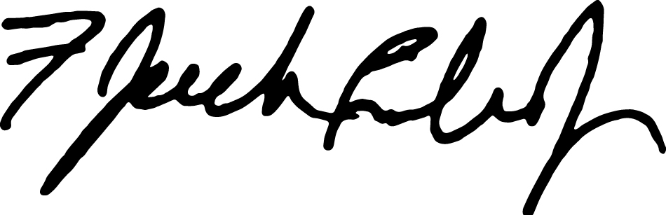  F. JACK LIEBAU, JR.  Chairman of the Board

Notice of Annual Meeting of Shareholders
The Annual Meeting of Shareholders (the “Annual Meeting”) of Strattec Security Corporation, a Wisconsin corporation, will be held at The Pfister Hotel, 424 E Wisconsin Avenue, Milwaukee, Wisconsin 53202, on Tuesday, October 13, 2026, at 8:00 a.m. local time, for the purposes of considering and taking action on the following:

Meeting Information

 |  |  |  | 
Tuesday, October 13, 2026  8:00 a.m. local time |  | Pfister Hotel, 424 E Wisconsin Avenue, Milwaukee, Wisconsin 53202 |  | Shareholders of record at the close of business on August 14, 2026 are entitled to vote at the Annual Meeting.

Meeting Agenda

Item |  | Board Recommendation
1. | To elect seven directors to serve until the 2027 Annual Meeting of Shareholders; | FOR
2. | To ratify the appointment of Deloitte & Touche LLP as our independent registered public accounting firm for the fiscal year ending June 27, 2027; | FOR
3. | To approve, on an advisory basis, a resolution approving the compensation of the Company's named executive officers; | FOR
4. | To take action with respect to any other matters that may be properly brought before the Annual Meeting and that might be considered by the shareholders of a Wisconsin corporation at their annual meeting.

By order of the Board of Directors
James Denis,
Secretary

Milwaukee, Wisconsin
September 16, 2026

Shareholders of record at the close of business on August 14, 2026 are entitled to vote at the Annual Meeting. Your vote is important to ensure that a majority of our stock is represented. Whether or not you plan to attend the Annual Meeting in person, please complete, sign and date the enclosed proxy card and return it promptly in the enclosed envelope. Your vote is being solicited by the Board of the Directors of the Company. If you later find that you may be present at the Annual Meeting or for any other reason desire to revoke your proxy, you may do so at any time before it is voted. Shareholders holding shares in brokerage accounts (“street name” holders) who wish to vote at the Annual Meeting will need to obtain a proxy form and voting instructions from the institution that holds their shares.

TABLE OF CONTENTS
A Letter from Our Independent Chair
Notice of 2026 Annual Meeting of Shareholders to be held on October 13, 2026
Proxy Summary |  | 1
About Strattec |  | 1
Financial Highlights
Governance Highlights |  | 3
Corporate Governance Matters |  | 7
Board Leadership Structure |  | 7
Board Committees |  | 7
Audit Committee |  | 7
Compensation Committee |  | 7
Nominating and Governance Committee |  | 8
Board Oversight of Risk |  | 8
Board Self-Assessment and Evaluation |  | 8
Code of Ethics |  | 9
Transactions with Related Persons |  | 9
Contacting the Board |  | 9
Shareholder Proxy Access and Shareholder Communications |  | 9
Director Nominees |  | 11
Proposal 1:
Election of Directors |  | 11
Director Nominees |  | 11
Director Nomination and Selection Process |  | 16
Director Independence; Audit Committee Financial Expert |  | 16
Director Qualifications and Skills Matrix |  | 17
Committee Membership, Meetings and Attendance |  | 18
Stock Ownership Requirements |  | 18
Attendance of Directors at Annual Meeting of Shareholders |  | 18
Director Compensation |  | 19
Director Summary Compensation Table |  | 19
Executive Compensation (say-on-pay) |  | 20
Proposal 2:
Advisory Vote to Approve Executive Compensation (Say-on-Pay) |  | 20
Compensation Discussion and Analysis |  | 21
Compensation Highlights |  | 21
Compensation Governance Practices: What we do and what we don't do |  | 22
Compensation Decision Process |  | 23
Summary Compensation Table |  | 27
Outstanding Equity Awards |  | 30
Stock Ownership Requirements |  | 30
Employment Agreements and Potential Severance |  | 31
Equity Compensation Plan Information |  | 35
Pay versus Performance |  | 36
CEO Pay Ratio |  | 38
Compensation Risk Assessment |  | 39
Hedging and Margin Account Policies |  | 39
Clawback Policy |  | 40
Compensation Committee Report |  | 41

Audit Matters |  | 42
Proposal 3:
Ratification of Appointment of Independent Registered Public Accounting Firm |  | 42
Audit Committee report |  | 43
Fees of Independent Registered Public Accounting Firm |  | 44
Principal Shareholders |  | 45
Security Ownership of Certain Beneficial Owners |  | 45
Security Ownership of Directors and Executive Officers
Additional Information |  | 47
Voting Information |  | 47
Proxies and Shareholders Entitled to Vote |  | 47
Quorum and Required Vote |  | 47
Annual Report on Form 10-K |  | 48
Shareholder Proposals / Nominations for the 2027 Annual Meeting |  | 48
Delinquent Section 16(a) Reports |  | 48
Other Matters |  | 49

Frequently Referenced Topics
Fiscal Year 2026 Financial Highlights | 2
Shareholder Engagement | 3
Directors’ Skills Matrix | 17
Director Committees | 18
Pay Versus Performance | 36
Important Notice Regarding the Availability of Proxy Materials for the 2026 Annual Meeting of Shareholders to be held on October 13, 2026: This Proxy Statement and the Accompanying Annual Report are Available at www.strattec.com
This Proxy Statement is furnished in connection with the solicitation by the Board of Directors of Strattec Security Corporation ("Strattec", "the Company," "we," "us," or "our") of proxies, in the accompanying form, to be used at the Annual Meeting to be held at The Pfister Hotel, 424 E Wisconsin Avenue, Milwaukee, Wisconsin 53202, on Tuesday, October 13, 2026, at 8:00 a.m. local time, and any adjournments thereof. Only shareholders of record at the close of business on August 14, 2026 will be entitled to notice of and to vote at the Annual Meeting. There will be no presentation regarding our operations at the Annual Meeting. The only matters to be discussed at the Annual Meeting are the matters set forth in this Proxy Statement for the 2026 Annual Meeting of Shareholders and such other matters as are properly presented at the Annual Meeting.
Our principal executive offices are located at 3333 West Good Hope Road, Milwaukee, Wisconsin 53209. It is expected that our Annual Report to

Shareholders, this Proxy Statement and the accompanying form of proxy will be mailed, furnished or otherwise made available to shareholders on or about September 16, 2026.

Proxy Summary / About Strattec

PROXY SUMMARY
This summary highlights information contained elsewhere in this Proxy Statement and also provides business, financial and governance highlights. Please read the entire Proxy Statement carefully before voting.

About Strattec (Nasdaq: STRT)
Strattec is a global automotive access company that designs and delivers safe, secure, and highly engineered access solutions for the automotive and mobility industries. Built on generations of access and security engineering expertise, Strattec partners closely with OEMs to create differentiated, system-level access experiences for end consumers. Strattec’s portfolio spans the access journey from Permission, enabling secure vehicle entry through advanced mechanical and electronic systems; to Motion, delivering effortless, reliable powered access that enhances everyday usability; and through to Hold, providing precision-engineered latching solutions that give drivers confidence through proven strength, safety, and durability trusted by OEMs worldwide. As access becomes increasingly intelligent, connected, and central to vehicle experience, Strattec’s strategy is to expand its market share, further diversify its customers and geographic reach while becoming the most trusted access partner to drive long-term growth across global automotive and mobility markets.


 |  | FY 2026 Closing Price
 |  | $82.64
52-Week High/Low
$90.91 / $60.32
Permission  Lock and Key |  | 52-Week High/Low  $90.91 / $60.32
  Motion  Power Access |  | Institutional Ownership  88.5%
Insider Ownership
3.3%

  Hold  Latches |  | Shares Outstanding  4.0M
Founded:
1908
Public Company:
1995

www.strattec.com 1

Proxy Summary / About Strattec

Financial Results

Net Sales  ($ in millions) |  | Gross Profit & Margin |  | Diluted Earnings per Share
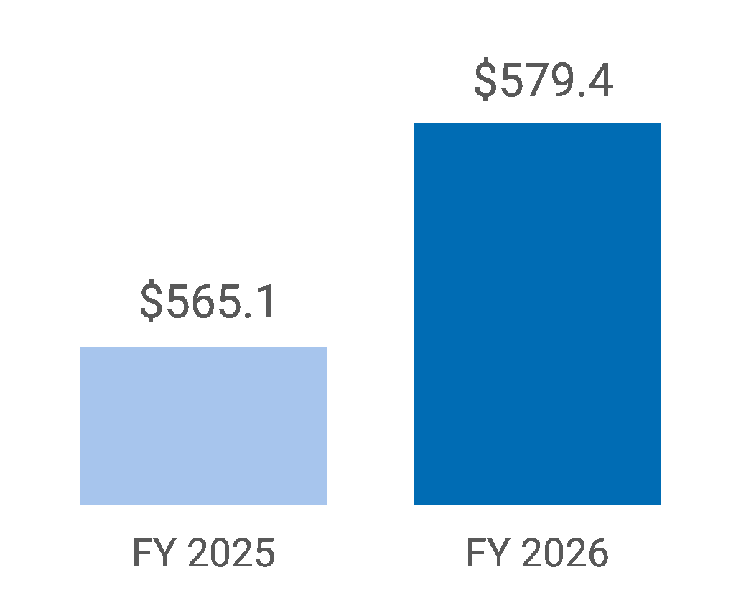 |  | 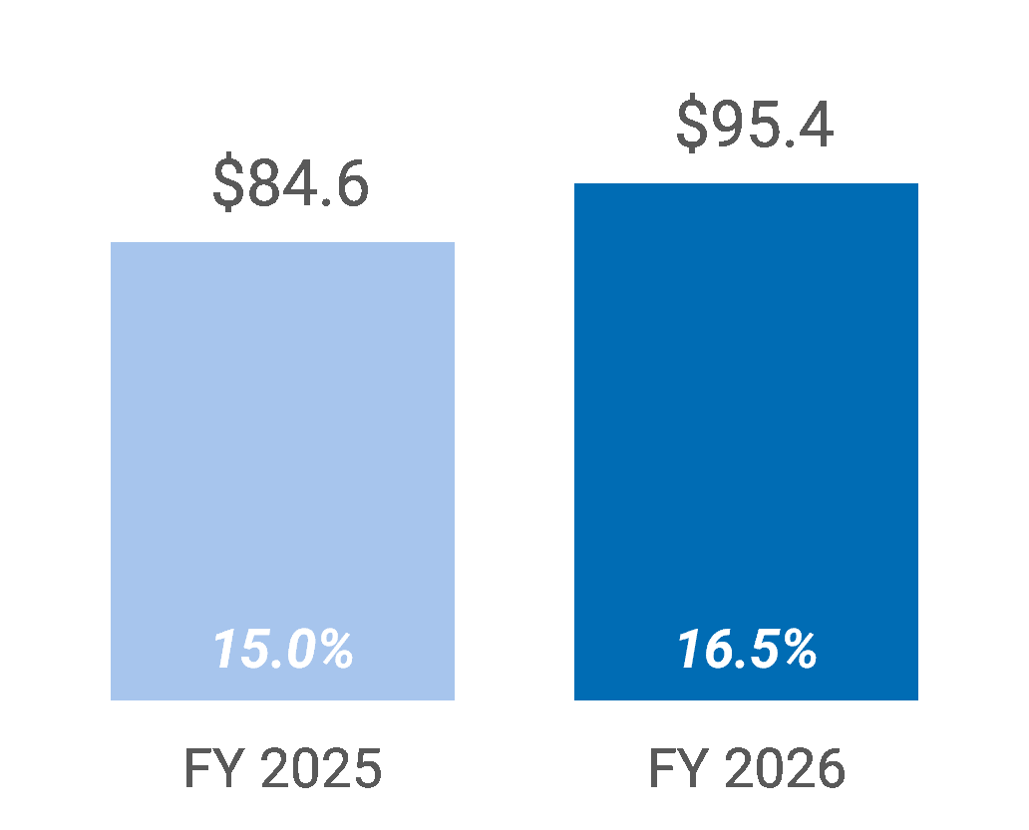 |  | 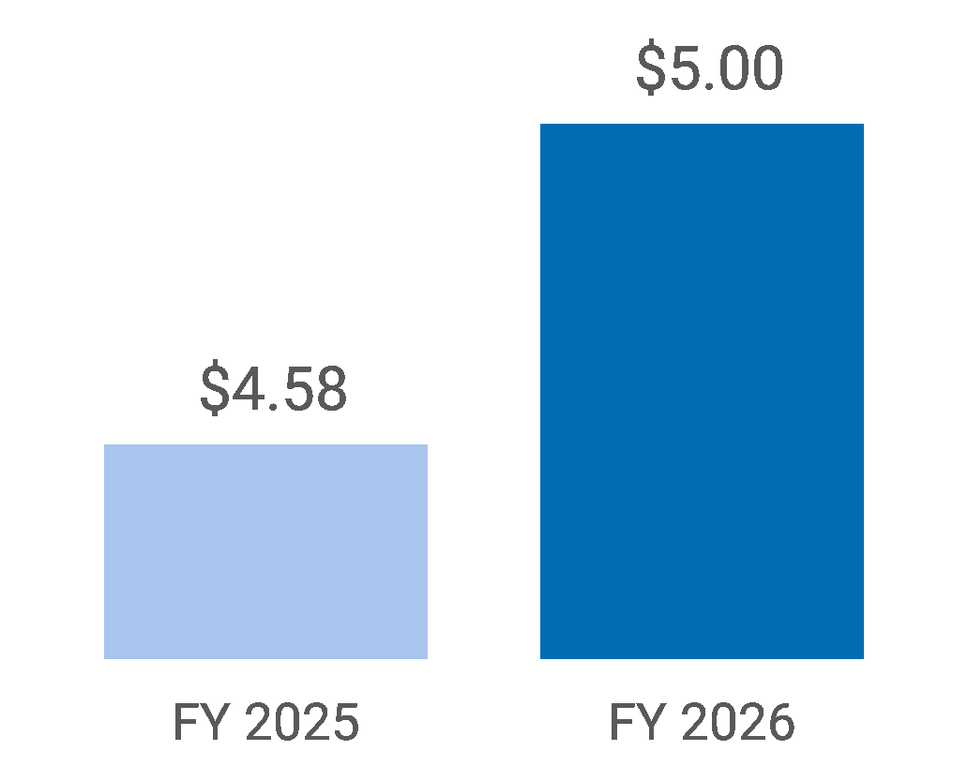
Cash Flow from Operations  ($ in millions) |  | Strong Balance Sheet: Cash on hand  ($ in millions) |  | FY26 compared to FY25
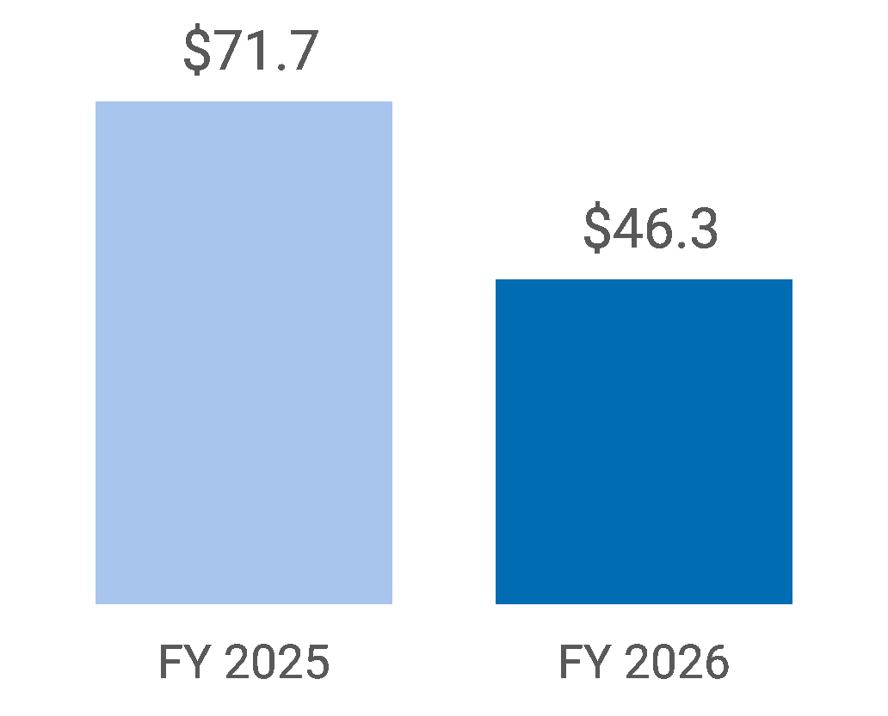 |  | 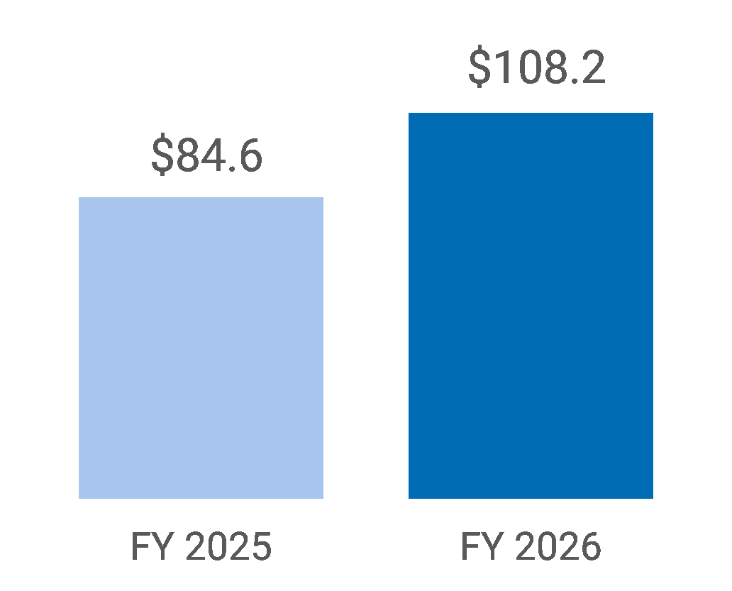 |  | Net Sales Increase of  2.5%  Gross Profit increase of  150bps

2 Strattec | 2026 Proxy Statement

Proxy Summary / Governance Highlights

Governance Highlights

 | Shareowner Rights   One vote per share and no dual-  class share structure  Annual elections and majority  voting for directors  Shareholder right to proxy  access  Direct access  for communication to the Board |  |  | Board Independence  6 of 7 director nominees are  independent  Separate roles of Chair and  CEO  Executive sessions without  management at all Board  meetings  Recently refreshed Board with  5 of 6 independent directors  new in the last 5 years  Focus on board composition  with skills matrix |  |  | Other Governance Practices  Active and engaged directors  with 100% attendance  Annual board, committee and  individual director  self-evaluations  Gender and ethnically diverse  Board  Meaningful stock ownership  and retention requirements  Strong anti-hedging &  anti-pledging stock trading  provisions and Clawback  Policy

Shareholder Engagement

Continued proactive investor relations program
Quarterly earnings calls for shareholders throughout fiscal 2025 and fiscal 2026
Actively participated in investor conferences and shareholder one-on-one meetings
Met with 77 investors, including 29% of the 3.5 million shares held by institutional holders

www.strattec.com 3

Proxy Summary / Board Overview

Board Overview
Director Nominees
The following table provides summary information about each of the director nominees, and the committees they serve on.
Name and Occupation | Age | Director Since | Independent
Matteo Anversa  Chief Financial Officer, Logitech International | 55 | 2024 | Yes
Thomas W. Florsheim, Jr.  Chairman of the Board and  Chief Executive Officer, The Weyco Group, Inc. | 68 | 2012 | Yes
F. Jack Liebau, Jr.  Private Investor | 62 | 2023 | Yes
Bruce M. Lisman  Private Investor | 79 | 2023 | Yes
R. Bruce McDonald  Chairman of the Board, Dana Incorporated | 66 | N/A | Yes
Jennifer L. Slater  President and Chief Executive Officer, Strattec | 52 | 2024 | No
Patricia (Tribby) Warfield  Private Investor | 66 | N/A | Yes

Director Skills Matrix
The Director Skills Matrix shown below summarizes the key skills and expertise that we consider important for our directors considering our business strategy.

Enterprise Leadership and Governance: |  |  |  | Industry and Operating Experience:
Senior Executive Leadership |  | 7/7 |  | Automotive & Mobility Industry |  | 4/7
Public Company Governance |  | 7/7 |  | Engineering, Product Development & Innovation |  | 2/7
Financial Reporting, Accounting & Audit |  | 7/7 |  | Manufacturing, Operations & Supply Chain |  | 4/7
Strategy & Capital Allocation |  | 7/7 |  | Global Business Leadership |  | 6/7
Mergers & Acquisitions, Business Development |  | 7/7 |  | Enterprise-Wide Business Transformations |  | 5/7
Risk Management & Compliance |  | 7/7 |  | Customer, Commercial & Market Development |  | 4/7
Technology, Talent and Risk:
Technology, Cybersecurity, Data & AI |  | 4/7
Human Capital Management |  | 2/7
Executive Compensation |  | 7/7
Legal, Regulatory & Geopolitical |  | 3/7

Board Refreshment
 |  |  |  |  |  |  |  |  |  |  |  | 
2024 |  | 2012 |  | 2023 |  | 2023 |  | N/A |  | 2024 |  | N/A
Matteo  Anversa |  | Thomas W.  Florsheim, Jr. |  | F. Jack  Liebau, Jr. |  | Bruce M.  Lisman |  | R. Bruce  McDonald |  | Jennifer  Slater |  | Tribby  Warfield

4 Strattec | 2026 Proxy Statement

Proxy Summary / Board Overview

Strattec Named Executive Officers

 |  |  | Jennifer L. Slater
 |  |  | President and CEO
•
With over 26 years in the automotive industry, Ms. Slater is recognized as a transformative leader with extensive experience in engineering, finance, sales and product strategy.
•
Prior to joining Strattec, Ms. Slater advanced through increasingly challenging roles at Sensata Technologies (NYSE: ST) to EVP and General Manager. In that role, she led its $2.7 billion global Performance Sensing Segment serving the automotive and heavy vehicle/off road markets. Previously at Clarios, LLC, she led the over $3 billion Original Equipment business and shaped the global efforts to address the growing demand for vehicle electrification and autonomy.
•
She earned a Bachelor of Science in Mechanical Engineering from the University of Michigan-Dearborn and a Master of Business Administration from Walsh College.
•
Ms. Slater has served as a director of Valvoline Inc. (NYSE: VVV), an American retail automotive services company, since July 2022 and is a member of the MEMA Original Equipment Suppliers board of directors since January 2025.
•
Ms. Slater was recognized by Automotive News 100 leading women in 2025.

www.strattec.com 5

Proxy Summary / Board Overview

 |  |  | Matthew P. Pauli
 |  |  | Senior Vice President and Chief Financial Officer
•
Mr. Pauli is a seasoned and strategic financial executive with over 25 years of experience driving growth, optimizing financial performance, and ensuring operational excellence.
•
Before joining Strattec, he was Executive Advisor and CFO of CentroMotion, a global manufacturer of highly engineered products serving a broad variety of industrial markets, where he managed the global financial, information technology and legal operations. Previously, Mr. Pauli held senior finance roles at Enerpac (NYSE: EPAC), including Corporate Controller/Chief Accounting Officer, and VP Finance.
•
Mr. Pauli began his career at Ernst & Young and holds Bachelor of Business Administration in Accounting from the University of Wisconsin-Whitewater.

 |  |  | Chey D. Becker-Varto
 |  |  | Senior Vice President and Chief Commercial Officer
•
Ms. Becker-Varto has over 25 years of experience in the automotive industry ranging from finance, through purchasing and into sales and global executive leadership roles. She previously served as Chief Commercial Officer at Vayan Group, where she doubled the sales pipeline, implemented more sophisticated customer relationship management systems, and modernized revenue operations. Prior to that, she held leadership roles at Clarios, JD Norman Industries, and GST AutoLeather, driving growth, enhancing procurement strategies, and optimizing organizational processes. She began her career at Lear Corporation.
•
Ms. Becker-Varto holds a Master of Science in Information Management & Communications from Walsh College and a dual Bachelor of Science in International Business & Spanish from Central Michigan University, including study abroad in Mexico.

 |  |  | Richard P. Messina
 |  |  | Former Senior Vice President and Chief Technology Officer (Current Engineering Technical Fellow)
•
Mr. Messina has over 40 years of experience in the automotive industry and has served in a variety of positions during his 17 years of tenure with Strattec. He was appointed to his current position in March 2026, after serving as Senior Vice President and Chief Technology Officer since June 2023. Prior to that, Mr. Messina was the Chief Engineer of Delphi Power Products and held several leadership roles within Delphi.
•
Mr. Messina earned a Master of Business Administration from Oakland University and a Bachelor of Science in Mechanical Engineering from Kettering University

6 Strattec | 2026 Proxy Statement

Corporate Governance Matters / Board Leadership Structure

CORPORATE GOVERNANCE MATTERS

Board Leadership Structure
We currently have different persons serving as our Chief Executive Officer and as Chairman of our Board of Directors. Mr. Liebau has served as the Chair of our Board since January 1, 2024, and Jennifer Slater is our President and Chief Executive Officer. Although our Board of Directors does not have a formal policy with respect to its leadership structure, we have historically had different persons serve as our Chief Executive Officer and Chairman of the Board of Directors. The Board of Directors believes that the current structure of appointing an independent non-executive Chair best serves Strattec as a good governance practice because it allows Ms. Slater to focus on managing the Company's day-to-day business and implementing our strategies while allowing Mr. Liebau to lead the Board of Directors in its primary role of review and oversight of executive management. The Board of Directors also believes that its leadership structure has created an environment of open, efficient communication between the Board of Directors and management, enabling the Board of Directors to maintain an active, informed role in fulfilling its duties.
Although we believe that separating the Chairman and Chief Executive Officer roles is appropriate for the foreseeable future, we will continue to review this issue periodically to determine whether, based on the relevant facts and circumstances at such time, combining these offices would serve our best interests and the best interests of our shareholders and other constituencies.

Members in 2026:  Matteo Anversa, Chair  Tina Chang  Thomas W. Florsheim, Jr.  F. Jack Liebau, Jr.  Bruce Lisman  Independence:  All members of the committee  are independent  Meetings in 2026: 8 |  | Audit Committee
 |  | The Audit Committee is responsible for assisting our Board of Directors with oversight of:
 |  | (1) the integrity of our financial statements;
 |  | (2) our compliance with legal and regulatory requirements;
 |  | (3) our independent auditor’s qualifications and independence;
 |  | (4) the performance of our internal accounting function and the independent auditors; and
 |  | (5) the scope and adequacy of our internal controls.
 |  | In addition, Audit Committee members participate in quarterly meetings with members of management and our outside auditors to review our quarterly earnings releases and quarterly financial statements prior to their issuance or filing with the U.S. Securities and Exchange Commission (the “Commission”). Our Audit Committee has the direct authority and responsibility to appoint, replace, compensate, oversee and retain the independent auditors, and is an “audit committee” for purposes of Section 3(a)(58)(A) of the Securities Exchange Act of 1934.

Members in 2026:  Thomas W, Florsheim, Jr.,  Chair  Matteo Anversa  Tina Chang  F. Jack Liebau, Jr.  Bruce Lisman  Independence:  All members of the committee  are independent  Meetings in 2026: 4 |  | Compensation Committee
 |  | The Compensation Committee is responsible for oversight of the:
 |  | (1) compensation and benefits of our executive officers (including our Chief Executive Officer);
 |  | (2) recommendations to our Board of Directors with respect to incentive compensation plans and equity-based plans;
 |  | (3) administration of our incentive compensation plans and equity-based plans in accordance with the responsibilities assigned to the Committee under any and all such plans; and
 |  | (4) recommendations to our Board of Directors with respect to the compensation of our non-employee directors.

www.strattec.com 7

Corporate Governance Matters / Nominating and Corporate Governance Committee

Members in 2026:  Tina Chang, Chair  Matteo Anversa  Thomas W. Florsheim, Jr.  F. Jack Liebau, Jr.  Bruce Lisman  Independence:  All members of the committee  are independent  Meetings in 2026: 4 |  | Nominating and Corporate Governance Committee
 |  | The Nominating and Corporate Governance Committee is responsible for assisting our Board of Directors by:
 |  | (1) identifying individuals qualified to become members of our Board of Directors and its committees;
 |  | (2) recommending guidelines and criteria to the Board of Directors to determine the qualifications of potential directors;
 |  | (3) making recommendations to the Board of Directors concerning the size and composition of the Board and its committees, including developing and annually reviewing our director skills matrix;
 |  | (4) recommending to our Board of Directors nominees for election to the Board at the annual meeting of shareholders;
 |  | (5) developing and recommending to our Board of Directors a set of corporate governance principles applicable to our business; and
 |  | (6) assessing director performance and the effectiveness of the Board of Directors as a whole.

Charters of Committees
Our Board of Directors has adopted, and may amend from time to time, a written charter for each of the Audit Committee, Compensation Committee and Nominating and Corporate Governance Committee. We make available on our website at www.strattec.com, free of charge, copies of each of these charters. We are not including the information contained on or available through our website as a part of, or incorporating such information by reference into, this Proxy Statement.

Board Oversight of Risk
The Board, as a whole and through its committees, has responsibility for the oversight of risk management at the Company. In its risk oversight role, the Board has the responsibility to satisfy itself that the risk management processes designed and implemented by management are adequate and functioning as designed. The Board receives reports from management on financial, operational, legal, regulatory, technology, compliance and reputation risks and the degree of exposure to those risks.
The Board oversees an enterprise-wide approach to risk management, which is designed to (i) support the achievement of organizational objectives, including strategic objectives, (ii) improve long-term organizational performance and (iii) enhance shareholder value. Several Board committees are responsible for risk oversight in specific areas. The Board relies on the Audit Committee to address significant financial risk exposures and the steps management has taken to monitor, control and report such exposures to the Board, including the Company’s risk assessment and risk management guidelines and policies. The Compensation Committee monitors and evaluates risks arising from the Company’s compensation policies and practices for its employees. The Nominating and Corporate Governance Committee has oversight responsibility to ensure that Strattec’s governance standards establish effective systems for monitoring and accountability.

Board Self-Assessment and Evaluation
As part of an annual self-evaluation process, the directors consider various topics relating to the Board’s and each Board committee’s role, structure, composition, relationship with management, access to information and resources, process, and responsibilities, as well as the overall mix of director experiences and skills. The Board and each of its committees independently review and discuss the results of the annual self-assessments. Any matters arising from the self-evaluation process are discussed with both the Chair and in executive session among the directors. The Board’s succession planning considers the results of this self-evaluation, together with other information, including the overall mix of tenure, experience, and skills of the directors, upcoming expected retirements of individual directors, the experience and skills that would be desirable for future directors, and the needs of the Board and its committees at the time.
8 Strattec | 2026 Proxy Statement

Corporate Governance Matters / Code of Business Ethics

Code of Business Ethics
We have adopted a Code of Business Ethics that applies to all of our employees, including our principal executive officer, principal financial officer and principal accounting officer, and to our non-employee directors. A copy of our Code of Business Ethics is available on our website. We also intend to disclose any amendments to, or waivers from, our Code of Business Ethics on our corporate website.
Further, we have established whistle-blower procedures which provide a process for the confidential and anonymous submission, receipt, retention and treatment of complaints regarding financial accounting, internal controls or auditing matters. These procedures provide protections to employees who report possible misconduct impacting the Company.

Transactions with Related Persons
During fiscal 2026, Strattec did not engage in any related party transactions within the meaning of the rules of the Commission.
The charter for our Audit Committee provides that one of the responsibilities of our Audit Committee is to review and approve related party transactions in accordance with the listing standards or requirements of the NASDAQ Stock Market. Although we do not currently have a formal written set of policies and procedures for the review, approval or ratification of related party transactions, we do have written procedures in place to identify related party transactions that may require Audit Committee approval. These procedures include annual submission of director and officer questionnaires. Where a related party transaction is identified, the Audit Committee reviews and, where appropriate, approves the transaction based on whether it believes that the transaction is at arm’s length and contains terms that are no less favorable than what we could have obtained from an unaffiliated third party.

Communications between Shareholders and the Board of Directors
Our shareholders may communicate with our Board of Directors or any of our individual directors by directing such communication to our Secretary at the address of our corporate headquarters, 3333 West Good Hope Road, Milwaukee, Wisconsin 53209. Each such communication should indicate that the sender is a shareholder of Strattec and that the sender is directing the communication to one or more of our individual directors or to our Board as a whole.
All communications will be compiled by our Secretary and submitted to our Board of Directors or the applicable individual directors on a monthly basis unless such communications are considered, in the reasonable judgment of our Secretary, to be improper for submission to the intended recipient(s). Examples of shareholder communications that would be considered improper for submission include, without limitation, customer complaints, solicitations, communications that do not relate directly or indirectly to Strattec or our business or communications that relate to improper or irrelevant topics. Our Secretary may also attempt to handle a communication directly where appropriate, such as where the communication is a request for information about Strattec.

Shareholder Proxy Access
In accordance with our Bylaws, as amended, a shareholder may also request that the Company include in its proxy statement in which it solicits proxies with respect to the election of directors at an annual meeting of shareholders, any person nominated for election (a “Shareholder Nominee”) to the Board by a shareholder or by a group of not more than twenty Shareholders that (i) satisfies the requirements of 2.01(d) of our Bylaws (such individual shareholder or shareholder group, including each member thereof, to the extent the context requires, an “Eligible Shareholder”), and (ii) expressly requests in the notice required by such Section 2.01(d) to have the Shareholder Nominee included in the Company’s proxy materials pursuant to such Section 2.01(d). The information that the Company will include in its Proxy Statement is the information provided by the Eligible Shareholder to the Secretary of the Company concerning the Shareholder Nominee and the Eligible Shareholder that is required to be disclosed in the Company’s Proxy Statement by the regulations promulgated under the Securities Exchange Act of 1934, as amended (the “Exchange Act”), and if the Eligible Shareholder so elects, a written statement, not to exceed 500 words, in support of the Shareholder Nominee’s candidacy (the “Statement”). The Company may omit from its proxy materials any information or Statement (or portion thereof) that it, in good faith, believes would violate any applicable law or regulation. The Company will not be required pursuant to Section 2.01(d) to include any information regarding a Shareholder Nominee in its proxy materials for any meeting of shareholders for which any person is engaging in a solicitation within the meaning of Rule 14a-1(l) under the Exchange Act in support of the election of any individual as a director at such meeting other than Shareholder Nominees or nominees of the Board. The maximum number of Shareholder Nominees nominated by all Eligible Shareholders that the Company shall be required to include in its proxy materials with respect to an Annual Meeting generally shall not exceed the greater of (i) two, or (ii) 20% of the total number of members of the Company’s Board rounded to the closest whole number below 20%.

www.strattec.com 9

Corporate Governance Matters / Shareholder Proxy Access

The Company will be required to include information regarding a Shareholder Nominee in its proxy materials with respect to an Annual Meeting only if the notice of the nomination relating to the Shareholder Nominee is delivered to, or mailed to and received by, the Secretary of the Company no earlier than 120 days and no later than 90 days before the anniversary of the previous year’s annual meeting of shareholders, provided, however, that if the annual meeting is called for a date that is not within 30 days before or after such anniversary date, notice by the shareholder must be received not later than the close of business on the tenth day following the day on which notice of the date of the annual meeting was mailed or public disclosure of the date of the annual meeting was made, whichever first occurs, or if the Company is holding a special meeting of shareholders, then the shareholder must deliver the notice a reasonable time before the Company issues its proxy materials, as specified by the Company in a Current Report on Form 8-K filed pursuant to Item 5.08.
10 Strattec | 2026 Proxy Statement

Director Nominees / Proposal 1: Election of Seven Directors

DIRECTOR NOMINEES

Proposal 1: Election of Directors

The Proposal
Our Board currently has established the number of directors at seven members. The Board has nominated each of the following individuals for election for a one-year term expiring at the annual meeting of shareholders to be held in 2027.
Nominees for election at the Annual Meeting:

Board of Directors Recommendation

The Board of Directors recommends that shareholders vote FOR the election of the following nominees as directors of Strattec to serve for a one year term expiring at the 2027 Annual Meeting of Shareholders, provided that Proposal 1 is approved by shareholders: Matteo Anversa, Thomas W. Florsheim, Jr., F. Jack Liebau, Jr., Bruce M. Lisman, R. Bruce McDonald, Jennifer L. Slater, and Tribby Warfield.

Matteo Anversa
Chief Financial Officer of Logitech International
Mr. Anversa has served as the Chief Financial Officer of Logitech International (SIX: LOGN) (Nasdaq: LOGI), a Swiss public company that designs software-enabled hardware solutions since 2024. He previously served as Executive Vice President of Finance, Chief Financial Officer, and Treasurer of Gentherm, Inc. (Nasdaq: THRM), a market leader in thermal and pneumatic comfort in the automotive industry, from January 2019 through August 2024.
Skills and Qualifications
•
Mr. Anversa provides extensive financial expertise, including as a public company executive officer, and brings substantial experience in the automotive industry and global finance. His experience as a director of a foreign exchange listed company also enhances his qualifications.


Independent
Age 55
Director Since 2024
Committees
 Audit (Chair)
 Compensation
 Nominating and
Corporate Governance

www.strattec.com 11

Director Nominees / Proposal 1: Election of Seven Directors

Thomas W. Florsheim, Jr.
Chairman of the Board and Chief Executive Officer of the Weyco Group, Inc.
Mr. Florsheim has served as the Chairman of the Board and Chief Executive Officer of Weyco Group, Inc. (NASDAQ: WEYS), a company engaged in the business of the design and distribution of quality and innovative footwear, since 2002.
Skills and Qualifications
•
Mr. Florsheim offers extensive leadership experience as the Chief Executive Officer of a public company, with expertise in mergers and acquisitions, financial oversight, compensation matters and organizational development. His career in consumer goods has given him meaningful experience in manufacturing, marketing and global operations.


Independent
Age 68
Director Since 2012
Committees
 Audit
 Compensation (Chair)
 Nominating and
Corporate Governance

F. Jack Liebau, Jr.
Private investor
Mr. Liebau is a private investor. Mr. Liebau formerly served as managing director of Beach Investment Counsel, Inc., an investment management company. Mr. Liebau is the former President and CEO of Roundwood Asset Management, a subsidiary managing public equities for Alleghany Corporation’s insurance companies, the former President and Founder, Liebau Asset Management Company and the former Partner and Portfolio Manager for Davis Funds and Primecap Management Company, investment management firms.
Mr. Liebau’s current and former directorships include: Board Chair and director of Myers Industries, Inc. (NYSE: MYE) since 2015; director of Motorcar Parts of America, Inc. (Nasdaq:MPAA), a remanufacturer, manufacturer, and distributor of automotive aftermarket parts (2024-2025); and director of BNY Mellon ETF Trust.
Skills and Qualifications
•
Mr. Liebau brings deep financial, strategic and investment expertise. He has significant corporate governance experience through service on numerous public and private boards across industries, and brings an ability to work effectively with management teams, analyze strategic options and communicate with various constituencies.


Independent
Age 62
Director Since 2023
Committees
 Audit
 Compensation
 Nominating and
Corporate Governance

12 Strattec | 2026 Proxy Statement

Director Nominees / Proposal 1: Election of Seven Directors

Bruce M. Lisman
Private investor
Mr. Lisman is a private investor. He serves on the boards of two other public companies — Myers Industries (NYSE: MYE) since 2015 and Associated Capital Group (NYSE: AC) since 2015, and several private companies. He also previously served on the board of directors of CIRCOR International (2020-2023). Mr. Lisman was previously Chairman of JP Morgan’s Global Equity Division (2008-2009), and Head or Co-Head of Bear Stearns Global Equity Division from 1987 to 2008.
Skills and Qualifications
•
Mr. Lisman contributes extensive public company board and committee leadership experience, as well as senior executive expertise in capital markets and investment management.



Independent
Age 79
Director Since 2023
Committees
 Audit
 Compensation
 Nominating and
Corporate Governance

R. Bruce McDonald
Executive Chairman of Dana Incorporated
Mr. McDonald has served Dana Incorporated (NYSE: DAN), a global manufacturer of automotive and commercial vehicle powertrain products, first as the Chairman and Chief Executive Officer from November of 2024 through June of 2026, and currently as the Executive Chairman. Previously, Mr. McDonald was the Chairman and Chief Executive Officer of Adient plc (NYSE: ADNT),a global manufacturer of automotive seating & interior products. Mr. McDonald served for fifteen years in roles of increasing responsibility and complexity with Johnson Controls, Inc. (NYSE: JCI), a global manufacturer of automotive seating & interior products, automotive batteries and non-residential building HVAC systems. Earlier in his career, Mr. McDonald advanced through managerial and executive level positions with multiple companies in the automotive industry.
In addition to his directorships with Adient and Dana, Mr. McDonald’s prior board service includes Andrew Peller Limited (TSE: ADW-B), where he served as Chairman from February 2024 through August 2026.
Skills and Qualifications
•
Mr. McDonald’s extensive industry-specific, executive and board-level experience leading global manufacturing organizations, including serving as Chairman and Chief Executive Officer of a global automotive parts supplier and previously as Vice Chairman and Chief Financial Officer of a global manufacturer, will enable him to provide a deep understanding of the financial and operational risks affecting the Company. In addition, his international experience strengthens the Board's strategic oversight by providing valuable global insights into emerging opportunities and risk management considerations.

Independent
Age 66

www.strattec.com 13

Director Nominees / Proposal 1: Election of Seven Directors

Jennifer L. Slater
President and Chief Executive Officer of Strattec
Ms. Slater has served as Strattec's President and Chief Executive Officer since July 1, 2024. Ms. Slater had most recently served as Executive Vice President and General Manager, Performance Sensing, of Sensata Technologies, Inc. (NYSE: ST), a global industrial technology company, since April 2024, after serving as Senior Vice President, Automotive & Aftermarket, beginning April 2023. Ms. Slater also served as the Vice President and General Manager of Sensata’s Heavy Duty and Off-Road business from September 2022 through March 2023. From 2019 to September 2022, Ms. Slater served as Group Vice President and General Manager, Global OE and Products, at Clarios, LLC, a manufacturer and distributor of advanced energy storage solutions for the automotive market. Ms. Slater has served as a director of Valvoline Inc. (NYSE: VVV), an American retail automotive services company since 2022.
Skills and Qualifications
•
Ms. Slater brings significant leadership experience in the automotive and industrial technology sectors, with expertise in product management, strategy and sales. Her role as CEO of Strattec and service on another public company board strengthen her qualifications.



Age 52
Director Since 2024
Committees
NA

Tribby Warfield
Private Investor
Ms. Warfield formerly served as Chief Executive Officer and Chairman of the Board of APC Automotive Technologies, one of the largest North American suppliers of aftermarket automotive components for passenger vehicles, light, medium, and heavy-duty trucks and commercial vehicles. Prior to APC, Ms. Warfield served as Senior Vice President, Business Development and Strategy for Nitta Corporation, a global provider of power transmission and conveyor belting products. Earlier in her career, Ms. Warfield held various senior level positions at Kaman Corporation and Gates Corporation where she served for twenty-five years.
Ms. Warfield’s current and former directorships include: Myers Industries, Inc. (NYSE: MYE) since 2026; Badger Infrastructure Solutions Ltd (BDGI:TSX) since 2023; Motorcar Parts of America, Inc. (Nasdaq:MPAA) from 2023 to 2025; and Ms. Warfield also serves as a board advisor to several private equity-sponsored global diversified manufacturing and automotive aftermarket portfolio companies.
Skills and Qualifications
•
Ms. Warfield brings deep board-level corporate governance experience from serving on both public and private company boards including meaningful committee experience on audit, compensation, and governance committees, as well as significant strategic and operational expertise in restructuring transactions, transformation initiatives, risk management, and cultural leadership.


Independent
Age 66

14 Strattec | 2026 Proxy Statement

Director Nominees / Proposal 1: Election of Seven Directors

Directors not standing for Election at the Annual Meeting:
Ms. Chang will not stand for reelection at the Annual Meeting. The decision not to nominate Ms. Chang for reelection was not the result of any disagreement with the Company, management, or the Board on any matter relating to the Company's operations, policies, or practices. The Board thanks Ms. Chang for her years of dedicated service and valuable contributions to the Company.

 |   Independent  Age 53  Director Since 2022  Committees   Audit   Compensation   Nominating and  Corporate Governance  (Chair) |  | Tina Chang
 |  |  | Chairman of the Board and Chief Executive Officer of SysLogic, Inc.
 |  |  | Ms. Chang has served as Chairman of the Board and the Chief Executive Officer of SysLogic, Inc., an information systems consulting and services firm since 1996. Ms. Chang is also an owner of several other companies focused on product innovation, social benefits and cybersecurity. Ms. Chang has served on the board of directors of Central States, Inc. since 2019. She has also served as a director of Weyco Group, Inc. (Nasdaq: WEYS) since 2007.

Board of Directors Recommendation

Our Board of Directors unanimously recommends voting FOR the election of each of the nominees.

www.strattec.com 15

Director Nominees / Director Nominations and Selection Process

Director Nominations and Selection Process
The Nominating and Corporate Governance Committee will consider director nominees recommended by shareholders in accordance with our Bylaws, as amended. Pursuant to Section 2.01(c) of our Bylaws, a shareholder may nominate a candidate for election as a director of the Company only if written notice of such intention is received by the Secretary, either by personal delivery or by United States mail, postage prepaid, and received at the Company's principal executive offices (i) in the case of an annual meeting, not less than 90 nor more than 120 days prior to the one year anniversary date of the immediately preceding annual meeting of shareholders; provided, however, that in the event that the annual meeting is called for a date that is not within 30 days before or after such anniversary date, notice by the shareholder in order to be timely must be so received not later than the close of business on the tenth day following the day on which notice of the date of the annual meeting was mailed or public disclosure of the date of the annual meeting was made, whichever first occurs; and (ii) in the case of a special meeting of shareholders called for the purpose of electing directors, not later than the close of business on the tenth day following the day on which notice of the date of the special meeting was mailed or public disclosure of the date of the special meeting was made, whichever first occurs. The proponent's notice must include the undertakings and information required by Section 2.01(c).
The Nominating and Corporate Governance Committee believes that a nominee recommended for a position on our Board of Directors must have an appropriate mix of director characteristics, experience, diverse perspectives and skills. In light of the foregoing, our Board has adopted director selection criteria, a copy of which are available on our website. These criteria are periodically reviewed by the Nominating and Corporate Governance Committee and generally require absence of material conflicts of interest of all independent and non-management directors. The criteria also describe the personal attributes and the broad mix of skills and experience of directors sought by the Company in order to enhance the diversity of perspectives, professional experience, education and other relevant attributes and the overall strength of the composition of the Board taking into account the uniqueness attributable to Strattec’s industry. These director selection criteria work in concert with our director skills matrix and amended Bylaws, as described above, in helping our Nominating and Corporate Governance Committee identify and select director candidates to our Board. In this regard, some of the criteria that may be taken into account by the Nominating and Corporate Governance Committee include personal integrity and high ethical character; professional excellence; accountability and responsiveness; absence of conflicts of interest; fresh intellectual perspectives and ideas; and relevant expertise and experience (including related to financial and accounting matters) and the ability to offer advice and guidance to management based on that expertise and experience that coincides with Strattec’s strategic initiatives.

Director Independence; Audit Committee Financial Expert
Our Board of Directors has reviewed the independence of our continuing directors and the nominees for election to the Board at the Annual Meeting under the applicable listing standards of the NASDAQ Stock Market. Based on this review, our Board of Directors determined that all directors and nominees listed in this Proxy Statement are independent under the NASDAQ Stock Market listing standards other than Ms. Slater, who is not independent due to her role as Strattec's President and Chief Executive Officer.
Our Board of Directors has determined that at least one of the members of our Audit Committee qualifies as an “audit committee financial expert” as defined by the rules of the Commission. Mr. Anversa, the Chair of the Audit Committee, and Mr. Liebau, Board Chair, each qualify as an “audit committee financial expert” based on their respective work experience and education.

16 Strattec | 2026 Proxy Statement

Director Nominees / Director Qualifications and Skills Matrix

Director Qualifications and Skills Matrix
We believe our director nominees are talented individuals with diverse skill sets and backgrounds, as reflected in their biographies set forth below. Many of the directors have extensive and direct automotive industry experience and/or experience in various industries that impact key functional areas of our business, such as in electronics, financial and technology matters. The directors also have varying educational backgrounds, levels of schooling and public company board experience, including a mix of college, post-graduate and multiple public board and committee experience that brings strengths and diversity to our Board.
The director skills matrix shown below summarizes the key skills and expertise that are important for our directors, considering our business strategy. Specifically, the following matrix highlights the key skills, experiences, qualifications and attributes that our Nominating and Corporate Governance Committee considers in evaluating the strength and diversity of the Board. A mark indicates a specific area of focus or expertise on which the Board particularly relies. Not having a mark does not mean the incumbent or nominee director does not possess that qualification or skill.

 | Anversa | Florsheim | Liebau | Lisman | McDonald | Slater | Warfield
Enterprise Leadership and Governance:
Senior Executive Leadership | 
Public Company Governance
Financial Reporting, Accounting & Audit
Strategy & Capital Allocation
Mergers & Acquisitions, Business Development
Risk Management & Compliance
Industry and Operating Experience:
Automotive & Mobility Industry
Engineering, Product Development & Innovation
Manufacturing, Operations & Supply Chain
Global Business Leadership
Enterprise-Wide Business Transformations
Customer, Commercial & Market Development
Emerging and People Capabilities:
Technology, Cybersecurity, Data & AI
Human Capital Management
Executive Compensation
Legal, Regulatory & Geopolitical

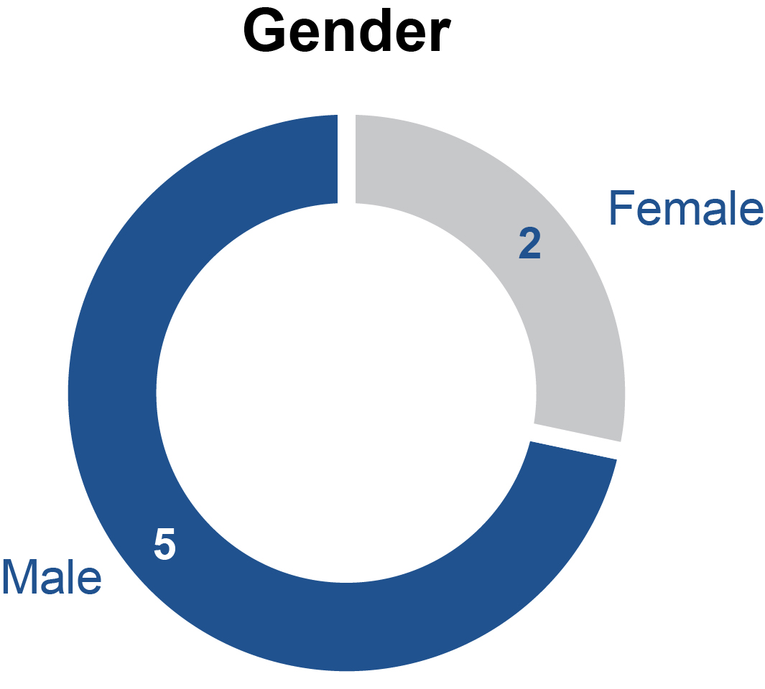 |  |  |  | 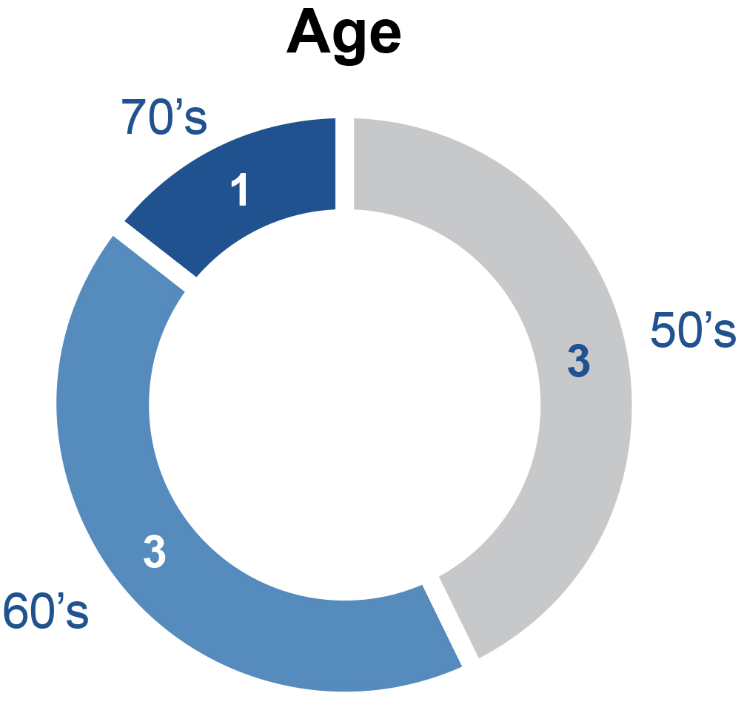
 | 29%  WOMEN |  | 64 YRS  AVERAGE

www.strattec.com 17

Director Nominees / Committee Membership, Meetings and Attendance

Committee Membership, Meetings and Attendance

Meetings and Director Attendance
Our Board of Directors held six meetings in fiscal 2026, and all of our directors who served as directors during fiscal 2026 attended more than 75% of the meetings of the Board and the committees of the Board on which they served at the time of such meetings. Executive sessions, or meetings of non-employee directors without management present, are held at each Board meeting.
The committees of our Board of Directors consist of the Audit Committee, the Compensation Committee, and the Nominating and Corporate Governance Committee. The chart below identifies the members and chair of each of these committees during fiscal 2026.

Committee Members | Audit | Compensation | Nominating and  Corporate  Governance
Matteo Anversa | (Chair)
Tina Chang |  |  | (Chair)
Thomas Florsheim |  | (Chair)
Jack Liebau
Bruce Lisman

Ms. Slater, as our Chief Executive Officer, is not a member of any Board committee but regularly attends Board and committee meetings.

Stock Ownership Requirements
The Board of Directors believes that directors should maintain a meaningful equity interest in Strattec to further align their interests with those of shareholders and reinforce a long-term ownership perspective. Accordingly, the Board has adopted stock ownership guidelines applicable to all non-employee directors. Under the guidelines, each non-employee director is expected to beneficially own shares of Strattec common stock having a market value equal to at least five times the annual cash retainer paid for Board service (currently equal to $425,000). Directors are expected to achieve the applicable ownership level within five years of first becoming subject to the guidelines. The Compensation Committee reviews compliance with the stock ownership guidelines periodically. As of the record date for the Annual Meeting, all non-employee directors were either in compliance with the ownership guidelines or within the applicable phase-in period.

Attendance of Directors at Annual Meetings of Shareholders
Although we do not have a formal policy regarding the attendance of our directors and nominees for election as directors at our Annual Meeting, our directors are encouraged to attend the Annual Meeting. Accordingly, we expect that all of our directors, whether up for re-election at the Annual Meeting or not, will attend the Annual Meeting absent a valid reason, such as a schedule conflict or as a result of other extenuating circumstances. All persons then being elected to serve as one of our directors attended the Annual Meeting of Shareholders held on October 15, 2025.

Compensation Committee Interlocks
None of the Compensation Committee members have at any time been an officer or employee of the Company. In the past fiscal year, none of our NEOs have served as a member of the board of directors or compensation committee of any entity that has one or more NEOs serving on the Company’s Board or Compensation Committee. Accordingly, during fiscal 2026, there were no compensation committee interlocks requiring disclosure under SEC rules.
18 Strattec | 2026 Proxy Statement

Director Nominees / Director Compensation

Director Compensation

General Information
Each non-employee director received, with respect to their fiscal 2026 service, an annual retainer fee of $170,000, payable $85,000 in cash, quarterly in arrears, and approximately $85,000 in restricted stock, generally awarded on the day of the annual meeting of shareholders subject to vesting on the date of the following year’s annual meeting of shareholders at the completion of the non-employee directors’ elected terms. These shares have all the rights of our shares of Common Stock (including voting rights), other than the right to receive cash dividends while such shares are not vested.
Non-employee directors with significant additional duties received the following additional annual retainers for fiscal year 2026: (i) $60,000 for the Chair of the Board of Directors; (ii) $20,000 for the Chair of the Audit Committee, and (iii) $15,000 for the Chairs of the Compensation and Nominating and Corporate Governance Committees.

Director Summary Compensation Table
The following table summarizes the compensation of all of our non-employee directors for fiscal year 2026.

Name |  | Fees Earned or  Paid in Cash |  |  |  |  |  | Stock  Awards (1) |  |  |  |  |  | Non-Equity  Incentive Plan  Compensation |  |  |  |  |  | All Other  Compensation |  |  |  |  |  | Total
Bruce Lisman |  |  | $ | 85,000 |  |  |  |  | $ | 83,169 |  |  |  |  | $ | — |  |  |  |  | $ | — |  |  |  |  | $ | 168,169
F. Jack Liebau, Jr. |  |  | $ | 145,000 |  |  |  |  | $ | 83,169 |  |  |  |  | $ | — |  |  |  |  | $ | — |  |  |  |  | $ | 228,169
Tina Chang |  |  | $ | 100,000 |  |  |  |  | $ | 83,169 |  |  |  |  | $ | — |  |  |  |  | $ | — |  |  |  |  | $ | 183,169
Matteo Anversa |  |  | $ | 105,000 |  |  |  |  | $ | 83,169 |  |  |  |  | $ | — |  |  |  |  | $ | — |  |  |  |  | $ | 188,169
Thomas W. Florsheim |  |  | $ | 100,000 |  |  |  |  | $ | 83,169 |  |  |  |  | $ | — |  |  |  |  | $ | — |  |  |  |  | $ | 183,169

(1)
The amounts reported in this column represent the aggregate grant date fair value of restricted stock awards granted on October 15, 2026, as computed in accordance with Financial Accounting Standard Board Accounting Standards Codification Topic 718. These amounts reflect the accounting cost that will be incurred by the Company over the requisite service period of one-year, beginning at the date of grant, and do not represent the actual economic value that may be realized. For information on the assumptions used to calculate the grant date fair value of the restricted stock awards, please see the notes to our consolidated financial statements included in our Annual Report on Form 10-K for the year ended June 28, 2026.
The Compensation Committee annually reviews and approves non-employee director compensation. As part of this process, the Committee evaluates director compensation practices at the Company's peer group and other public companies of comparable size, considering both revenue and market capitalization. The Committee seeks to provide compensation that generally approximates the median of these companies, both in total compensation and by individual pay element, including compensation for directors serving in additional leadership roles. Based on its most recent review, the Committee approved adjustments to director compensation for fiscal 2027, representing the first increase since fiscal 2025.
In fiscal 2027, the annual retainer fee will be $190,000, payable in equal portions of $95,000 in cash, quarterly in arrears, and $95,000 in restricted stock or restricted stock units, generally to be awarded on the day of the annual meeting of shareholders during the fiscal year, subject to vesting on the date of the following year’s annual meeting of shareholders at the completion of the non-employee directors’ elected terms. In addition, non-employee directors with significant additional duties shall receive the following additional annual retainers in fiscal 2027: (i) $75,000 for the Chair of the Board of Directors; (ii) $25,000 for the Chair of the Audit Committee, and (iii) $15,000 for the Chairs of the Compensation and Nominating and Corporate Governance Committees.

www.strattec.com 19

Executive Compensation / Proposal 2: Advisory Vote to Approve Executive Compensation (Say-on-Pay)

EXECUTIVE COMPENSATION

Proposal 2: Advisory Vote to Approve Executive Compensation (Say-on-Pay)

The Proposal
In accordance with Exchange Act Rule 14a-21(a), and consistent with the similar proposal on executive compensation submitted to our shareholders in connection with previous shareholder annual meetings, our Board of Directors has authorized a non-binding advisory shareholder vote to approve the compensation of our named executive officers as reflected in the Compensation Discussion and Analysis section of this Proxy Statement, the disclosures regarding named executive officer compensation provided in the various tables included in this Proxy Statement, the accompanying narrative disclosures, and the other executive compensation information provided in this Proxy Statement. This proposal, commonly known as “Say-on-Pay,” gives our shareholders the opportunity to endorse or not endorse our executive pay programs and policies.
We believe that our compensation policies and procedures, which are reviewed and approved by our Compensation Committee, are designed to align our executive officers’ compensation with our short-term and long-term performance and to provide the compensation and incentives needed to attract, motivate and retain key executives who are important to our continued success. Our Compensation Committee periodically reviews and approves our compensation policies and procedures, and periodically reviews our executive compensation programs and takes any steps it deems necessary to continue to fulfill the objectives of our compensation programs.
Shareholders are encouraged to carefully review the “Compensation Discussion and Analysis” section of this Proxy Statement for a discussion of our executive compensation programs. These programs have been designed to promote a performance-based culture which aligns the interests of our named executive officers and other senior managers with the interests of our shareholders. This includes annual incentive cash compensation based on the Company achieving specified financial performance measures and a substantial portion of our named executive officers’ compensation comprised of equity awards with long-term vesting requirements based both on service and performance.
Accordingly, shareholders are being asked to vote on the following advisory resolution:
“Resolved, that the compensation paid to Strattec's named executive officers, as disclosed in this Proxy Statement pursuant to the compensation disclosure rules of the Securities and Exchange Commission (including pursuant to Item 402 of Regulation S-K), including the compensation tables and narrative discussion, is hereby approved on an advisory basis.”
Although the vote on this advisory resolution is non-binding, the Compensation Committee and Board of Directors value our shareholders’ opinions and will take into account the outcome of the vote when considering future executive compensation arrangements. At our 2025 Annual Meeting of Shareholders, over 93% of the votes cast on the Say-on-Pay proposal were voted in favor of the proposal. Our advisory Say-on-Pay vote occurs annually.

Vote Required for Approval
The affirmative vote of the holders of a majority of the shares of our common stock as are represented in person or by proxy and entitled to vote on the proposal is required to approve the advisory resolution on the compensation of our named executive officers. A properly executed proxy of a holder of shares of common stock entitled to vote marked "abstain" with respect to Proposal 2 will not be voted with respect to the proposal; accordingly, for purposes of Proposal 2, abstentions will be counted in determining the required vote and will have the effect of a vote “against” approving the advisory resolution.

Board of Directors Recommendation

Our Board of Directors unanimously recommends voting FOR the approval of the advisory resolution approving the compensation of our named executive officers.

20 Strattec | 2026 Proxy Statement

Compensation Discussion and Analysis / Compensation Process Overview

COMPENSATION DISCUSSION AND ANALYSIS
Table of Contents

Compensation Discussion and Analysis |  | 21
Compensation Process Overview |  | 21
Executive Compensation Decision-Making Process |  | 23
Summary Compensation Table |  | 27
Outstanding Equity Awards at Fiscal Year End |  | 30
Stock Ownership Requirement |  | 30
Employment Agreements |  | 31
Post Employment Compensation |  | 31
Equity Compensation Plan Information |  | 35
Pay Versus Performance Disclosure |  | 36
Pay Versus Performance Table |  | 36
CEO Pay Ratio |  | 38
Relationship Between Compensation Actually Paid and Performance Measures |  | 37
Hedging and Margin Account Policies |  | 39
Compensation Risk Assessment |  | 39
Excess Incentive Compensation Recovery (Clawback) Policy |  | 40

This Compensation Discussion and Analysis describes the material elements of the compensation of the Company’s named executive officers (“NEOs”) identified below, the objectives and principles underlying executive compensation programs, recent compensation decisions, and the factors considered by the Compensation Committee and management in making those decisions. The Company’s NEOs for fiscal 2026 were:

Name | Title
Jennifer Slater | President and Chief Executive Officer
Matthew Pauli | Senior Vice President and Chief Financial Officer
Chey Becker-Varto | Senior Vice President and Chief Commercial Officer
Richard Messina | Former Senior Vice President and Chief Technology Officer (Current Engineering Technical Fellow)

Compensation Process Overview
Executive Compensation Highlights. Our compensation program is designed to reflect our philosophy that executive compensation should be directly linked to Company performance, with the ultimate goal of increasing long-term shareholder value. Key highlights of our compensation program are as follows:
•
The Compensation Committee and management continued to work with the Committee’s independent compensation consultant to ensure its compensation program supports the business strategy and reinforces accountability for achieving our financial commitments in areas that will create long-term value for our shareholders.
•
The Company's short-term incentive program was unchanged for fiscal 2026 and based entirely on the achievement of adjusted earnings before interest, taxes, depreciation and amortization ("Adjusted EBITDA") and cash flow goals. Payout was not based on individual performance or other subjective factors.
•
Short-term incentive goals for fiscal 2026 required $42.5 million of Adjusted EBITDA and $42.5 million of cash flow from operations for payout at target (100% of an individual's target opportunity).
www.strattec.com 21

Compensation Discussion and Analysis / Compensation Process Overview

•
The Company's financial results for fiscal 2026 represented a significant improvement over prior year actual performance as well as our target performance expectations:
o
Sales increased from $565 million in fiscal 2025 to $580 million in fiscal 2026 (+3%).
o
Adjusted EBITDA increased from $43.8 million in fiscal 2025 to $50.6 million in fiscal 2026.
o
Cash flow from operations was $46.2 million.
o
These financial results produced short-term incentive payouts for our NEOs and other employees equal to 145.2% of their target opportunity and helped our stock price increase from $62.21 at the start of fiscal 2026 to $82.64 at the end. This represented a 33% return, which ranked at the 57th percentile of the Russell 2000.
The Company uses EBITDA and Adjusted EBITDA in this Proxy Statement which are non-GAAP financial measures and are intended to supplement the results provided in accordance with accounting principles generally accepted in the United States. The Company's management uses Adjusted EBITDA to make strategic decisions, establish budget plans and forecasts, identify trends affecting Strattec's business and evaluate performance. We believe that such information provides insights into the true operating performance of the Company and offers an additional measurement of the Company’s performance.
Alignment of Compensation to Drive Performance. Our executive compensation program is designed to foster a culture of performance, attract and retain highly experienced executives, and provide balanced incentives for the achievement of near-term and long-term objectives, without encouraging executives to take excessive risks. Key components of our compensation program include base salary, short-term annual cash incentives, long-term equity incentives, other benefits, and limited perquisites. The program is designed to align with our financial and strategic objectives, which are intended to create long-term shareholder value. The key tenets of our business model and near-term focus, include strengthening the Company’s profitability and driving cash flow from operations to continue to transform and invest in the business. We believe these focused efforts will allow us to capitalize on our technical engineering expertise, market leading positions and strong customer relationships to generate innovative solutions and predictable sales growth with new and existing customers. Our compensation program links executive pay with effective execution of the business transformation – driving growth in sales, earnings, cash flow and ultimately, stock price appreciation.
Compensation and Governance Practices. The Company’s executive compensation program is also designed to reflect appropriate governance practices aligned with the needs of our business. Below is a summary of compensation practices the Company has adopted that are consistent with those principles, followed by a list of practices the Company does not subscribe to because we do not believe they serve shareholder long-term interests.
 |  | What We Do |  |  |  | What We Do NOT Do
 |  | Increased At-Risk Pay Elements with 75% of our CEO's  target annual compensation at risk and 50% in the form of  long-term equity-based incentives that foster alignment  with shareholders.  Link Pay to Performance with performance goals tied to  improving the reliability, profitability and accountability of  our operations to create long-term shareholder value, and  with annual & long-term incentives based entirely on  consolidated financial goals.  Independent Compensation Consultant that is directly  engaged by the Compensation Committee to advise on  executive and director compensation matters.  Stock Ownership Guidelines that align our executive  officers’ long-term interests with those of our  shareholders.  Clawback Policy that mandates recoupment of  erroneously awarded incentive compensation to executive  officers on accounting restatement consistent with  Securities and Exchange Commission ("SEC") and  Nasdaq requirements. |  |  |  | •  No Hedging or Pledging of our Stock. We prohibit our executive officers from engaging in hedging transactions or using our stock as collateral for loans.  •  No Excise Tax Gross-Ups. We do not provide gross ups on excise taxes in connection with a change in control.  •  Limited Perquisites. Perquisites and other personal benefits are in line with industry standards.

22 Strattec | 2026 Proxy Statement

Compensation Discussion and Analysis / Executive Compensation Decision-Making Process

Executive Compensation Decision-Making Process
The Role of the Compensation Committee. The Compensation Committee oversees the executive compensation program for our NEOs. The Committee is comprised solely of independent, non-employee directors. The Compensation Committee retains the ability to engage with outside advisors to assist in its efforts and works closely with its independent compensation consultant, outside counsel and management to examine the effectiveness of the Company’s executive compensation program and to ensure that the Committee is meeting the terms of its charter. The Compensation Committee determines the CEO’s compensation, including salary, bonus, incentive, and equity-based compensation, taking into account the goals and objectives of the Company, the performance evaluation of the CEO conducted by the Board in light of those goals and objectives, and the compensation of chief executive officers at comparable companies. The Compensation Committee also makes all final compensation and equity award decisions regarding our other NEOs, taking into account the CEO’s recommendations and evaluations of each officer’s performance, the Company’s overall performance, and comparable compensation paid to similarly situated executives in comparable companies.
The Role of Management. Members of our management team regularly attend Compensation Committee meetings to provide background information and additional context on the Company’s strategies, policies and practices; report financial results relating to the achievement of the Company’s financial goals; assist in the development of the Company’s incentive goals; and help in planning each meeting’s agenda and related materials. The CEO also provides the Committee recommendations pertaining to the compensation of the other NEOs and key executives. Only Compensation Committee members can vote on decisions regarding NEO compensation, including that of the CEO.
The Role of Compensation Consultant. The Compensation Committee retained Pay Governance LLC ("Pay Governance") as its independent compensation consultant to provide market information, analysis and advice related to executive compensation. Pay Governance assisted the Compensation Committee in, among other things, developing an appropriate peer group for compensation benchmarking; assessing and recommending changes to the compensation program for non-employee directors; structuring employment offers for new executives; evaluating competitive compensation levels for key executives; reviewing the structure of incentive plans and recommending appropriate changes; and monitoring market trends and developments. In accordance with applicable SEC and Nasdaq requirements, the Compensation Committee assessed the independence of Pay Governance and concluded that no conflicts of interest existed that would impair Pay Governance's ability to provide independent advice to the Compensation Committee.
The Role of Peer Group Companies. The Compensation Committee strives to set a competitive level of total compensation for each NEO as compared with executive officers in similar positions at peer companies. For purposes of setting fiscal 2026 compensation levels, the Compensation Committee took into account publicly-available data for the group of peer companies listed below along with executive compensation survey data, where appropriate. Selection criteria for determining our compensation peer group focused on U.S.-based publicly-traded companies in similar industries (automotive parts & equipment; construction & heavy transportation equipment; industrial machinery parts & equipment; electronic parts & equipment), comparable revenues and market capitalization as well as other factors of size and scale including, but not limited to assets, invested capital and number of employees.
www.strattec.com 23

Compensation Discussion and Analysis / Executive Compensation Decision-Making Process

 | Compensation Peer Group
 | · Allient, Inc. |  | · Holley, Inc. |  | · Motorcar Parts of America, Inc.
 | · Core Molding Technologies |  | · Hurco Companies, Inc. |  | · NN, Inc.
 | · Commercial Vehicle Group, Inc. |  | · L.B. Foster Co. |  | · Power Solutions International
 | · Douglas Dynamics |  | · Mayville Engineering Co. |  | · Stoneridge, Inc.
 | · FreightCar America, Inc. |  | · Methode Electronics, Inc. |  | · Twin Disc, Inc.
 | · Gorman-Rupp |  | · Miller Industries, Inc. |  | · Vishay Precision Group, Inc.
During fiscal 2026, the Compensation Committee updated its compensation benchmarking peer group to better align with the Company's size, business profile, and talent market. The Committee removed Powell Industries, Inc. (market cap size) and Manitex International, Inc. (acquired) and added Core Molding Technologies. The updated peer group was used as one reference point among several factors considered in evaluating executive compensation.
Components of Executive Compensation. We seek to pay our executives fairly and competitively and to link their pay with objective performance measures. The main elements of total direct compensation are base salary, a short-term incentive in the form of an annual cash bonus, and long-term equity incentives in the form of stock-based awards which, for our NEOs in fiscal 2026, one-half were subject to vesting according to continued service and one-half were subject to vesting based on achieving three-year financial performance objectives.
The Company’s annual pay program emphasizes incentive compensation opportunities that reward executives when they deliver targeted financial results that we believe will create value for our shareholders. For fiscal 2026, total direct compensation at risk included the annual cash bonus and equity incentive awards, which accounted for 75% of Ms. Slater’s target total compensation and 54% of the average target compensation opportunity of the other NEOs.

CEO Compensation Mix | Other NEOs Compensation Mix (Average)
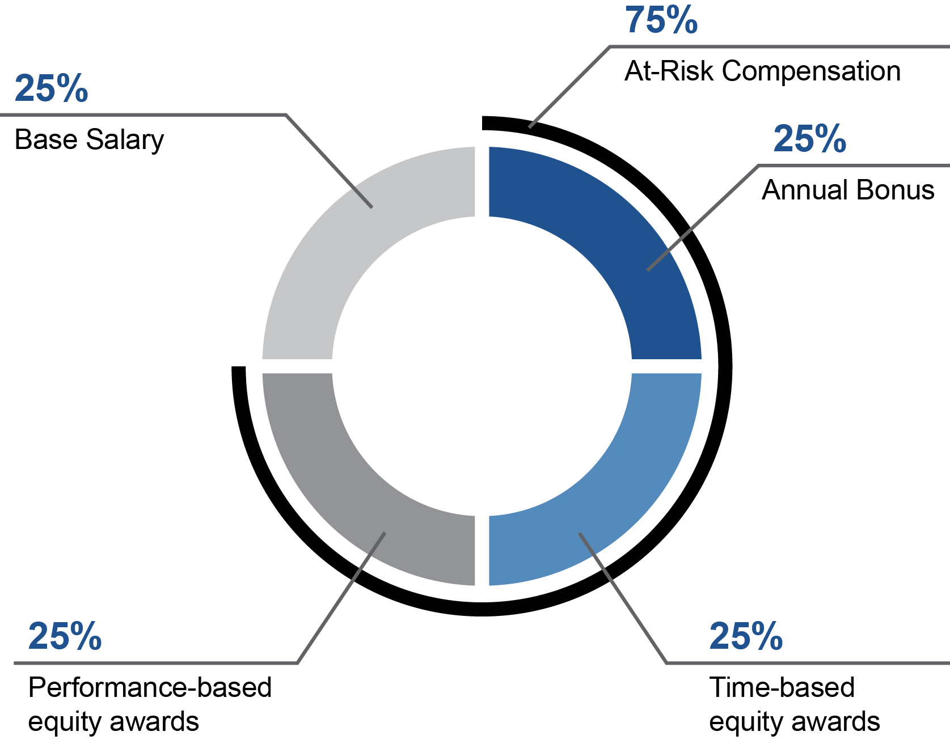 | 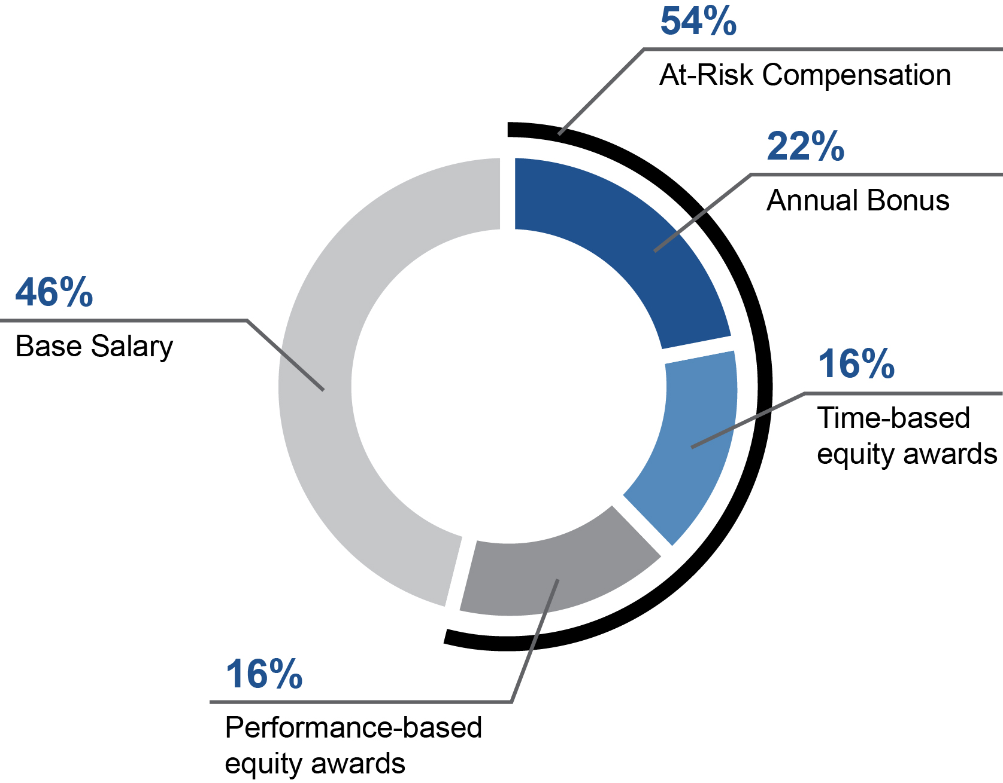

24 Strattec | 2026 Proxy Statement

Compensation Discussion and Analysis / Executive Compensation Decision-Making Process

Base Salary. Base salaries are intended to compensate our NEOs based on their roles with the Company. For each NEO, base salaries are reviewed annually subject to adjustments based upon Company financial performance, the individual performance of the particular executive, and the competitiveness of their base salaries relative to market median results. Our Compensation Committee typically establishes base salaries for the new fiscal year for our executive officers at its regular meeting in August of each year. The new base salaries take effect on January 1 of the following year. Merit increases for NEOs in fiscal 2026 ranged from 3% to 7% and were differentiated based on individual performance, market positioning, and the executives role in achieving the Company's strategic and financial objectives. Salaries continued to reasonably approximate market medians following these increases, consistent with the Company’s pay philosophy.
Short-Term Incentive Plan (STIP). The Compensation Committee believes that performance-based annual cash incentives are an effective way to motivate executives and certain other non-executive employees to achieve short-term specific Company financial goals. In accordance with this philosophy, the Company's approach to annual incentives focuses on objective financial results rather than other subjective factors.
Participants in our STIP, including our NEOs and substantially all U.S. employees, have an opportunity to earn an annual cash bonus based on achievement of certain performance targets tied to achieving our annual operating budget. Actual annual bonuses paid can range from 0% to 200% of a participant’s target bonus opportunity to the degree actual performance fails to meet or exceeds our target expectations. Target bonus opportunities for our NEOs were unchanged from fiscal 2026, reflect market medians for executives in similar roles at companies of comparable size and can produce median cash compensation (salary and bonus) when target goals are achieved.
The following table summarizes the fiscal 2026 annual bonus opportunity for named executive officers:

 |  | STIP Opportunity
 |  | Percentage of Base Salary |  |  |  |  |  |  | Total Opportunity
Named Executive Officer |  | Minimum |  | Target |  | Maximum |  | Minimum |  |  |  |  |  | Target |  |  |  |  |  | Maximum
Jennifer Slater |  | 0% |  | 100% |  | 200% |  |  | $ | - |  |  |  |  | $ | 700,000 |  |  |  |  | $ | 1,400,000
Matthew Pauli |  | 0% |  | 60% |  | 120% |  |  |  | - |  |  |  |  |  | 290,400 |  |  |  |  |  | 580,800
Chey Becker-Varto |  | 0% |  | 45% |  | 90% |  |  |  | - |  |  |  |  |  | 162,450 |  |  |  |  |  | 324,900
Richard Messina |  | 0% |  | 35% |  | 70% |  |  |  | - |  |  |  |  |  | 132,510 |  |  |  |  |  | 265,020

For fiscal 2026, as in fiscal 2025, 100% of each participant’s annual bonus payout was dependent on the achievement of our consolidated financial goals. This increases the focus on accomplishment of our shared objectives, underscores the importance of transforming the Company, and supports transformation efforts and implementation of a long-term strategy for the Company. STIP payments for fiscal 2026 were based on two equally weighted financial metrics that we consider critical to our long-term strategy to increase value for shareholders: Adjusted EBITDA and Cash Flow from Operations.
Adjusted EBITDA was defined as net income before interest expense, income taxes, depreciation and amortization, further adjusted for certain items, to be consistent with target setting and financial results as reported to shareholders on a quarterly basis. These adjustments included restructuring and similar charges, cancelled program settlements, executive transition costs, and business transformation costs. For purposes of STIP, Adjusted EBITDA is determined on a constant currency basis consistent with the Company’s annual operating plan and target setting. The Committee retained discretion to exclude or include unusual items to ensure executive compensation appropriately reflected underlying operating performance. The Committee did not make any such adjustments in fiscal 2026.
The performance targets for each metric were approved by the Compensation Committee and were aligned with our annual operating budget, which takes into account our recent financial results, plans for the coming year, market conditions, and the general economic environment. Performance ranges around target hold management accountable for achieving goals, motivate them to exceed those expectations, reflect the practices of peers and other companies and consider the degree of difficulty of achieving minimum and maximum performance levels. The table below shows the Company’s fiscal 2026 STIP financial targets, actual results and the resulting annual incentive payout percentage (in millions, except percentages):

www.strattec.com 25

Compensation Discussion and Analysis / Executive Compensation Decision-Making Process

Performance Metric | <Threshold |  |  |  |  |  | Threshold |  |  |  |  |  | Target |  |  |  |  |  | Maximum |  |  |  |  |  | FY2026  Result
Adjusted EBITDA | $ | <34.0 |  |  |  |  |  | $ | 34.0 |  |  |  |  | $ | 42.5 |  |  |  |  | $ | 59.5 |  |  |  |  | $ | 54.1
Cash Flow from Operations | $ | <34.0 |  |  |  |  |  | $ | 34.0 |  |  |  |  | $ | 42.5 |  |  |  |  | $ | 59.5 |  |  |  |  | $ | 46.3
Payout % of Target Opportunity |  |  | 0 | % |  |  |  |  | 50 | % |  |  |  |  | 100 | % |  |  |  |  | 200 | %

Based on these financial results, annual bonuses for our NEOs were achieved at 145.2% of target and are reported in the Summary Compensation Table. Actual bonus payouts for fiscal 2025 equaled 200% of target.
Long-term equity incentive awards. We believe a significant portion of executive compensation should be made in the form of equity awards because of the strong alignment to the value created for shareholders. If the Company’s stock price declines, so does the value of this component of our NEOs’ compensation, and vice versa.
The Committee generally approves annual grants of long-term equity incentive awards to our NEOs and other employees on a single date each year (following the Compensation Committee's first regular meeting of each fiscal year). While the vast majority of awards to NEOs and other employees have historically been made as part of the Company's annual grant program, the Committee occasionally makes awards to NEOs or other employees at other times, such as in connection with hiring, promotions, or for retention purposes. The timing of equity award grants to our executive officers is not coordinated in a manner that intentionally benefits our executive officers. The Company does not grant stock options, stock appreciation rights, or similar instruments with option-like features and has no policies or practices to disclose pursuant to Item 402(x)(1) of Regulation S-K.
Our annual long-term incentive program consists of a combination of restricted stock awards ("RSAs"), which vest based entirely on continued service, and performance stock units ("PSUs"), which vest based on achievement of long-term financial performance goals as well as continued service.
In determining the annual long-term incentives for our NEOs in fiscal 2026, the Committee considered the median long-term incentive opportunities awarded to executives of peer companies and the appropriate mix of time- and performance-based equity awards. Based on those considerations, one-half (50%) of each NEO's target long-term incentive opportunity was delivered in RSAs, which solely vest with the passage of time, and one-half (50%) was delivered in PSUs, which will vest based on meeting certain long-term financial performance goals as well as continued service. This mix reflects the practices of our peers, achieves balance between awards aimed at retaining executives (RSAs) and those intended to motivate them to achieve long-term results (PSUs), and supports a performance-oriented culture. The Company's practices in these areas remained unchanged from the structure of the awards it made in fiscal 2025.
Restricted Stock. RSAs vest in one-third increments on each of the three anniversaries following the grant date, subject to continued service through the vesting date. The actual number of RSAs granted to participants are determined by dividing the target value by the average closing price of our stock over the 20 trading days immediately preceding the grant date. The amount ultimately earned with respect to RSAs will be a result of the performance of the Company’s stock price during the vesting period.
Performance Stock Units. PSUs have a three-year performance period, with vesting based on achievement of financial targets as well as the executive’s continued service through the end of the period. If the performance goals are met at the end of the performance period, PSUs are settled in an equivalent number of shares of our common stock. The amount ultimately earned for PSUs will be a result of the performance of the Company’s stock price, as well as the Company’s performance against pre-established financial goals for the three-year performance period. A new three-year performance cycle starts annually with grants made in the first quarter of each fiscal year. The financial metrics and performance goals to earn threshold, target and maximum awards also are determined by the Compensation Committee at the start of each cycle considering our historical performance, peer benchmarking, Company annual operating plan, the state of the automotive industry and other external economic factors.
The potential vesting for the PSUs granted in fiscal 2026 are based on the Company’s achievement of performance goals for EBITDA margin (percentage) over a three-year period. At the start of the cycle, the Committee approved an EBITDA margin target for the first year of the cycle based on the Company’s annual operating plan. In addition, the Committee approved annual levels of margin improvement that would be applied to the prior year’s results to determine the performance targets for the two subsequent years. The target rates of improvement for years two and three of the awards are 50 basis points for the fiscal 2026 grant. Average achievement of each year’s target results determines the final vesting of the PSUs which can range from 50% (threshold) to 200% (maximum) of target, predicated on achieving 80% to 120% of the target EBITDA margin. The Company first awarded PSUs in fiscal 2025 (covering fiscal years 2025, 2026, and 2027) and has not completed the first performance cycle of such awards.
26 Strattec | 2026 Proxy Statement

Compensation Discussion and Analysis / Executive Compensation Decision-Making Process

Retirement and Other Benefits. The Company also provides additional benefit programs to its employees, including NEOs, to attract and retain them as well as to provide a competitive total compensation program.
Our NEOs participate in other benefit plans generally available to all employees on the same terms as similarly situated employees, including participation in medical, health, including health savings accounts, dental, disability, life insurance and 401(k) plans. The Company match in our 401(k) plan is 100% on the first 5% of an employee’s annual wages, up to the federal limit.
In addition, our NEOs each receive at least two times their annual base salary, up to $500,000, of group term life insurance coverage and participate in a supplemental executive retirement plan ("SERP"). Under the SERP, which has a five year vesting schedule, participant accounts are credited with 8% of base salary and cash bonus each December 31, plus accrued interest at 120% of the long-term applicable Federal Rate published by the Internal Revenue Service. A lump-sum benefit is the only distribution option available under the SERP. The SERP allows the Company to provide NEOs with competitive retirement benefits, which are limited for highly compensated employees under the Company's qualified retirement plan due to statutory limits on compensation and benefits under the Internal Revenue Code.
Tax Deductibility. Section 162(m) of the Internal Revenue Code generally places an annual limit of $1 million on the amount of compensation paid to certain “covered employees” (which include our Named Executive Officers) that may be deducted by the Company. The Compensation Committee believes that shareholder interests are best served if it retains discretion and flexibility in awarding executive compensation. Even though some compensation awards may result in non-deductible compensation expenses, the Compensation Committee intends to maintain strong pay-for-performance alignment of executive compensation arrangements.

Summary Compensation Table
The following table sets forth information concerning compensation earned or paid to the Company's Named Executive Officers during fiscal 2026. Prior-year compensation information is presented only to the extent required by the SEC rules applicable to each executive officer for the periods presented.

Name and Principal Position |  | Fiscal  Year |  | Salary (1) |  |  |  | Bonus (2) |  |  |  |  |  | Stock  Awards (3) |  |  |  | Non-Equity  Incentive Plan  Compensation (4) |  |  |  |  |  | All Other  Compensation (5) |  |  |  |  |  | Total
Jennifer Slater |  | 2026 |  | $ | 675,000 |  |  |  | $ | 150,000 |  |  |  | $ | 1,372,950 |  |  |  | $ | 1,016,400 |  |  |  |  | $ | 195,404 |  |  |  | $ | 3,409,754
President &  Chief Executive Officer |  | 2025 |  | $ | 650,000 |  |  |  | $ | 550,000 |  |  |  | $ | 2,804,248 |  |  |  | $ | 1,300,000 |  |  |  |  | $ | 73,818 |  |  |  | $ | 5,378,066
Matthew Pauli |  | 2026 |  | $ | 477,000 |  |  |  | $ | — |  |  |  | $ | 474,660 |  |  |  | $ | 421,661 |  |  |  |  | $ | 107,825 |  |  |  | $ | 1,481,146
Senior Vice President &  Chief Financial Officer |  | 2025 |  | $ | 299,173 |  |  |  | $ | — |  |  |  | $ | 212,520 |  |  |  | $ | 564,000 |  |  |  |  | $ | 11,872 |  |  |  | $ | 1,087,565
Chey Becker-Varto |  | 2026 |  | $ | 355,500 |  |  |  | $ | — |  |  |  | $ | 230,040 |  |  |  | $ | 235,877 |  |  |  |  | $ | 72,355 |  |  |  | $ | 893,772
Senior Vice President &
Chief Commercial Officer
Richard Messina |  | 2026 |  | $ | 365,320 |  |  |  | $ | — |  |  |  | $ | 108,540 |  |  |  | $ | 192,405 |  |  |  |  | $ | 62,610 |  |  |  | $ | 728,875
Former Senior Vice President &  Chief Technology Officer |  | 2025 |  | $ | 353,220 |  |  |  | $ | 101,400 |  |  |  | $ | 110,666 |  |  |  | $ | 247,254 |  |  |  |  | $ | 62,413 |  |  |  | $ | 874,953
 |  | 2024 |  | $ | 343,000 |  |  |  | $ | — |  |  |  | $ | 63,156 |  |  |  | $ | 132,655 |  |  |  |  | $ | 45,170 |  |  |  | $ | 583,981

Explanatory Notes for Summary Compensation Table:
(1)
Amount represents annual salary paid in the fiscal year.
(2)
Amount represents a retention bonus for Ms. Slater in accordance with her initial employment offer and a retention bonus for Mr. Messina associated with executive transitions.
(3)
The amounts reported in this column represent the aggregate grant date fair value of RSAs and PSUs granted in fiscal 2026, as computed in accordance with Financial Accounting Standards Board Accounting Standards Codification Topic 718. These amounts reflect the accounting cost that will be incurred by the Company over the requisite service period beginning at the date of grant and do not represent the actual economic value that may be realized by the NEO. For information on the assumptions used to calculate the grant date fair value of awards, please see the notes to our consolidated financial statements included in our Annual Report on Form 10-K for the year-ended June 28, 2026.
(4)
Non-Equity Incentive Plan Compensation amounts represent annual incentive bonuses earned during the fiscal year but paid in August of the following year.
(5)
All other compensation includes the following:

www.strattec.com 27

Compensation Discussion and Analysis / Executive Compensation Decision-Making Process

Name |  | Year |  | 401(k)  Match |  |  |  |  |  | SERP  Contribution |  |  |  |  |  | Life  Insurance |  |  |  |  |  | Perquisites |  |  |  |  |  |  | Total
Jennifer Slater |  | 2026 |  |  | $ | 19,021 |  |  |  |  | $ | 156,000 |  |  |  |  | $ | 1,380 |  |  |  |  | $ | 19,003 |  |  |  |  | $ | 195,404
 |  | 2025 |  |  |  | 28,438 |  |  |  |  |  | 26,000 |  |  |  |  |  | 1,380 |  |  |  |  |  | 18,000 |  |  |  |  |  | 73,818
Matthew Pauli |  | 2026 |  |  |  | 23,725 |  |  |  |  |  | 82,720 |  |  |  |  |  | 1,380 |  |  |  |  |  | — |  |  |  |  |  | 107,825
 |  | 2025 |  |  |  | 5,875 |  |  |  |  |  | 5,134 |  |  |  |  |  | 863 |  |  |  |  |  | — |  |  |  |  |  | 11,872
Chey Becker-Varto |  | 2026 |  |  |  | 17,775 |  |  |  |  |  | 53,200 |  |  |  |  |  | 1,380 |  |  |  |  |  | — |  |  |  |  |  | 72,355
Richard Messina |  | 2026 |  |  |  | 12,774 |  |  |  |  |  | 48,456 |  |  |  |  |  | 1,380 |  |  |  |  |  | — |  |  |  |  |  | 62,610
 |  | 2025 |  |  |  | 22,581 |  |  |  |  |  | 38,452 |  |  |  |  |  | 1,380 |  |  |  |  |  | — |  |  |  |  |  | 62,413
 |  | 2024 |  |  |  | 16,750 |  |  |  |  |  | 27,040 |  |  |  |  |  | 1,380 |  |  |  |  |  | — |  |  |  |  |  | 45,170

28 Strattec | 2026 Proxy Statement

Compensation Discussion and Analysis / Executive Compensation Decision-Making Process

Grants of Plan-Based Awards
The following table summarizes information regarding all grants of equity-based and non-equity incentive plan-based awards made to our Named Executive Officers during fiscal 2026.
 | Grant  Date |  | Estimated Future Payouts Under Non-Equity Incentive Plan Awards  ($) |  |  |  |  |  |  |  |  |  | Estimated Future Payouts Under Equity Incentive Plan Awards  (#) |  |  |  |  |  |  |  |  | All other  Stock  Awards:  Number of  Shares of  Stock or  Units  (#) |  |  | Grant Date  Fair Value  of Stock  Awards  ($)
Name | Grant  Date |  | Threshold |  |  | Target |  |  | Maximum |  |  |  | Threshold |  |  | Target |  |  | Maximum
Jennifer Slater
STIP Bonus Opportunity | 8/19/2025 |  |  | — |  | $ | 700,000 |  | $ | 1,400,000 |  |  |  | — |  |  | — |  |  | — |  |  | — |  |  | —
Annual Grant - PSU | 8/22/2025 | (1) |  | — |  |  | — |  |  | — |  |  |  | — |  |  | 10,170 |  |  | 20,340 |  |  | — |  | $ | 686,475
Annual Grant - RSA | 8/22/2025 | (1) |  | — |  |  | — |  |  | — |  |  |  | — |  |  | — |  |  | — |  |  | 10,170 |  | $ | 686,475
Matthew Pauli
STIP Bonus Opportunity | 8/19/2025 |  |  | — |  | $ | 290,400 |  | $ | 580,800 |  |  |  | — |  |  | — |  |  | — |  |  | — |  |  | —
Annual Grant - PSU | 8/22/2025 | (1) |  | — |  |  | — |  |  | — |  |  |  | — |  |  | 3,516 |  |  | 7,032 |  |  | — |  | $ | 237,330
Annual Grant - RSA | 8/22/2025 | (1) |  | — |  |  | — |  |  | — |  |  |  | — |  |  | — |  |  | — |  |  | 3,516 |  | $ | 237,330
Chey Becker-Varto
STIP Bonus Opportunity | 8/19/2025 |  |  | — |  | $ | 162,450 |  | $ | 324,900 |  |  |  | — |  |  | — |  |  | — |  |  | — |  |  | —
Annual Grant - PSU | 8/22/2025 | (1) |  | — |  |  | — |  |  | — |  |  |  | — |  |  | 1,704 |  |  | 3,408 |  |  | — |  | $ | 115,020
Annual Grant - RSA | 8/22/2025 | (1) |  | — |  |  | — |  |  | — |  |  |  | — |  |  | — |  |  | — |  |  | 1,704 |  | $ | 115,020
Richard Messina
STIP Bonus Opportunity | 8/19/2025 |  |  | — |  | $ | 132,510 |  | $ | 265,020 |  |  |  | — |  |  | — |  |  | — |  |  | — |  |  | —
Annual Grant - PSU | 8/22/2025 | (1) |  | — |  |  | — |  |  | — |  |  |  | — |  |  | 804 |  |  | 1,608 |  |  | — |  | $ | 54,270
Annual Grant - RSA | 8/22/2025 | (1) |  | — |  |  | — |  |  | — |  |  |  | — |  |  | — |  |  | — |  |  | 804 |  | $ | 54,270

Explanatory Notes for Grants of Plan-Based Awards Table:
(1)
These awards were granted under the Long-term Equity Incentive Plan. See discussion of the plan in "Compensation Discussion and Analysis".

Stock Awards Vesting
The following table provides information regarding stock awards that vested during fiscal 2026 for each NEO. The value realized upon vesting is based on the closing market price of Strattec Security Corporation common stock on the applicable vesting date and does not necessarily represent cash received by the executive. Amounts shown reflect the aggregate value of shares that vested during the fiscal year before any shares withheld to satisfy applicable tax obligations:

 |  | RSAs |  |  |  |  |  |  |  | PSUs
Name |  | Number of Shares Acquired on Vesting (#) |  |  |  | Value Realized on Vesting ($) |  |  |  | Number of Shares Acquired on Vesting (#) |  |  |  | Value Realized on Vesting ($)
Jennifer Slater |  |  | 30,862 |  |  | $ | 1,196,173 |  |  |  | — |  |  |  | —
Matthew Pauli |  |  | 1,731 |  |  | $ | 117,431 |  |  |  | — |  |  |  | —
Chey Becker-Varto |  |  | - |  |  | $ | - |  |  |  | — |  |  |  | —
Richard Messina |  |  | 2,850 |  |  | $ | 190,770 |  |  |  | — |  |  |  | —

www.strattec.com 29

Compensation Discussion and Analysis / Executive Compensation Decision-Making Process

Outstanding Equity Awards at Fiscal Year End
The following table sets forth information on unvested restricted stock awards and performance share units held by the NEOs as of our fiscal year ending June 28, 2026.

 |  | Stock Awards
Name |  | Grant Date |  | RSA:  Number of  Shares or  Units of  Stock That  Have Not  Vested (#) |  |  |  |  |  | RSA:  Market Value  of Shares or  Units of  Stock That  Have Not  Vested ($) (1) |  |  |  |  |  | PSU:  Equity Incentive  Plan Awards:  Number of  Unearned  Shares, Units or  Other Rights  That Have Not  Vested (#) |  |  |  |  |  | PSU:  Equity Incentive  Plan Awards:  Market or Payout  Value of Unearned  Shares, Units or  Other Rights That  Have Not  Vested ($) (2)
Jennifer Slater |  | 8/22/2025 |  |  |  | 10,170 |  |  |  |  | $ | 840,449 |  | (5) |  |  |  | 20,340 |  |  |  |  | $ | 1,680,898 |  | (7)
 |  | 10/25/2024 |  |  |  | 11,252 |  |  |  |  |  | 929,865 |  | (5) |  |  |  | 33,756 |  |  |  |  |  | 2,789,596 |  | (6)
 |  | 10/25/2024 |  |  |  | 25,236 |  |  |  |  |  | 2,085,503 |  | (3)
Matthew Pauli |  | 8/22/2025 |  |  |  | 3,516 |  |  |  |  | $ | 290,562 |  | (5) |  |  |  | 7,032 |  |  |  |  | $ | 581,124 |  | (7)
 |  | 11/13/2024 |  |  |  | 3,460 |  |  |  |  |  | 285,934 |  | (4)
Chey Becker-Varto |  | 8/22/2025 |  |  |  | 1,704 |  |  |  |  | $ | 140,819 |  | (5) |  |  |  | 3,408 |  |  |  |  |  | 281,637 |  | (7)
Richard Messina |  | 8/22/2025 |  |  |  | 804 |  |  |  |  | $ | 66,443 |  | (5) |  |  |  | 1,608 |  |  |  |  |  | 132,885 |  | (7)
 |  | 8/20/2024 |  |  |  | 1,900 |  |  |  |  |  | 157,016 |  | (5)
 |  | 8/23/2023 |  |  |  | 950 |  |  |  |  |  | 78,508 |  | (5)

(1)
Market value of restricted stock awards equals the closing market price of our common stock on June 26, 2026, the last trading day prior to our fiscal year end of June 28, 2026, of $82.64, multiplied by the number of shares of restricted stock.
(2)
Market value of performance share units equals the closing market price of our common stock on June 26, 2026, the last trading day prior to our fiscal year end of June 28, 2026, of $82.64, multiplied by the maximum number of performance share units that have not vested.
(3)
The shares of restricted stock were granted on October 25, 2024 and represent Ms. Slater's new-hire awards. In aggregate, the shares vest one-third each year over a three year period on the anniversary date of Ms. Slater's hiring (July 1).
(4)
The shares of restricted stock were granted on November 13, 2024 and represent Mr. Pauli's new-hire awards. The shares vest one-third each year over a three year period on the anniversary of the grant date.
(5)
The shares of restricted stock vest one-third each year over a three year period on the anniversary date of the grant date.
(6)
The performance share units granted on October 25, 2024 vest at the end of fiscal year 2027, subject to applicable performance conditions. Performance-to-date exceeds target, therefore PSU awards are shown at maximum vesting potential.
(7)
The performance share units granted on August 22, 2025 vest at the end of fiscal year 2028, subject to applicable performance conditions. Performance-to-date exceeds target, therefore PSU awards are shown at maximum vesting potential.

Stock Ownership Requirements
Ownership of Company stock by executives directly aligns their interests with shareholders. Accordingly, the Company maintains stock ownership guidelines for NEOs equal in value to a multiple of their base salary, with the levels for current NEOs set forth in the table below.
•
CEO: 5x annual base salary
•
Other NEOs: 2x annual base salary
Shares directly and beneficially owned will be counted towards these holding guidelines, as well as time-based restricted share grants prior to vesting. Unvested, unearned PSUs are not counted as part of an executive's stock ownership. Executives are expected to meet these guidelines within 5 years of being in their position and are required to hold all net vested shares from equity awards until they meet their guideline.
30 Strattec | 2026 Proxy Statement

Compensation Discussion and Analysis / Executive Compensation Decision-Making Process

Employment Agreements
Each of our named executive officers has signed an employment agreement. The current term of Ms. Slater’s employment agreement ends on June 30, 2027, subject to automatic renewal thereafter for an additional year each July 1, unless advance notice of non-renewal is provided not less than 60 days prior to the end of the then-current term. The current term of Mr. Pauli’s employment agreement ends on November 12, 2026, subject to automatic renewal for an additional year each November 13 unless advance notice of non-renewal is provided not less than 60 days prior to the end of the then-current term. The current term of Ms. Varto’s employment agreement ends on November 10, 2026, subject to automatic renewal for an additional year each November 11 unless advance notice of non-renewal is provided not less than 60 days prior to the end of the then-current term. The current term of Mr. Messina’s employment agreement ends on June 30, 2027, subject to automatic renewal for an additional year each July 1 unless notice of non-renewal is provided not less than 30 days prior to the end of the then current term.
The following summarizes other principal terms of the employment agreements of our NEOs:
•
each of these executive officers is entitled to a base salary under the employment agreement that is subject to adjustment annually provided that any decrease must be proportional to Company-wide reductions applicable to senior management;
•
each of these executive officers is entitled to participate in our incentive plans, including our annual cash STIP and our 2024 Equity Incentive Plan;
•
each of these executive officers is eligible to participate in any medical, health, dental, disability and life insurance policy that we maintain for the benefit of our other senior management;
•
each of these executive officers will also receive at our expense group term life insurance coverage equal to two times their base salary subject to a maximum amount of coverage equal to $500,000;
•
each of these executive officers has agreed not to compete with us during employment and for a period equal to the shorter of one year following termination of employment or the duration of the employee’s employment with us and has agreed to maintain the confidentiality of our proprietary information and trade secrets during the term of employment and for two years thereafter; and
•
each employment agreement contains severance benefits, which are summarized below under “Post-Employment Compensation.”

Post-Employment Compensation
Potential Payments Upon Termination or Change of Control
The Company has entered into employment agreements with NEOs that provide for severance benefits following certain terminations of employment, including in connection with a change of control (as defined in the respective employment agreements or change of control agreement). The Company does not provide excise tax gross-up payments in connection with any termination benefits, and any change-in-control severance benefits and accelerated vesting of equity awards are subject to a double-trigger requirement, requiring both a change in control and a qualifying involuntary termination of employment. The Compensation Committee believes that these arrangements and their associated terms and benefits are consistent with those commonly provided by the Company's peer group and other publicly traded companies of similar size and are necessary to maintain a competitive executive compensation program.

www.strattec.com 31

Compensation Discussion and Analysis / Post-Employment Compensation

Severance Benefits upon Certain Terminations, Including in Connection with a Change in Control
The following table summarizes benefits available to our NEOs under their respective agreements if certain terminations of employment had occurred in fiscal 2026.

 | Triggering Event |  |  | Benefit |  |  | Jennifer Slater |  | Matthew Pauli |  | Chey Becker-Varto |  | Richard Messina
 | Termination by reason of retirement(1) |  |  | Cash Payment |  |  | Not applicable |  | Not applicable |  | Not applicable |  | None
 |  |  |  | LTI Awards |  |  | Not applicable |  | Not applicable |  | Not applicable |  | All unvested restricted stock awards fully vest and performance stock unit awards, if any, vest at Compensation Committee discretion
 |  |  |  | Certain Benefits and Perquisites |  |  | Not applicable |  | Not applicable |  | Not applicable |  | Amounts payable under any employee benefit plan of the Company in accordance with the terms of such plan
 | Termination by reason of death or disability |  |  | Cash Payment |  |  | Base salary earned but unpaid plus any prior year annual bonus accrued but unpaid, paid in a lump sum within 30 days |  | Base salary earned but unpaid and any prior year annual bonus accrued and unpaid, paid in a lump sum within 30 days |  | Base salary earned but unpaid and any prior year annual bonus accrued and unpaid, paid in a lump sum within 30 days |  | Base salary for a period of six months after termination, less amounts paid pursuant to a disability plan or policy (in the event of disability)
 |  |  |  | LTI Awards |  |  | Outstanding unvested restricted stock awards fully vest and performance stock unit awards vest at target performance |  | Outstanding unvested restricted stock awards fully vest and performance stock unit awards, if any, vest at target performance |  | Outstanding unvested restricted stock awards fully vest and performance stock unit awards, if any, vest at target performance |  | Outstanding unvested restricted stock awards fully vest and performance stock unit awards, if any, vest at target performance
 |  |  |  | Certain Benefits and Perquisites |  |  | Amounts payable under any employee benefit plan of the Company in accordance with the terms of such plan |  | Amounts payable under any employee benefit plan of the Company in accordance with the terms of such plan |  | Amounts payable under any employee benefit plan of the Company in accordance with the terms of such plan |  | Amounts payable under any employee benefit plan of the Company in accordance with the terms of such plan
 | Termination without cause or resignation for good reason |  |  | Severance Payment |  |  | Base salary earned but unpaid and any prior year bonus accrued but unpaid, plus amount equal to any unpaid portion of initial retention bonuses, a pro rata portion of current year actual bonus (if termination occurs on or after January 1), one year’s base salary, and average of prior two year’s bonuses (or target current year bonus if tenure is less than two years), paid in |  | Base salary earned but unpaid and any prior year bonus accrued but unpaid, plus amount equal to one year’s base salary, paid in lump sum within 60 days |  | Base salary earned but unpaid and any prior year bonus accrued but unpaid, plus amount equal to one year’s base salary, paid in lump sum within 60 days |  | Base salary earned but unpaid and any prior year bonus accrued but unpaid, plus amount equal to one year’s base salary, paid in lump sum within 30 days.
32 Strattec | 2026 Proxy Statement

Compensation Discussion and Analysis / Post-Employment Compensation

 |  |  |  |  |  |  | lump sum within 60 days
 |  |  |  | LTI Awards |  |  | Any unvested portion of the Sign-On Equity Grant and Initial Annual Equity Grant vest immediately, with the Initial Annual Equity Grant vesting at target performance and unvested performance stock unit awards fully vest at target performance |  | Any unvested portion of the Sign-On Equity Grant shall fully vest and unvested performance stock unit awards, if any, fully vest at target performance |  | Unvested performance stock unit awards, if any, fully vest at target performance |  | Unvested performance stock unit awards, if any, fully vest at target performance
 |  |  |  | Certain Benefits and Perquisites |  |  | Reimbursement of COBRA premiums for continuation of coverage under medical, dental and vision plans for 12 months |  | Reimbursement of COBRA premiums for continuation of coverage under medical, dental and vision plans for 12 months or until eligible for coverage with new employer |  | Reimbursement of COBRA premiums for continuation of coverage under medical, dental and vision plans for 12 months or until eligible for coverage with new employer |  | Reimbursement of COBRA premiums for continuation of coverage under medical, dental and vision plans for 12 months or until eligible for coverage with new employer
 | Termination without cause or resignation for good reason in connection with a change in control |  |  | Severance Payment |  |  | Any prior year bonus accrued but unpaid, plus amount equal to any unpaid portion of initial retention bonuses, a pro rata portion of current year bonus at target, two times the sum of (A) current base salary, and (B) average of prior two year’s bonuses (or target current year bonus if tenure is less than two years), paid in lump sum within 60 days |  | Any prior year bonus accrued but unpaid, plus an amount equal to 1.5 times the sum of (A) current base salary, and (B) average of prior two year’s bonuses (or target current year bonus if tenure is less than two years), paid in lump sum within 60 days |  | Any prior year bonus accrued but unpaid, plus an amount equal to 1.5 times the sum of (A) current base salary, and (B) average of prior two year’s bonuses (or target current year bonus if tenure is less than two years), paid in lump sum within 60 days |  | Any base salary accrued but unpaid at time of termination, plus a pro rata portion of current year bonus at target, plus an amount equal to the sum of (A) 2 times current base salary, and (B) the highest annual bonus earned in the prior ten years, paid in a lump sum within 30 days.
 |  |  |  | LTI Awards |  |  | Outstanding unvested restricted stock awards fully vest and unvested performance stock unit awards fully vest at target performance |  | Outstanding unvested restricted stock awards fully vest and unvested performance stock unit awards, if any, fully vest at target performance |  | Outstanding unvested restricted stock awards fully vest and unvested performance stock unit awards, if any, fully vest at target performance |  | Outstanding unvested restricted stock awards fully vest and unvested performance stock unit awards, if any, fully vest at target performance
 |  |  |  | Certain Benefits and Perquisites |  |  | Reimbursement of COBRA premiums for continuation of coverage under medical, dental and vision plans for 24 months |  | Reimbursement of COBRA premiums for continuation of coverage under medical, dental and vision plans for 18 months, and up to $10,000 for one year of outplacement services |  | Reimbursement of COBRA premiums for continuation of coverage under medical, dental and vision plans for 18 months, and up to $10,000 for one year of outplacement services |  | Continued payment of company contributions to medical, dental and health insurance premiums under COBRA plus continued life and disability insurance coverage for up to 2 years, plus outplacement services, plus immediate vesting of any deferred compensation
www.strattec.com 33

Compensation Discussion and Analysis / Post-Employment Compensation

 | Termination with cause or resignation without good reason |  |  | Other Terms |  |  | Compensation earned but unpaid |  | Compensation earned but unpaid |  | Compensation earned but unpaid |  | Compensation earned but unpaid

(1)
Mr. Messina was the only NEO eligible for retirement at June 28, 2026.
Summary of Potential Termination Payments and Benefits
The following table summarizes the value of termination payments and benefits that each of our NEOs would have received if they had terminated employment under each of the circumstances shown on June 28, 2026.

Named Executive Officer |  | Retirement (1) |  |  |  |  |  | Death or  Disability |  |  |  |  |  | Termination  for Cause or  Voluntary  Resignation  without  Good  Reason |  |  |  |  |  | Termination  without  Cause or  Resignation  for Good  Reason  (unrelated  to a Change  in Control  Disability) |  |  |  |  | Termination  without  Cause or  Resignation  for Good  Reason in  connection  with a  Change in  Control
Jennifer Slater
Cash Severance |  |  |  | — |  |  |  |  |  | — |  |  |  |  |  | — |  |  |  |  | $ | 850,000 |  |  |  | $ | 1,550,000
Bonus Severance |  |  |  | — |  |  |  |  | $ | 1,016,400 |  |  |  |  |  | — |  |  |  |  | $ | 2,174,600 |  |  |  | $ | 3,332,800
Equity Acceleration (2) |  |  |  | — |  |  |  |  | $ | 6,091,064 |  |  |  |  |  | — |  |  |  |  | $ | 5,250,615 |  |  |  | $ | 6,091,064
Other Benefits |  |  |  | — |  |  |  |  |  | — |  |  |  |  |  | — |  |  |  |  | $ | 21,005 |  |  |  | $ | 42,010
 |  |  |  | — |  |  |  |  | $ | 7,107,464 |  |  |  |  |  | — |  |  |  |  | $ | 8,296,220 |  |  |  | $ | 11,015,873
Matthew Pauli
Cash Severance |  |  |  | — |  |  |  |  |  | — |  |  |  |  |  | — |  |  |  |  | $ | 484,000 |  |  |  | $ | 726,000
Bonus Severance |  |  |  | — |  |  |  |  | $ | 421,661 |  |  |  |  |  | — |  |  |  |  | $ | 421,661 |  |  |  | $ | 632,491
Equity Acceleration (2) |  |  |  | — |  |  |  |  | $ | 867,059 |  |  |  |  |  | — |  |  |  |  | $ | 576,497 |  |  |  | $ | 867,059
Other Benefits |  |  |  | — |  |  |  |  |  | — |  |  |  |  |  | — |  |  |  |  | $ | 32,475 |  |  |  | $ | 58,712
 |  |  |  | — |  |  |  |  | $ | 1,288,720 |  |  |  |  |  | — |  |  |  |  | $ | 1,514,633 |  |  |  | $ | 2,284,262
Chey Becker-Varto
Cash Severance |  |  |  | — |  |  |  |  |  | — |  |  |  |  |  | — |  |  |  |  | $ | 361,000 |  |  |  | $ | 541,500
Bonus Severance |  |  |  | — |  |  |  |  | $ | 235,877 |  |  |  |  |  | — |  |  |  |  | $ | 235,877 |  |  |  | $ | 413,158
Equity Acceleration (2) |  |  |  | — |  |  |  |  | $ | 281,637 |  |  |  |  |  | — |  |  |  |  | $ | 140,819 |  |  |  | $ | 281,637
Other Benefits |  |  |  | — |  |  |  |  |  | — |  |  |  |  |  | — |  |  |  |  |  | — |  |  |  | $ | 10,000
 |  |  |  | — |  |  |  |  | $ | 517,515 |  |  |  |  |  | — |  |  |  |  | $ | 737,696 |  |  |  | $ | 1,246,295
Richard Messina
Cash Severance |  |  |  | — |  |  |  |  | $ | 189,300 |  |  |  |  |  | — |  |  |  |  | $ | 378,600 |  |  |  | $ | 757,200
Bonus Severance |  |  |  | — |  |  |  |  |  | — |  |  |  |  |  | — |  |  |  |  | $ | 192,405 |  |  |  | $ | 247,254
Equity Acceleration (2) |  |  | $ | 368,409 |  |  |  |  | $ | 368,409 |  |  |  |  |  | — |  |  |  |  | $ | 66,443 |  |  |  | $ | 368,409
Other Benefits |  |  | $ | 430,205 |  |  |  |  | $ | 430,205 |  |  |  |  |  | — |  |  |  |  | $ | 21,422 |  |  |  | $ | 52,844
 |  |  | $ | 798,614 |  |  |  |  | $ | 987,914 |  |  |  |  |  | — |  |  |  |  | $ | 658,869 |  |  |  | $ | 1,425,707

(1)
Mr. Messina was the only NEO eligible for retirement benefits as of June 28, 2026
(2)
Values for these amounts are based on the closing price of our common stock on June 26, 2026, the last trading day prior to our fiscal year-end of June 28, 2026, of $82.64.
34 Strattec | 2026 Proxy Statement

Compensation Discussion and Analysis / Post-Employment Compensation

Equity Compensation Plan Information
The following table sets forth certain information as of June 28, 2026 concerning our equity compensation plans:
Plan Category | Number of Common  Shares to Be Issued  Upon Exercise of  Outstanding Options,  Warrants and Rights(1) |  |  |  |  |  | Weighted-  Average  Exercise Price of  Outstanding Options,  Warrants and Rights(2) |  |  |  |  |  | Number of Common  Shares Available for  Future Issuance  Under Equity  Compensation Plans(3)
Equity compensation plans approved by shareholders |  |  | 35,533 |  |  |  |  |  | — |  |  |  |  |  | 364,808
Equity compensation plans not approved by shareholders |  |  | — |  |  |  |  |  | — |  |  |  |  |  | —
Total |  |  | 35,533 |  |  |  |  |  | — |  |  |  |  |  | 364,808

(1)
Amount represents target awards of performance-based restricted stock units granted pursuant to the 2024 Equity Incentive Plan, the vesting of which is contingent upon corporate performance measured by EBITDA margin/percentage performance during the applicable three-year performance period commencing in the year of grant. Amount does not include outstanding awards of service-based restricted shares totaling 90,402 which are subject to pro-rata vesting on the first three anniversaries of the grant dates, conditioned upon continued employment of the participants on such anniversary dates.
(2)
The weighted average exercise price is not determinable for the awards of performance-based shares described in footnote (1).
(3)
Amount represents shares available for future issuance under the 2024 Equity Incentive Plan at June 28, 2026.
www.strattec.com 35

Compensation Discussion and Analysis / Pay Versus Performance Disclosure

Pay Versus Performance Disclosure
As required by Section 953(a) of the Dodd-Frank Wall Street Reform and Consumer Protection Act of 2010 and Rule 402(v) of Regulation S-K, we are providing the following information regarding the relationship between executive compensation actually paid ("CAP") to our principal executive officer ("PEO") and our non-PEO named executive officers ("Non-PEO NEOs") and certain financial performance of the Company.
Amounts included as CAP do not represent the value of cash compensation and equity awards actually received by our PEO and Non-PEO NEOs but instead are amounts calculated pursuant to Commission rules and which result in adjustments to the amounts reported above in the summary compensation table. For further information concerning the Company's pay-for-performance philosophy and how we seek to align executive compensation with performance, refer to “Executive Compensation.” Our Compensation Committee did not consider the following Pay Versus Performance analysis and disclosures in making compensation decisions with respect to any fiscal year shown below.

Pay Versus Performance Table

Fiscal Year |  | Summary  Compensation  Table Total for  the First PEO (1) |  |  |  |  |  | Compensation  Actually Paid  to First  PEO ($) (2) (3) |  |  |  |  |  | Summary  Compensation  Table Total for  the Second  PEO (1) |  |  |  |  |  | Compensation  Actually Paid  to Second  PEO ($) (2) (3) |  |  |  |  |  | Average  Summary  Compensation  Total for Non-  PEO NEOs(1) (4) |  |  |  |  |  | Average  Compensation  Actually Paid to  Non-PEO  NEOs (3) |  |  |  |  |  | Value of Initial  Fixed $100  Investment  Based  on Total  Shareholder  Return (TSR) (5) |  |  |  |  |  | Value of Initial  Fixed $100  Investment  Based  on Peer Group Total  Shareholder  Return (TSR) (6) |  |  |  |  |  | Net (Loss)  Income (7)
2026 |  |  | $ | 3,409,754 |  |  |  |  | $ | 5,224,512 |  |  |  |  | $ | — |  |  |  |  | $ | — |  |  |  |  | $ | 1,034,598 |  |  |  |  | $ | 1,150,430 |  |  |  |  | $ | 455.57 |  |  |  |  | $ | 86.61 |  |  |  | $ |  | 20,598,000
2025 |  |  | $ | 5,352,066 |  |  |  |  | $ | 7,097,945 |  |  |  |  | $ | — |  |  |  |  | $ | — |  |  |  |  | $ | 1,063,825 |  |  |  |  | $ | 1,204,957 |  |  |  |  | $ | 336.38 |  |  |  |  | $ | 71.21 |  |  |  | $ |  | 18,685,000
2024 |  |  | $ | 737,445 |  |  |  |  | $ | 805,641 |  |  |  |  | $ | 795,876 |  |  |  |  | $ | 839,093 |  |  |  |  | $ | 585,006 |  |  |  |  | $ | 625,550 |  |  |  |  | $ | 137.82 |  |  |  |  | $ | 77.79 |  |  |  | $ |  | 16,313,000

(1)
The dollar amounts reported in this column are the total compensation reported in the “Total” column of the Summary Compensation Table for the 2026, 2025 and 2024 fiscal years for the persons serving as PEO and Non-PEO NEOs for such applicable year. The individuals included as our PEO and Non-PEO NEOs for each applicable fiscal year are set forth in the following table (note that during fiscal year 2024, Mr. Krejci served as our PEO for six months until his retirement on December 31, 2023 and Rolando Guillot served as our interim PEO for six months from January 1, 2024 through June 30, 2024 so the information provided for our PEO for fiscal year 2024 is based on their pro rated amounts reported.

Fiscal Year |  | First PEO |  | Second PEO |  | Non-PEO Named Executive Officers
2026 |  | Jennifer Slater |  | N/A |  | Matthew Pauli, Chey Becker-Varto, Richard Messina
2025 |  | Jennifer Slater |  | N/A |  | Matthew Pauli, Rolando Guillot
2024 |  | Frank Krejci |  | Rolando Guillot |  | Richard Messina, Al-Waleed Hamdan

(2)
The dollar amounts reported in this column represent the amount of compensation actually paid for our PEO as computed in accordance with Item 402(v) of Regulation S-K.
36 Strattec | 2026 Proxy Statement

Compensation Discussion and Analysis / Pay Versus Performance Disclosure

(3)
The following table provides the adjustments to the Summary Compensation Table “Total” compensation column to determine our PEO's compensation actually paid and our Non-PEO NEOs average compensation actually paid:

 |  | 2026 |  |  |  |  |  |  |  |  |  |  |  | 2025 |  |  |  |  |  |  |  |  |  |  |  | 2024
 |  | First PEO ($) |  |  |  |  |  | Average for  Non-PEO  NEOs ($) |  |  |  |  |  | First PEO ($) |  |  |  |  |  | Average for  Non-PEO  NEOs ($) |  |  |  |  |  | First PEO ($) |  |  |  |  |  | Second  PEO ($) |  |  |  |  |  | Average for  Non-PEO  NEO ($)
Summary Compensation Table Total: |  |  | $ | 3,409,754 |  |  |  |  | $ | 1,034,598 |  |  |  |  | $ | 5,378,066 |  |  |  |  | $ | 1,063,825 |  |  |  |  | $ | 737,445 |  |  |  |  | $ | 795,876 |  |  |  |  | $ | 585,006
Adjustments:
Deduction for Amounts Reported in the “Stock Awards” Column in the Summary Compensation Table: |  |  | $ | (1,372,950 | ) |  |  |  | $ | (271,080 | ) |  |  |  | $ | (2,804,248 | ) |  |  |  | $ | (207,736 | ) |  |  |  | $ | (113,016 | ) |  |  |  | $ | (76,452 | ) |  |  |  | $ | (69,804 | )
Increase for fair value of awards granted during the covered fiscal year that vested during the covered fiscal year: |  |  |  | — |  |  |  |  |  | — |  |  |  |  |  | — |  |  |  |  |  | — |  |  |  |  | $ | 129,234 |  |  |  |  |  | — |  |  |  |  |  | —
Increase for fair value of awards granted during the covered fiscal year that remain outstanding and unvested as of the covered fiscal year end: |  |  | $ | 1,680,898 |  |  |  |  | $ | 331,882 |  |  |  |  | $ | 4,524,127 |  |  |  |  | $ | 263,637 |  |  |  |  |  | — |  |  |  |  | $ | 86,250 |  |  |  |  | $ | 78,750
Increase (deduction) for year-over-year change in fair value at covered fiscal year end of awards granted in any prior fiscal year that were outstanding and unvested at the covered fiscal year end: |  |  | $ | 1,423,886 |  |  |  |  | $ | 45,474 |  |  |  |  |  | — |  |  |  |  | $ | 62,135 |  |  |  |  |  | — |  |  |  |  | $ | 23,324 |  |  |  |  | $ | 19,208
Increase (deduction) for change in vesting date fair value of awards granted during the prior fiscal years that vested during the covered fiscal year compared to fair value of awards of prior fiscal year end: |  |  | $ | 82,924 |  |  |  |  | $ | 9,556 |  |  |  |  |  | — |  |  |  |  | $ | 23,096 |  |  |  |  | $ | 51,978 |  |  |  |  | $ | 10,095 |  |  |  |  | $ | 12,390
Total Adjustments: |  |  | $ | 1,814,758 |  |  |  |  | $ | 115,832 |  |  |  |  | $ | 1,719,879 |  |  |  |  | $ | 141,132 |  |  |  |  | $ | 68,196 |  |  |  |  | $ | 43,217 |  |  |  |  | $ | 40,544
Compensation Actually Paid: |  |  | $ | 5,224,512 |  |  |  |  | $ | 1,150,430 |  |  |  |  | $ | 7,097,945 |  |  |  |  | $ | 1,204,957 |  |  |  |  | $ | 805,641 |  |  |  |  | $ | 839,093 |  |  |  |  | $ | 625,550

(4)
The dollar amounts reported in this column represent the average of the amounts reported for our Non-PEO named executive officers as a group in the “Total” column of the Summary Compensation Table in each applicable year.
(5)
The amounts reported in this column reflect our cumulative TSR, assuming an initial fixed $100 investment in our Common Stock starting June 30, 2023 through the end of each listed fiscal year. Cumulative TSR is calculated by dividing the sum of cumulative amount of dividends for the measurement period, assuming dividend reinvestment, and the difference between our stock price at the end and the beginning of the measurement period by our stock price at the beginning of the measurement period. No dividends were paid on our Common Stock during fiscal 2026, 2025, or 2024.
(6)
The amounts reported in this column reflect the cumulative TSR of the Nasdaq US Benchmark Auto Parts TR Index, which we have selected as our peer group for purposes of this disclosure, assuming an initial fixed $100 investment in the Index starting June 30, 2023 through the end of each listed fiscal year. Cumulative TSR is calculated by dividing the sum of the cumulative amount of dividends for the measurement period, assuming dividend reinvestment, and the difference between the Index value at the end and the beginning of the measurement period by the Index value at the beginning of the measurement period.
(7)
The dollar amounts reported represent the amount of net (loss) income attributable to Strattec’s shareholders as reflected in our consolidated financial statements for each applicable year.

Relationship Between Compensation Actually Paid and Performance Measures
As described above under “Compensation Discussion and Analysis,” Strattec generally seeks to (1) provide strong financial incentives, at reasonable cost, for positive financial performance and enhanced value of our shareholders’ investment and (2) use
www.strattec.com 37

Compensation Discussion and Analysis / Pay Versus Performance Disclosure

cash bonus plans to recognize positive short-term performance and equity based plans to support the long-term needs and goals of Strattec and our shareholders. We, therefore, do not specifically align our performance measures with “compensation actually paid” as determined under Item 402(v) of Regulation S-K for a particular fiscal year. Nonetheless, in accordance with such rule we are providing the following descriptions of the relationships between information presented in the above Pay Versus Performance Table. The following charts illustrate how “compensation actually paid” as determined under Item 402(v) of Regulation S-K to our PEO and the average “compensation actually paid” to our non-PEO NEOs aligns with our financial performance as measured by our TSR and our net income (loss) for the past three fiscal years:
Compensation Actually Paid and Net (Loss) Income:

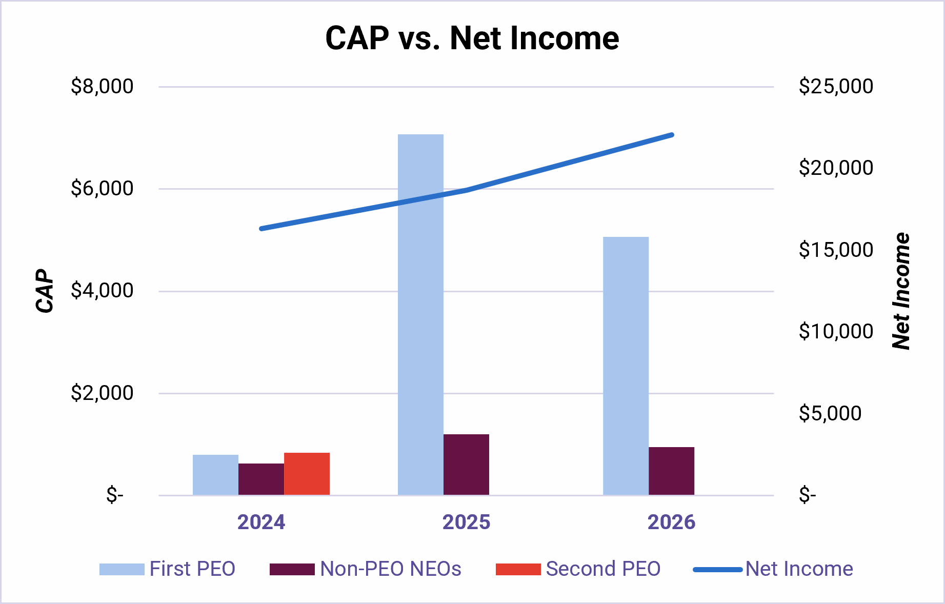
Compensation Actually Paid and Cumulative TSR:

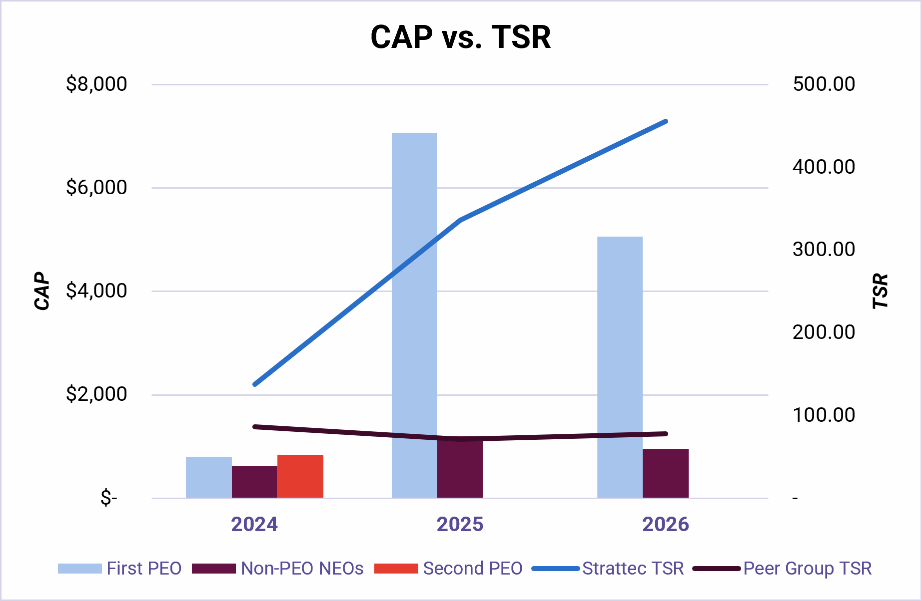

All information provided above under the “Pay Versus Performance Disclosure” heading will not be deemed to be incorporated by reference in any filing of the Company under the Securities Act of 1933, as amended, or the Securities Exchange Act of 1934, as amended, whether made before or after the date hereof and irrespective of any general incorporation language in any such filing.

CEO Pay Ratio
As required by Section 953(b) of the Dodd-Frank Wall Street Reform and Consumer Protection Act and Item 402(u) of Regulation S-K, we are providing the following information regarding the relationship of the annual total compensation of our Chief Executive Officer to the annual total compensation of our median employee.
38 Strattec | 2026 Proxy Statement

Compensation Discussion and Analysis / Pay Versus Performance Disclosure

To identify our median employee, we reviewed the compensation of all individuals employed by the Company and its subsidiaries as of June 28, 2026, excluding our Chief Executive Officer. In determining the median employee, a listing of all employees (the Company’s full employee population, but excluding the CEO) employed during fiscal 2026, was prepared and the Company identified a “consistent compensation measure” to determine the median employee. For the consistent compensation measure, the Company looked to annualized base salaries of employees, as it represents the primary compensation component paid to all of our employees. Non-U.S. employees were included in the determination of the median employee compensation, with the salary amounts of such non-U.S. employees converted to U.S. dollars using the applicable exchange rate as of June 28, 2026. After identifying the median employee, we calculated annual total compensation for that employee using the same methodology required for determining annual total compensation reported for Ms. Slater in the Summary Compensation Table.
For fiscal 2026:
•
Annual total compensation of our Chief Executive Officer, Ms. Slater, as reported in the Summary Compensation Table: $3,409,754
•
Annual total compensation of our median employee: $12,098

Based on the methodology described above, we determined that the ratio of the annual total compensation of our Chief Executive Officer to the annual total compensation of our median employee for fiscal 2026 was 282 to 1. Approximately 85% of Strattec’s employee population is employed in manufacturing operations outside the United States. As a result, compensation practices, local wage rates, labor markets, and currency exchange rates may significantly influence the reported pay ratio from year to year and relative to other public companies. The SEC rules for identifying the median compensated employee and calculating the pay ratio based on that employee’s annual total compensation allow companies to adopt a variety of methodologies, to apply certain exclusions, and to make reasonable estimates and assumptions that reflect their compensation practices. Accordingly, the pay ratio reported by other companies may not be comparable to the pay ratio reported above, as other companies may have different employment and compensation practices and may utilize different methodologies, exclusions, estimates and assumptions in calculating their own pay ratios.

Compensation Risk Assessment
The Compensation Committee annually reviews the Company's compensation programs and policies to determine whether they create risks that are reasonably likely to have a material adverse effect on the Company. In conducting this assessment, the Committee considers the design of the Company's executive and broad-based employee compensation programs, performance metrics, payout opportunities, governance controls, and risk mitigation features.
The Committee believes that the Company's compensation programs do not encourage excessive or unnecessary risk-taking for several reasons, including:
•
The use of a balanced mix of fixed and variable compensation.
•
Annual and long-term incentive opportunities that are linked to a financial performance objectives.
•
Compensation programs that promote sustained performance and long-term stockholder value creation rather than short-term results.
•
Limits on incentive award opportunities and payouts.
•
Oversight by the Compensation Committee in the establishment of performance goals and the review of performance results.
•
Stock ownership guidelines and anti-hedging and anti-pledging policies applicable to executive officers and directors.
•
A clawback policy permitting recovery of certain incentive compensation as required by applicable SEC and Nasdaq rules.
•
Internal controls and governance processes designed to monitor the achievement of performance objectives and the accuracy of related financial and operational results.

Based on its review, the Compensation Committee believes that the design of the Company’s compensation program does not encourage employees to take unnecessary or excessive risks that could harm the Company’s long-term value.

Hedging, Margin Account, and Pledging Account Policies
Our stock trading policies prohibit our directors and employees, including our executive officers, from: (a) purchasing any financial instrument, or otherwise engaging in any transaction, that is designed to hedge or offset any decrease in the market value of our Common Stock, including prepaid forward contracts, equity swaps, zero-cost collars and forward sale contracts; (b) engaging in short sales related to our common stock; (c) maintaining margin accounts holding Strattec securities and (d) pledging Strattec securities as collateral for any loan. All transactions in Strattec securities by directors and executive officers must be pre-cleared with our Chief Financial Officer or General Counsel under our stock trading policies.

www.strattec.com 39

Compensation Discussion and Analysis / Pay Versus Performance Disclosure

Excess Incentive Compensation Recovery (Clawback) Policy
Our Board of Directors has adopted an Excess Incentive Compensation Recovery (Clawback) Policy. A copy of this policy is available on our website. Under this policy, the Board of Directors will require reimbursement or forfeiture of any excess incentive compensation awarded or paid in the event of an accounting restatement resulting from material noncompliance with financial reporting requirements under federal securities laws. The excess incentive compensation recovery covers all awards granted or paid during the last three completed fiscal years. The amount to be recovered is the excess amount of the incentive compensation received by the executive officer based on the erroneous data from the accounting restatement.
40 Strattec | 2026 Proxy Statement

Compensation Discussion and Analysis / Pay Versus Performance Disclosure

Report of the Compensation Committee
The Compensation Committee has reviewed and discussed with management the Compensation Discussion and Analysis contained in this Proxy Statement. In connection with its review, the Compensation Committee considered the Company's executive compensation philosophy, compensation objectives, compensation program design, compensation decisions for the Named Executive Officers, and the relationship between executive compensation and Company performance.
Based on its review and discussions with management, the Compensation Committee concluded that the Compensation Discussion and Analysis accurately describes the Company's executive compensation programs and policies and recommended to the Board of Directors that the Compensation Discussion and Analysis be included in in this Proxy Statement and incorporated by reference in Strattec Security Corporation's Annual Report on Form 10-K for fiscal 2026.
Submitted by the Compensation Committee of the Board of Directors:

COMPENSATION COMMITTEE:
Thomas W. Florsheim, Jr. — Chair
Tina Chang
F. Jack Liebau, Jr.
Bruce M. Lisman
Matteo Anversa

www.strattec.com 41

Audit Matters / Proposal 3: Approval of the Ratification of the Appointment of Independent Registered Public Accounting Firm

AUDIT MATTERS

Proposal 3: Approval of the Ratification of the Appointment of Independent Registered Public Accounting Firm

Board of Directors Recommendation

Our Board of Directors unanimously recommends voting "FOR" ratification of the appointment of Deloitte & Touche LLP as our independent registered public accounting firm for the fiscal year ending June 27, 2027.

The Proposal
Deloitte & Touche LLP has been our independent registered public accounting firm since 2023, and has performed an audit of our consolidated financial statements for the fiscal year ended June 28, 2026 and the effectiveness of our internal control over financial reporting as of June 28, 2026. The Board of Directors recommends that the shareholders ratify the appointment of Deloitte & Touche LLP to audit the consolidated financial statements of the Company and the effectiveness of the Company’s internal control over financial reporting for the fiscal year ending June 27, 2027. Shareholder ratification of the appointment of Deloitte & Touche LLP as the Company’s independent auditor is not required by the Company’s bylaws, but the Audit Committee is submitting the appointment of Deloitte & Touche LLP for shareholder ratification because the Audit Committee values shareholders’ views on the Company’s independent auditors. If the shareholders fail to ratify the appointment, the Audit Committee will reconsider whether to retain Deloitte & Touche LLP. The Audit Committee also retains the right to direct the appointment of a different independent accounting firm at any time during the year if it determines that such a change would be in the best interests of the Company and its shareholders. The Audit Committee is solely responsible for retaining or terminating the Company’s independent auditors. A representative of Deloitte & Touche LLP is expected to attend the Annual Meeting.
42 Strattec | 2026 Proxy Statement

Audit Matters / Report of the Audit Committee

Report of the Audit Committee
The Audit Committee is currently comprised of five members of our Board of Directors. Based upon the review described above under “Corporate Governance Matters — Director Independence,” our Board of Directors has determined that each member of the Audit Committee is independent as defined in the applicable listing standards of the NASDAQ Stock Market and the rules of the Commission. The duties and responsibilities of our Audit Committee are set forth in the Audit Committee Charter, which may be found on our website.
In accordance with its written charter adopted by the Board of Directors, our Audit Committee has oversight responsibility for the quality and integrity of the financial reporting practices of Strattec. While the Audit Committee has oversight responsibility, the primary responsibility for our financial reporting, disclosure controls and procedures and internal control over financial reporting and related internal controls and procedures rests with our management, and our independent auditors are responsible for auditing our financial statements. In discharging its oversight responsibility as to the audit process, the Audit Committee has:
•
reviewed and discussed our audited financial statements for the fiscal year ended June 28, 2026 with our management and with our independent auditors;
•
discussed with our independent auditors the matters required to be discussed by the applicable requirements of the Public Company Accounting Oversight Board and the Commission;
•
received and discussed with our independent auditors the written disclosures and the letter from our independent auditors required by applicable requirements of the Public Company Accounting Oversight Board regarding the independent auditor’s communications with the audit committee concerning independence; and
•
met with the independent auditors without management present and discussed the auditor’s independence.
Based on such review and discussions with management and with the independent auditors, the Audit Committee recommended to our Board of Directors that the Strattec audited financial statements be included in our Annual Report on Form 10-K for the fiscal year ended June 28, 2026, for filing with the Commission.

AUDIT COMMITTEE:
Matteo Anversa — Chair
Tina Chang
F. Jack Liebau, Jr.
Bruce M. Lisman
Thomas W. Florsheim, Jr.

www.strattec.com 43

Audit Matters / Fees of the Independent Registered Public Accounting Firm

Fees of Independent Registered Public Accounting Firm
Deloitte & Touche LLP, an independent registered public accounting firm, performed an audit of our consolidated financial statements for the fiscal years ended June 28, 2026 and June 29, 2025 and the effectiveness of our internal control over financial reporting for the same periods. Aggregate fees for professional services rendered for the Company by Deloitte & Touche LLP for the past two fiscal years were as follows:

Service Type |  | Fiscal Year Ending  June 28, 2026 |  |  |  |  |  | Fiscal Year Ending  June 29, 2025
Audit Fees (1) |  |  | $ | 652,433 |  |  |  |  | $ | 710,879
Audit-Related Fees |  |  |  | 1,895 |  |  |  |  |  | 1,895
Tax Fees (2) |  |  |  | 489,990 |  |  |  |  |  | 521,240
All Other Fees |  |  |  | - |  |  |  |  |  | -
Total Fees Billed |  |  | $ | 1,144,318 |  |  |  |  | $ | 1,234,014

(1)
Audit fees were for professional services rendered for the audit of the Company's annual financial statements and related audit of the Company's internal control over financial reporting, the review of quarterly financial statements and the preparation of statutory and regulatory filings. Tax fees include professional services related to annual tax compliance and professional services related to tax planning, tax reform and tax advisory services. In addition to the fees above, the Company also reimbursed Deloitte & Touche for out-of-pocket expenses, which were less than $100,000 in fiscal 2026 and fiscal 2025. The Audit Committee of our Board of Directors considered that the provision of the services and the payment of these fees are compatible with maintaining the independence of Deloitte & Touche LLP.
(2)
The Audit Committee is responsible for reviewing and pre-approving any non-audit services to be performed by our independent auditors. The Audit Committee or the Audit Committee Chairman reviews and, if appropriate, approves non-audit service engagements, taking into account the proposed scope of the non-audit services, the proposed fees for the non-audit services, whether the non-audit services are permissible under applicable law or regulation and the likely impact of the non-audit services on the independence of the independent auditors. The Audit Committee has delegated certain of its pre-approval authority to the Chairman of the Audit Committee to act between meetings of the Audit Committee. Any pre-approval given by the Chairman of the Audit Committee pursuant to this delegation is presented to the full Audit Committee at its next regularly scheduled meeting. Each new engagement of our independent auditors to perform non-audit services has been approved in advance by our Audit Committee or the Chairman of our Audit Committee pursuant to the foregoing procedures.
44 Strattec | 2026 Proxy Statement

Principle Shareholders / Security Ownership

PRINCIPAL SHAREHOLDERS

Security Ownership
The following table sets forth information regarding the beneficial ownership of shares of our Common Stock as of August 14, 2026 by (1) each Director and Named Executive Officer (as defined below), (2) all directors and current executive officers as a group, and (3) each person or other entity known by us to beneficially own more than 5% of our outstanding Common Stock.
We have determined beneficial ownership in accordance with the rules of the Commission. Shares of our Common Stock subject to options that are either currently exercisable or exercisable within 60 days of August 14, 2026 are treated as outstanding and beneficially owned by the option holder for the purpose of computing the percentage ownership of the option holder. However, these shares are not treated as outstanding for the purpose of computing the percentage ownership of any other person. The table lists applicable percentage ownership based on 3,985,013 shares of Common Stock outstanding as of August 14, 2026.

 |  |  |  |  |  |  |  |  |  |  |  |  |  |  | Nature of Beneficial Ownership
Name and Address of Beneficial  Owner (1) |  | Total  Number  Of Shares  Beneficially  Owned |  |  |  |  |  | Percent  of  Class |  |  |  |  |  | Sole  Voting and  Investment  Power |  |  |  |  |  | Sole  Voting or  Investment  Power |  |  |  |  |  | Shared  Voting and  Investment  Power |  |  |  |  |  | Shared  Voting or  Investment  Power |  |  |  |  |  | Sole  Voting  Power  Only (2)
Principal Shareholders:
GAMCO Investors, Inc.(3) |  |  |  | 777,820 |  |  |  |  |  | 19.5 | % |  |  |  |  | 770,520 |  |  |  |  |  | 7,300 |  |  |  |  |  | — |  |  |  |  |  | — |  |  |  |  |  | —
BlackRock, Inc.(4) |  |  |  | 282,175 |  |  |  |  |  | 7.1 | % |  |  |  |  | 275,240 |  |  |  |  |  | 6,935 |  |  |  |  |  | — |  |  |  |  |  | — |  |  |  |  |  | —
AllianceBernstein L.P. (5) |  |  |  | 278,144 |  |  |  |  |  | 7.0 | % |  |  |  |  | 266,046 |  |  |  |  |  | — |  |  |  |  |  |  |  |  |  |  |  | — |  |  |  |  |  | —
Gabelli Equity Series Funds, Inc. - The Gabelli Small Cap Growth Fund(6) |  |  |  | 253,000 |  |  |  |  |  | 6.3 | % |  |  |  |  | 253,000 |  |  |  |  |  | — |  |  |  |  |  | — |  |  |  |  |  | — |  |  |  |  |  | —
Dimensional Fund Advisors LP(7) |  |  |  | 229,957 |  |  |  |  |  | 5.8 | % |  |  |  |  | 223,464 |  |  |  |  |  | 6,493 |  |  |  |  |  | — |  |  |  |  |  | — |  |  |  |  |  | —
Directors, Nominees and Executive Officers:
Matteo Anversa |  |  |  | 3,450 |  |  |  |  |  | 0.1 | % |  |  |  |  | 2,207 |  |  |  |  |  | — |  |  |  |  |  | — |  |  |  |  |  | — |  |  |  |  |  | 1,243
Chey Becker-Varto |  |  |  | 1,704 |  |  |  |  |  | 0.0 | % |  |  |  |  | 568 |  |  |  |  |  | — |  |  |  |  |  | — |  |  |  |  |  | — |  |  |  |  |  | 1,136
Tina Chang |  |  |  | 8,998 |  |  |  |  |  | 0.2 | % |  |  |  |  | 7,755 |  |  |  |  |  | — |  |  |  |  |  | — |  |  |  |  |  | — |  |  |  |  |  | 1,243
Thomas W. Florsheim, Jr. |  |  |  | 19,698 |  |  |  |  |  | 0.5 | % |  |  |  |  | 18,455 |  |  |  |  |  | — |  |  |  |  |  | — |  |  |  |  |  | — |  |  |  |  |  | 1,243
F. Jack Liebau |  |  |  | 7,748 |  |  |  |  |  | 0.2 | % |  |  |  |  | 6,505 |  |  |  |  |  | — |  |  |  |  |  | — |  |  |  |  |  | — |  |  |  |  |  | 1,243
R. Bruce McDonald |  |  |  | — |  |  |  |  |  | 0.0 | % |  |  |  |  | — |  |  |  |  |  | — |  |  |  |  |  | — |  |  |  |  |  | — |  |  |  |  |  | —
Patricia (Tribby) Warfield |  |  |  | — |  |  |  |  |  | 0.0 | % |  |  |  |  | — |  |  |  |  |  | — |  |  |  |  |  | — |  |  |  |  |  | — |  |  |  |  |  | —
Bruce M. Lisman |  |  |  | 9,748 |  |  |  |  |  | 0.2 | % |  |  |  |  | 8,505 |  |  |  |  |  | — |  |  |  |  |  |  |  |  |  |  |  | — |  |  |  |  |  | 1,243
Richard Messina |  |  |  | 11,624 |  |  |  |  |  | 0.3 | % |  |  |  |  | 10,138 |  |  |  |  |  | — |  |  |  |  |  | — |  |  |  |  |  | — |  |  |  |  |  | 1,486
Matthew P. Pauli (8) |  |  |  | 9,893 |  |  |  |  |  | 0.2 | % |  |  |  |  | 2,088 |  |  |  |  |  | — |  |  |  |  |  | 2,000 |  |  |  |  |  | — |  |  |  |  |  | 5,805
Jennifer L. Slater |  |  |  | 51,993 |  |  |  |  |  | 1.3 | % |  |  |  |  | 21,343 |  |  |  |  |  | — |  |  |  |  |  | — |  |  |  |  |  | — |  |  |  |  |  | 30,650
All directors, nominees and executive officers as a group (11 persons) |  |  |  | 124,856 |  |  |  |  |  | 3.1 | % |  |  |  |  | 77,564 |  |  |  |  |  | — |  |  |  |  |  | 2,000 |  |  |  |  |  | — |  |  |  |  |  | 45,292

*Less than 1%.
(1)
Unless otherwise indicated in the other footnotes, the address for each person listed is 3333 West Good Hope Road, Milwaukee, Wisconsin 53209.
(2)
All shares listed are unvested shares of restricted stock issued and outstanding under our 2024 Equity Incentive Plan as of August 14, 2026.
(3)
Mario J. Gabelli and on behalf of certain entities which he directly or indirectly controls, including the following, GAMCO Investors, Inc., GAMCO Asset Management Inc., Gabelli Funds LLC, Gabelli & Company Investment Advisers, Inc., Teton Advisors, Inc. GGCP, Inc., Associated Capital Group, Inc., and Gabelli Foundation, Inc. (collectively “GAMCO”), One Corporate Center, Rye, New York 10580, filed a Schedule 13D/A dated as of July 22, 2025 reporting that as of July 21, 2025 GAMCO beneficially owned 777,820 shares of Common Stock over which GAMCO has sole investment power. The shares of Common Stock beneficially owned by GAMCO include 770,520 shares of Common Stock as to which GAMCO has sole voting power.
www.strattec.com 45

Principle Shareholders / Security Ownership

(4)
BlackRock, Inc., 50 Hudson Yards, New York, New York 10001, filed a Schedule 13G/A dated as of October 17, 2025 reporting that as of September 30, 2025 BlackRock, Inc. beneficially owned 282,175 shares of Common Stock over which BlackRock, Inc. has sole investment power. The shares of Common Stock beneficially owned by BlackRock, Inc. include 275,240 shares of Common Stock as to which BlackRock, Inc. has sole voting power.
(5)
AllianceBernstein L.P., 501 Commerce Street, Nashville, Tennessee 37203, filed a Schedule 13G/A dated as of August 14, 2026, reporting that as of June 30, 2026 AllianceBernstein L.P. beneficially owned 278,144 shares of Common Stock over which AllianceBernstein L.P. has sole investment power. The shares of Common Stock beneficially owned by AllianceBernstein L.P. include 266,046 shares of Common Stock as to which AllianceBernstein L.P. has sole voting power.
(6)
Gabelli Equity Series Funds, Inc. - The Gabelli Small Cap Growth Fund (“Gabelli Equity”), One Corporate Center, Rye, New York 10580, filed a Schedule 13G/A dated January 16, 2024 reporting that as of December 31, 2023 it was the beneficial owner of 253,000 shares of Common Stock, with sole voting and investment power over all such shares.
(7)
Dimensional Fund Advisors LP, Building One, 6300 Bee Cave Road, Austin, Texas 78746, filed a Schedule 13G/A dated February 9, 2024 reporting that as of December 31, 2023 Dimensional Fund Advisors LP beneficially owned 229,957 shares of Common Stock over which Dimensional Fund Advisors LP has sole investment power. The shares of Common Stock beneficially owned by Dimensional Fund Advisors LP include 223,464 shares of Common Stock as to which Dimensional Fund Advisors LP has sole voting power.
(8)
Includes 2,000 shares of Common Stock held by Mr. Pauli's spouse.
The above beneficial ownership information is based on information furnished by the specified persons and is determined in accordance with Rule 13d-3 under the Securities Exchange Act of 1934, as amended, as required for purposes of this Proxy Statement. This information should not be construed as an admission of beneficial ownership for other purposes.
46 Strattec | 2026 Proxy Statement

Additional Information / Section 16(a) Reports

ADDITIONAL INFORMATION

Proxies and Voting Procedures
The shares represented by each valid proxy received in time will be voted at the Annual Meeting and, if a choice is specified in the form of proxy, it will be voted in accordance with that specification. If you submit a proxy without providing voting instructions, the shares represented by that proxy will be voted “For”:
•
election to the Board of Directors of the seven nominees named in the accompanying Proxy Statement as directors to serve until the 2027 Annual Meeting of Shareholders;
•
approval of the ratification of the appointment of Deloitte & Touche LLP as our independent registered public accounting firm for the fiscal year ending June 27, 2027;
•
approval, on an advisory basis, of the resolution approving compensation of our named executive officers.
If any other matters are properly presented at the Annual Meeting, including, among other things, consideration of a motion to adjourn the meeting to another time or place, the individuals named as proxies and acting thereunder will have the authority to vote on those matters according to their best judgment to the same extent as the person delivering the proxy would be entitled to vote. If the Annual Meeting is adjourned or postponed, a proxy will remain valid and may be voted at the adjourned or postponed meeting. As of the date of printing of this Proxy Statement, we do not know of any other matters that are to be presented at the Annual Meeting other than those matters listed above.
Shareholders may revoke proxies at any time to the extent they have not been exercised by giving us written notice or by delivering a later executed proxy. Attendance at the Annual Meeting will not automatically revoke a proxy, but a record shareholder attending the Annual Meeting may request a ballot and vote in person, thereby revoking a prior granted proxy. The cost of solicitation of proxies will be borne by Strattec. Shareholders holding shares in brokerage accounts (“street name” holders) who wish to vote at the Annual Meeting will need to obtain a proxy form and voting instructions from the institution that holds their shares. Solicitation will be made primarily by use of the mail; provided, however, some solicitation may be made by our management employees, without payment of any additional compensation, by telephone, by facsimile, by email or in person.
A “broker non-vote” occurs when a beneficial owner holds the shares of common stock in “street name” through a broker, bank, or other holder of record who is considered the registered shareholder with respect to those shares, and the beneficial owner does not provide the broker, bank, or other holder of record with instructions within the required timeframe before the Annual Meeting as to how to vote the shares on “non-routine” matters. Under NYSE rules, your broker, bank, or other holder of record cannot vote your shares of common stock on non-routine matters unless it receives instructions from you as to how to vote. NYSE determines which matters are routine or non-routine.

Shareholders Entitled to Vote
Only shareholders of record at the close of business on August 14, 2026 will be entitled to notice of and to vote at the Annual Meeting. On the record date, we had issued and outstanding 3,985,013 shares of our common stock, $0.01 par value per share (the “Common Stock”) entitled to one vote per share.

Quorum; Required Vote
A majority of the votes entitled to be cast at the Annual Meeting, represented either in person or by proxy, shall constitute a quorum with respect to the meeting. Under Wisconsin law and our Articles and Bylaws (as amended), the vote required for approval of the matters specified in the Notice of the Annual Meeting is as follows:
•
The Company has previously adopted a majority voting standard in uncontested elections of directors. Accordingly, for an uncontested election a majority of the votes properly cast in favor of the election of each nominee director is required for the election of that director. A majority of the votes cast means that the number of votes cast “for” a director’s election exceeds the number of votes cast “against” with respect to that director’s election. In the event of a contested election of directors, a plurality of votes cast is required for the election of directors. This means that in contested elections the director nominees with the most votes received will be elected to fill the open directorship positions.
www.strattec.com 47

Additional Information / Quorum; Required to Vote

•
Approval of the ratification of Deloitte & Touche LLP as our independent auditor for the fiscal year ending June 27, 2027 requires the number of properly cast votes in favor of this proposal to exceed the number of properly cast votes against this proposal.
•
Approval of the non-binding advisory proposal on executive compensation requires the number of properly cast votes in favor of this proposal to exceed the number of properly cast votes against this proposal.
•
Approval of any other matter that may properly be presented at the Annual Meeting will require the number of properly cast votes in favor of such matter to exceed the number of properly cast votes against such matter.
Abstentions and broker nonvotes (i.e., shares held by brokers in “street name,” voting on certain matters due to discretionary authority or instructions from the beneficial owners but not voting on other matters due to lack of authority to vote on such matters without instructions from the beneficial owner) will count toward the quorum requirement but will not count as votes cast in the determination of whether the directors are elected or whether such other matters noted above are approved. The Inspector of Election appointed by our Board of Directors will count the votes and ballots.

Annual Report to the Securities and Exchange Commission on Form 10-K
We are required to file an annual report, called a Form 10-K, with the Securities and Exchange Commission. A copy of Form 10-K for the fiscal year ended June 28, 2026 will be made available, without charge, to any person entitled to vote at the Annual Meeting. The written request related to the foregoing should be directed to James Denis, General Counsel and Secretary, Strattec Security Corporation, 3333 West Good Hope Road, Milwaukee, Wisconsin 53209.

Shareholder Proposals
Any shareholder who desires to submit a proposal for inclusion in our 2027 Proxy Statement in accordance with Rule 14a-8 must submit the proposal in writing to James Denis, General Counsel and Secretary, Strattec Security Corporation, 3333 West Good Hope Road, Milwaukee, Wisconsin 53209. We must receive a proposal by June 15, 2027 (120 days prior to the anniversary of the 2027 Annual Meeting) in order to consider the proposal for inclusion in our 2027 Proxy Statement.
Shareholder proposals that are not intended to be included in the proxy materials for the 2026 Annual Meeting of Shareholders, but that are to be presented by a shareholder from the floor are subject to advance notice provisions in our By-laws. According to our by-laws, in order to be properly brought before the meeting, a proposal not intended for inclusion in our proxy materials must be received at our principal offices no later than July 15, 2026, which is 90 calendar days prior to the anniversary of this year’s meeting date. The notice must set forth the information in Section 2.01 of our By-laws. If the notice does not comply with the requirements set forth in our by-laws, the chairman of the meeting may refuse to acknowledge the matter. If the chairman of the meeting decides to present a proposal despite its untimeliness, the people named in the proxies solicited by the Board of Directors for the 2026 Annual Meeting of Shareholders will have the right to exercise discretionary voting power with respect to such proposal.
In addition to satisfying the notice requirements under our by-laws, to comply with the universal proxy rules, shareholders who intend to solicit proxies in support of director nominees other than the Company’s nominees must also provide notice that sets forth the information required by Rule 14a-19 under the Exchange Act no later than July 15, 2026, 90 calendar days prior to the anniversary of the 2026 Annual Meeting.

Section 16(a) Reports
Pursuant to Section 16(a) of the Securities Exchange Act of 1934, the Company’s directors, officers and persons who beneficially own 10% or more of the common stock are required to file reports specifying their initial ownership of common stock and subsequent changes in that ownership to the Commission. These reports are required to be filed within specified time periods established by the Commission. Based solely on a review of copies of reports furnished to the Company and written representations from the reporting persons, the Company believes that during fiscal 2026 all Section 16(a) filing requirements applicable to its directors, executive officers, and greater than 10% beneficial owners were timely satisfied, except that one Form 4 reporting a transaction by Mr. Pauli was filed late due to an administrative oversight.

48 Strattec | 2026 Proxy Statement

Additional Information / Section 16(a) Reports

Other Matters
Our directors know of no other matters to be brought before the meeting. If any other matters properly come before the meeting, including any adjournment or adjournments thereof, it is intended that proxies received in response to this solicitation will be voted on such matters in the discretion of the person or persons named in the accompanying proxy form.

BY ORDER OF THE BOARD OF DIRECTORS
Strattec Security Corporation
James Denis, Secretary

Milwaukee, Wisconsin
September 16, 2026
www.strattec.com 49

Strattec investors.strattec.com Nasdaq: STRT

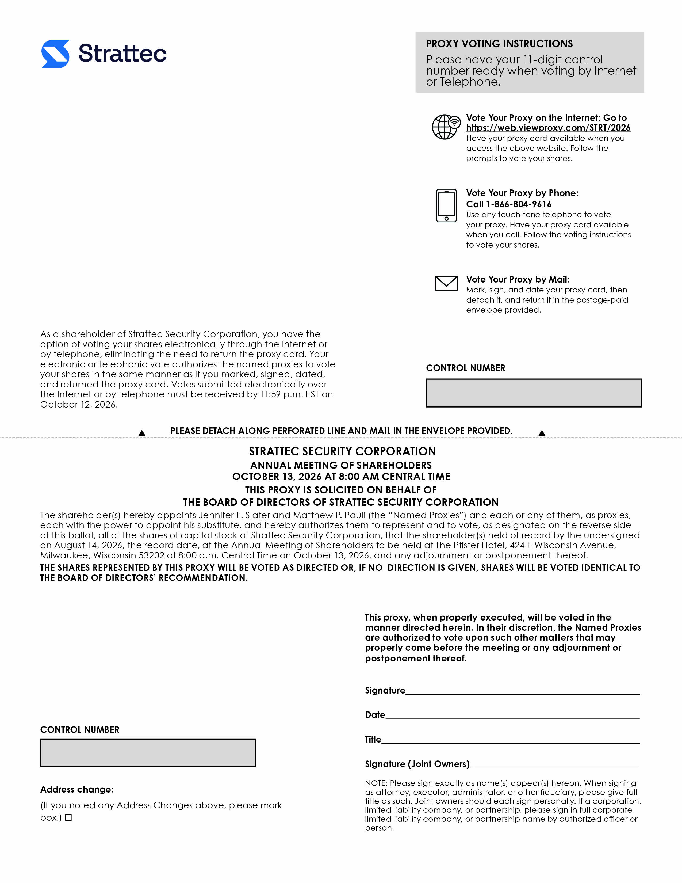

trattec PROXY VOTING INSTRUCTIONS Please have your 11-digit control number ready when voting by Internet or Telephone. Vote Your Proxy on the Internet: Go to https://web.viewproxy.com/STRT/2026 Have your proxy card available when you access the above website. Follow the prompts to vote your shares. Vote Your Proxy by Phone: Call 1-866-804-9616 Use any touch-tone telephone to vote your proxy. Have your proxy card available when you call. Follow the voting instructions to vote your shares. Vote Your Proxy by Mail: Mark, sign, and date your proxy card, then detach it, and return it in the postage-paid envelope provided. As a shareholder of Strattec Security Corporation, you have the option of voting your shares electronically through the Internet or by telephone, eliminating the need to return the proxy card. Your electronic or telephonic vote authorizes the named proxies to vote your shares in the same manner as if you marked, signed, dated, and returned the proxy card. Votes submitted electronically over the Internet or by telephone must be received by 11:59 p.m. EST on October 12, 2026. CONTROL NUMBER PLEASE DETACH ALONG PERFORATED LINE AND MAIL IN THE ENVELOPE PROVIDED. STRATTEC SECURITY CORPORATION ANNUAL MEETING OF SHAREHOLDERS OCTOBER 13, 2026 AT 8:00 AM CENTRAL TIME THIS PROXY IS SOLICITED ON BEHALF OF THE BOARD OF DIRECTORS OF STRATTEC SECURITY CORPORATION The shareholder(s) hereby appoints Jennifer L. Slater and Matthew P. Pauli (the "Named Proxies") and each or any of them, as proxies, each with the power to appoint his substitute, and hereby authorizes them to represent and to vote, as designated on the reverse side of this ballot, all of the shares of capital stock of Strattec Security Corporation, that the shareholder(s) held of record by the undersigned on August 14, 2026, the record date, at the Annual Meeting of Shareholders to be held at The Pfister Hotel, 424 E Wisconsin Avenue, Milwaukee, Wisconsin 53202 at 8:00 a.m. Central Time on October 13, 2026, and any adjournment or postponement thereof. THE SHARES REPRESENTED BY THIS PROXY WILL BE VOTED AS DIRECTED OR, IF NO DIRECTION IS GIVEN, SHARES WILL BE VOTED IDENTICAL TO THE BOARD OF DIRECTORS' RECOMMENDATION. This proxy, when properly executed, will be voted in the manner directed herein. In their discretion, the Named Proxies are authorized to vote upon such other matters that may properly come before the meeting or any adjournment or postponement thereof. Signature Date Title Signature (Joint Owners) NOTE: Please sign exactly as name(s) appears) hereon. When signing as attorney, executor, administrator, or other fiduciary, please give full title as such. Joint owners should each sign personally. If a corporation, limited liability company, or partnership, please sign in full corporate, limited liability company, or partnership name by authorized officer or person. CONTROL NUMBER Address change: (If you noted any Address Changes above, please mark box) mporailability of Proxy Materials for the Annual Meeting of Shareholders to be held on October 13, 2026: The Proxy Statement and Annual Report on Form 10-K are available at: https://web.viewproxy.com/STRT/2026 PLEASE DETACH ALONG PERFORATED LINE AND MAIL IN THE ENVELOPE PROVIDED. When properly executed, your proxy card/voting instruction form will be voted in the manner you direct. If you do not specify your choices, your shares will be voted in accordance with the Board of Directors' recommendations. Your Board of Directors recommends a vote "FOR"

Proposals 1, 2, and 3. Please mark your votes like this 1. Election of Directors NOMINEES: (1) Matteo Anversa (2) Thomas W. Florsheim, Jr. (3) F. Jack Liebau, Jr. (4) Bruce M. Lisman (5) Jennifer L. Slater (6) Tribby Warfield FOR AGAINST ABSTAIN 2. Ratify the appointment of Deloitte & Touche LLP as our independent registeredublic accounting firm for the fiscal year ending June 27, 2027. FOR AGAINST ABSTAIN 3. Approve, on an advisory basis, a resolution approving the compensation of the Company's named executive officers. FOR AGAINST ABSTAIN 4. To take action with respect to any other atters that may be properly brought before the Annual Meeting and that might be considered by the shareholders of a Wisconsin corporation at their annual meeting.

